

# **ACYCLE**

version 2.8

Time-series analysis software for paleoclimate research and education

**User’s Guide**

Mingsong Li

[www.acycle.org](http://www.acycle.org/)

Peking University, Beijing, China

July 18, 2025

Contents

ACYCLE - 1 -

What they say - 5 -

Copyright - 6 -

1. Acknowledgments - 7 -

2. References - 9 -

3. Software Specifications - 12 -

**3.1 System Requirements** - 12 -

**3.2 Downloading the *Acycle* software** - 13 -

**3.3 MatLab version** - 14 -

**3.3.1 Required Toolboxes** - 14 -

**3.3.2 Installation** - 14 -

**3.3.3 Startup** - 14 -

**3.3.4 Git Clone and Updates** - 15 -

**3.4 Mac stand-alone version** - 17 -

**3.4.1 Overview** - 17 -

**3.4.2 AcycleX.X-Mac-green** - 17 -

**3.5 Windows version** - 19 -

**3.5.1 Overview** - 19 -

**3.5.2 AcycleX.X-Win-green** - 20 -

**3.6 Data Requirements** - 21 -

4. *Acycle* Graphical User Interface (GUI) - 22 -

**4.1 Menu and Functions** - 23 -

**4.2 File** - 25 -

**4.3 Edit** - 26 -

**4.4 Plot** - 26 -

**4.5 Basic Series** - 31 -

**Insolation** - 31 -

**Astronomical Solution** - 33 -

**Milankovitch Calculator** - 33 -

**Signal/Noise Generator** - 34 -

**LR04 Stack** - 37 -

**CENOGRID** - 37 -

**Examples** - 37 -

**4.6 Math** - 41 -

**Sort / Unique / Delete Empty** - 41 -

**Interpolation** - 41 -

**Interpolation Pro** - 41 -

**Interpolation Series** - 42 -

**Select Parts** - 43 -

**Remove Parts** - 43 -

**Add Gaps** - 43 -

**Remove Peaks** - 44 -

**Clipping** - 44 -

**Column Manipulate** - 44 -

**Merge Series** - 45 -

**Multiply Series** - 45 -

**Data Transformation** - 45 -

**Simple Function** - 47 -

**Derivative** - 47 -

**Find max/min** - 47 -

**Changepoint** - 47 -

**Principal Component** - 48 -

**Image** - 48 -

**Show Image** - 48 -

**RGB to Grayscale** - 48 -

**RGB to CIE LAB** - 48 -

**Image Profile** - 49 -

**Plot Digitizer** - 50 -

**4.7 Time series** - 52 -

**Detrending | Curve Fitting** - 52 -

**Smoothing** - 53 -

**Pre-whitening** - 54 -

**Spectral Analysis** - 55 -

**Spectral Analysis (SWA)** - 58 -

**Evolutionary Spectral Analysis** - 59 -

**Wavelet** - 61 -

**Circular Spectral Analysis** - 67 -

**Recurrence Plot** - 68 -

**Coherence & Phase** - 69 -

**Lead/Lag Relationship** - 70 -

**Filtering** - 72 -

**Dynamic Filtering** - 75 -

**Empirical Mode Decomposition** - 76 -

**Amplitude Modulation** - 79 -

**Build Age Model** - 79 -

**Sedimentation Rate to Age Model** - 80 -

**Undatable** - 80 -

**Age Scale | Tuning** - 81 -

**Stratigraphic Correlation** - 85 -

**Power Decomposition Analysis** - 88 -

**Sedimentary Noise Model** - 88 -

**Correlation Coefficient (COCO/eCOCO)** - 89 -

**Evolutionary Correlation Coefficient (eCOCO)** - 92 -

**Spectral Moments** - 95 -

**4.8 Help** - 98 -

**文A/语言选择(language)** - 98 -

**What’s New** - 98 -

**Manuals** - 98 -

**Find Updates** - 98 -

**Copyright** - 98 -

**Contact** - 98 -

**4.9 Mini-robot** - 99 -

5. DYNOT model Description - 100 -

**5.1 Data format** - 100 -

**5.2 Startup** - 100 -

**5.3 Settings** - 101 -

**5.4. Running the DYNOT model** - 104 -

**5.5. Output Files** - 105 -

6. Case Studies - 106 -

**6.1 Typical procedures in cyclostratigraphy** - 106 -

**6.2 Example #1: Insolation** - 108 -

**Step 1: Load data** - 108 -

**Step 2: Data pre-processing** - 109 -

**Step 3: Detrending** - 109 -

**Step 4: Power Spectral Analysis** - 110 -

**Step 4: Evolutionary Spectral Analysis** - 111 -

**6.3 Example #2: La2004 Astronomical Solution (ETP)** - 112 -

**Step 1: Load data** - 112 -

**Step 2: Data pre-processing** - 113 -

**Step 3: Detrending** - 113 -

**Step 4: Power Spectral Analysis** - 114 -

**Step 5: Evolutionary Spectral Analysis** - 115 -

**Step 6: Wavelet transform** - 116 -

**6.4 Example #3: Carnian cyclostratigraphy** - 118 -

**Step 1. Load Data** - 118 -

**Step 2. Data Preparation** - 119 -

**Step 3. Interpolation** - 119 -

**Step 4. Detrending** - 121 -

**Step 5. Power spectral analysis** - 122 -

**Step 6. Evolutionary power spectral analysis** - 124 -

**Step 7. Correlation coefficient** - 124 -

**Step 8. Filtering** - 128 -

**Step 9. Age model & tuning** - 129 -

**Step 10. Repeat steps.** - 131 -

References - 132 -

T

ime series analysis plays a fundamental role in the natural sciences. In an increasingly important geoscience application, the recognition and interpretation of climate signals in proxy records can be time-consuming and subjective. Three factors motivated the development of the *Acycle* time-series analysis program: (1) the need to broaden and promote the use of time-series analysis in the geosciences, especially in paleoclimatology and cyclostratigraphy. (2) the need to accelerate the analysis workflow, which can be very time-consuming. (3) the need to provide objective methods for analyzing paleoclimate signals as reproducibility becomes a major challenge. We acknowledge our inspiring freeware predecessors: *Analyseries* (Paillard et al., 1996), *Anand*, and *Astrochron* (Meyers, 2014).

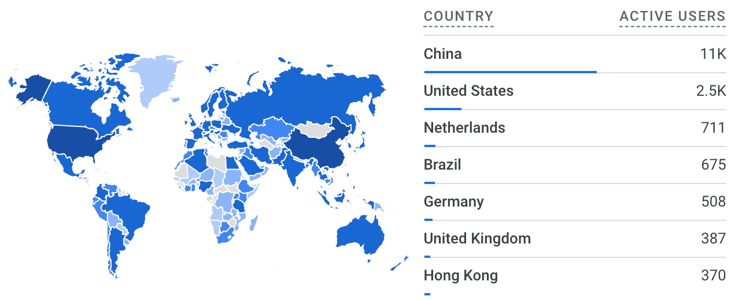

**Total: 20,119 unique visitors (Jan 2021 – July 2025)**

**Data source: <https://analytics.google.com>**



**Total: 2,736 unique visitors (Sept 2018 – Jan 2021)**

**Data source: <https://analytics.google.com>**

# **What they say**

**Dr. J. Fred Read** (Virginia Tech, USA)

**It is truly an amazing contribution to the geosciences community.** As someone who has spent much of the last 50 years trying to understand cyclic carbonates on shallow platforms, and having been involved with my students in some of the early work on stratigraphic modelling of the effects of Milankovitch forcing of carbonate platform stratigraphy, **I was blown away by the power of the**Acycle**software.** In the old days we used in house programs from our geophysicist Cahit Coruh, and recently I have used Analyseries, kSpectra and Timefrq43, moving from Dos to Windows to Mac, jumping from one to the other to get the job done. Acycle has done away with the need for this, and I have been impressed with how very user friendly the program is – an indication of the tremendous effort and thought that has gone into putting this together.

You should all feel very proud of this contribution. It opens up much needed access to these powerful tools for a wide audience in the sedimentary geology and paleoclimate community. Thanks again for all your efforts. **A really marvelous job.**

* **Dr. James G. Ogg** (Purdue University, USA):

“Mingsong Li’s ***Acycle*** software enables us to quickly analyze the potential of new outcrops and boreholes, and then to determine the sedimentation rates and elapsed time. His ***Acycle*** software will become the standard tool for time-scale applications by all international workers.”

* **Dr. Paul E. Olsen** (Columbia University, USA):

“Not only is this software powerful and effective, it is also simple to use and therefore benefits researchers and at all levels within the paleoclimatology community, from novices to experts.”

* **Dr. Arsenio Muñoz Jiménez (University of Zaragoza, Spain):**

“Thank you very much and congratulations for the ***acycle*** software. I am using it and it is very very useful and interesting.”

* **Dr. Marco Franceschi** (University of Padova, Italy):

“Dr. Li’s software is being immensely valuable to my work. Some of the stratigraphic series I am studying display a prominent cyclicity, but were deposited in contexts characterized by relevant changes in sedimentation rates and often lack accurate geochronological constraints. ***Acycle*** has been designed specifically for dealing with similar cases, by tackling them with a rigorous statistical approach, and therefore is providing an invaluable tool for their investigation.”

* **Dr. Xu Yao** (Lanzhou University, China):

“I am working on cyclostratigraphy and paleoclimate study of ancient strata and rocks (270 million years ago) with assistance from ***Acycle*** software. I also introduced this software to my colleagues whose research areas are paleoclimate implications of Quaternary loess (several thousand years ago). My colleagues have given me really good feedbacks about ***Acycle*** software.”

* **Dr. Christian Zeeden** (IMCCE, Observatoire de Paris, France):

“Dr. Li’s software is novel and valuable in this context, especially because it facilitates the easy application of otherwise complex calculations.”

* **Dr. Nicolas R. Thibault** (University of Copenhagen, Denmark):

“I’ve been playing a lot with the excellent ***Acycle*** package for Matlab that Mingsong developed. Congratulations, this is a very nice interface that simplifies a lot our work and makes it truly faster to analyse a time-series.”

* **Dr. Frits Hilgen** (Utrecht University, Netherlands):

“I used it this academic year for the first time in my MSc course on Astronomical climate forcing and time scales as replacement of the outdated *Analyseries* program. The main advantages of *Acycle* is that it is very user friendly, has a lot of different options for the statistical analysis of paleoclimate records and in addition first-rate plotting options. For instance you can directly see the trend that you aim to remove and then decide whether you want to continue with it. It is further also very good to see the fast and almost continuous improvement of *Acycle*, including the processing of reported bugs. And, not unimportantly, also my students were very enthusiastic about Acycle and I now use it now for my own research as well!”

# **Copyright**

Copyright © 2017-2025.

This software is freely downloadable, usable, and shareable by all users. It may be redistributed and/or modified under the terms of the GNU General Public License as published by the Free Software Foundation. To obtain a copy of the GNU General Public License, go to: <https://www.gnu.org/licenses>.

This program is distributed in the hope that it will be useful, but WITHOUT ANY WARRANTY; without even the implied warranty of MERCHANTABILITY or FITNESS FOR A PARTICULAR PURPOSE.

The *Acycle* authors reserve the right to license this program or modified versions of *Acycle* under other licenses at their discretion.

Questions about *Acycle* may be directed to:

|  |
| --- |
| *Mingsong Li*  *Assistant Professor*  *School of Earth and Space Sciences*  *Peking University*  *Beijing 100871, China*  *E-mail: msli@pku.edu.cn*  *Website: https://acycle.org/; https://faculty.pku.edu.cn/li/* |

# **1. Acknowledgments**

***Acycle* Authors:**

Mingsong Li (Peking University)

Linda A. Hinnov (George Mason University)

**Contributors:**

Jacques Laskar (Astronomical solution)

Richard Zeebe (Astronomical solution)

Eric Ruggieri (Bayesian Change Point)

Jonathan Levine, Peter Huybers (Insolation)

Matthias Sinnesael (Spectral Moments)

Christopher Torrence, Gilbert Compo (Wavelet)

Aslak Grinsted (Wavelet coherence, wavelet cross spectrum)

Yonggang Liu (Rectified Wavelet Power Spectrum)

Graham Weedon (Power spectrum with Smoothed Window Averages)

Bryan C. Lougheed, Stephen P. Obrochta (Undatable)

**Acknowledgments:**

Feng Cheng

Anne-Christine Da Silva

Jaume Dinarès-Turell

Mengyao Du

Hewei Duan

Zheng Gong

Zhengtang Guo

Yanan Fang

Marco Franceschi

Daniel R. Franco

Frits Hilgen

Xiaoni Hu

Chunju Huang

Zhengchuang Hui

Dorothée Husson

Qingqing Jiang

Arsenio Muñoz Jiménez

Ilja Kocken

Lee R. Kump

Dongyang Liu

Lucas Lourens

Kunyuan Ma

Mathieu Martinez

Stephen Meyers

James Ogg

Paul Olsen

Jeffrey Park

J. Fred Read

Chen Shen

Matthias Sinnesael

David Smith

Nicolas Thibault

Victor A. Piedrahita Velez

Chuanyue Wang

Meng Wang

Yujing Wu

Deke Xu

Yuzhen Yan

Xu Yao

Qiyan Zhang

Haotian Zhang

Haoxun Zhang

Xiaoyu Zhang

Yang Zhang

Ze Zhang

Hanyu Zhu

Christian Zeeden

Language verified by

Masayuki Ikeda (Japanese version)

**Advice and suggestions are always greatly appreciated. ​​​​​​​**

# **2. References**

**Please acknowledge *Acycle* in any publication of scientific results based on the use of *Acycle* by citing the following article in which *Acycle* is described:**

**Li, M., Hinnov, L.A., and Kump, L.R. 2019. *Acycle*: Time-series analysis software for paleoclimate projects and education, *Computers & Geosciences*, 127: 12-22. https://doi.org/10.1016/j.cageo.2019.02.011**

If you publish results using the following methods, please cite the corresponding publications:

**Bayesian Changepoint**:

* Ruggieri, E., 2013. A Bayesian approach to detecting change points in climatic records. International Journal of Climatology 33, 520-528, <https://doi.org/10.1002/joc.3447>.

**Correlation coefficient** (**COCO or eCOCO**):

* Li, M., Kump, L.R., Hinnov, L.A., Mann, M.E., 2018. Tracking variable sedimentation rates and astronomical forcing in Phanerozoic paleoclimate proxy series with evolutionary correlation coefficients and hypothesis testing. *Earth and Planetary Science Letters* 501, 165-179, <https://doi.org/10.1016/j.epsl.2018.08.041>.

**Evolutionary fast Fourier Transform (evoFFT)**:

* Kodama, K.P., Hinnov, L., 2015. *Rock Magnetic Cyclostratigraphy*. Wiley-Blackwell, 165 p., <https://doi.org/10.1002/9781118561294>.

**Filtering** (Gauss and Taner filters):

* Kodama, K.P., Hinnov, L.A., 2015. *Rock Magnetic Cyclostratigraphy*. Wiley-Blackwell, 165 p., <https://doi.org/10.1002/9781118561294>

**Multitaper data adaptive weighting and harmonic F-test**:

* From an unpublished SCILAB script by Jeffrey Park, Department of Geology and Geophysics, Yale University.

**Power decomposition analysis** (***pda.m***):

* Li, M., Huang, C., Hinnov, L.A., Ogg, J., Chen, Z.-Q., and Zhang, Y., 2016. Obliquity-forced climate during the Early Triassic hothouse in China. *Geology,* 44, 623-626, <https://doi.org/10.1130/G37970.1>

**Red noise modeling**:

**Classic AR(1)**

* Husson, D., 2014. MathWorks File Exchange: RedNoise_ConfidenceLevels, <https://www.mathworks.com/matlabcentral/fileexchange/45539-rednoise_confidencelevels> with corrections by L.A. Hinnov.

**Robust AR(1)**

* Mann, M.E., and Lees, J.M., 1996. Robust estimation of background noise and signal detection in climatic time series. *Climatic Change*, 33, 409-445, <https://doi.org/10.1007/BF00142586>.

**Sedimentary noise model** (**DYNOT** or ***ρ*1**):

* Li, M., Hinnov, L.A., Huang, C., Ogg, J., 2018. Sedimentary noise and sea levels linked to land–ocean water exchange and obliquity forcing. *Nature Communications*, 9, 1004, <https://doi.org/10.1038/s41467-018-03454-y>

**Smoothed Window Averages (Lomb-Scargle + SWA + FDR) Power Spectral Analysis**:

* Weedon, G.P., 2022. Problems with the current practice of spectral analysis in cyclostratigraphy: avoiding false_ml detection of regular cyclicity. Earth-Sci. Rev. 235, https://doi.org/10.1016/j.earscirev.2022.104261
* Weedon, G.P., 2020. Confirmed detection of Palaeogene and Jurassic orbitally-forced sedimentary cycles in the depth domain using false_ml Discovery Rates and Bayesian probability spectra. Boletin Geologico y Minero, 131, 207-230, https://doi.org/10.2170/bolgeomin.131.2.001
* Weedon, G.P., Page, K.N., and Jenkyns, H.C., 2019. Cyclostratigraphy, stratigraphic gaps and the duration of the Hettangian (Jurassic): insights from the Blue Lias Formation of Southern Britain. Geol. Mag. 156, 1469-1509, https://doi.org/10.1017/S0016756818000808

**MTM + SWA + FDR Power Spectral Analysis**:

* Jiang, Q., Li, M., Yao, W., Wei, R., Ji, K., Zhang, H., Jin, Z., 2025. Astrochronology of the Paleocene–Eocene Thermal Maximum on the East Tasman Plateau. Global and Planetary Change 252, 104882.

**Spectral Moments**:

* Sinnesael, M., Zivanovic, M., De Vleeschouwer, D., Claeys, P., 2018. Spectral Moments in Cyclostratigraphy: Advantages and Disadvantages compared to more classic Approaches. *Paleoceanography and Paleoclimatology* 33, 493–510. <https://doi.org/10.1029/2017PA003293>.

**Undatable**:

* Lougheed, B.C., Obrochta, S., 2019. A Rapid, Deterministic Age‐Depth Modeling Routine for Geological Sequences With Inherent Depth Uncertainty. Paleoceanography and Paleoclimatology 34, 122-133. <https://doi.org/10.1029/2018PA003457>.

**Wavelet analysis**:

* Torrence, C., Compo, G.P., 1998. A practical guide to wavelet analysis. *Bulletin of the American Meteorological Society*, 79, 61-78, [https://doi.org/10.1175/1520-0477(1998)079<0061:APGTWA>2.0.CO;2](https://doi.org/10.1175/1520-0477(1998)079%3c0061:APGTWA%3e2.0.CO;2).

**Wavelet coherence and cross wavelet transform**

* Grinsted, A., Moore, J. C., Jevrejeva, S., 2004, Application of the cross wavelet transform and wavelet coherence to geophysical time series, Nonlinear Processes in Geophysics, 11, 561566.

**Astronomical solutions**

**La2004**

Laskar, J., Robutel, P., Joutel, F., Gastineau, M., Correia, A.C.M., Levrard, B., 2004. A long-term numerical solution for the insolation quantities of the Earth. Astronomy & Astrophysics, 428, 261-285, <https://doi.org/10.1051/0004-6361:20041335>.

**La2010**

Laskar, J., Fienga, A., Gastineau, M., Manche, H., 2011. La2010: a new orbital solution for the long-term motion of the Earth. Astronomy & Astrophysics, 532. <https://doi.org/10.1051/0004-6361/201116836>.

* ***calculation method presented in***

Wu, H., Zhang, S., Jiang, G., Hinnov, L., Yang, T., Li, H., Wan, X., Wang, C., 2013. Astrochronology of the Early Turonian-Early Campanian terrestrial succession in the Songliao Basin, northeastern China and its implication for long-period behavior of the Solar System. Palaeogeography, Palaeoclimatology, Palaeoecology 385, 55-70, <https://doi.org/10.1016/j.palaeo.2012.09.004>.

**Waltham2015**

Waltham, D., 2015. Milankovitch period uncertainties and their impact on cyclostratigraphy. Journal of Sedimentary Research 85(8): 990-998. https://doi.org/10.2110/jsr.2015.66.

**ZB2017**

Zeebe, R.E., 2017. Numerical solutions for the orbital motion of the Solar System over the past 100 Myr: limits and new results. *The Astronomical Journal*, 154, 193, <https://doi.org/10.3847/1538-3881/aa8cce>

**ZB18a**

Zeebe, R.E., Lourens, L.J., 2019. Solar System chaos and the Paleocene–Eocene boundary age constrained by geology and astronomy, *Science*, 365, 926-929, <https://doi.org/10.1126/science.aax0612>.

# **3. Software Specifications**

## **3.1 System Requirements**

This software was developed in **MatLab version 2020b**. It was tested on the Big Sur (11.1) and Monterey (12.0) and Windows 7 & 10.

|  |
| --- |
| **Facts for stand-alone versions of *Acycle*:**  **\* Stand-alone versions of *Acycle* only require the MATLAB Runtime, not MATLAB.**  **\* MatLab Runtime is not MATLAB.**  **\* MatLab Runtime is free.**  **\* Use MatLab Runtime 2020b; other versions of runtime may NOT work.**  * **If you have MatLab 2020b, the MatLab Runtime 2020b is already installed.** |

[**1. MatLab version**]:

This version works with both macOS and Windows. MatLab is essential for the *Acycle* software package. Specified MatLab toolboxes (see section 3.3.1) may be needed.

[**2. Mac version**]:

This software is a stand-alone program. If the Mac does not have MATLAB installed, **MatLab Runtime** **2020b** is essential for the *Acycle* stand-alone software. See section 3.4.

**Warning: Other versions of MatLab Runtime may not work!**

*Acycle*X.X-Mac-green

**No installation needed**.

Size: ~30 Mb.

MatLab Runtime **2020b** is not included in this package and can be downloaded at: <https://www.mathworks.com/products/compiler/matlab-runtime.html>.

[**3. Windows version**]:

This software is a stand-alone program. It was tested on Windows 10.

v1. *Acycle*X.X-Win-green

Size: ~30 Mb.

If the computer does not have MATLAB 2020b installed, MatLab Runtime **2020b** is required for the *Acycle* stand-alone software.

**Warning: Other versions of MatLab Runtime may not work!**

## **3.2 Downloading the *Acycle* software**

The *Acycle* software is available for download from:

**Dropbox** (<https://www.dropbox.com/sh/t53vjs539gmixnm/AAC0BqTR0U5xghKwuVc1Iwbma?dl=0>),

**OneDrive** (<https://1drv.ms/u/s!AuOnvtrY8aRzhG17NCoXG14eOVIS>),

**Baidu Cloud** (<https://pan.baidu.com/s/14-xRzV_-BBrE6XfyR_71Nw>), or

**MatLab version** only available on

**GitHub** (*[https://github.com/mingsongli/acycle/](https://github.com/mingsongli/acycle/))*[)](https://github.com/mingsongli/acycle/)),



## **3.3 MatLab version**

### **3.3.1 Required Toolboxes**

Below is the complete list of nine MATLAB toolboxes required by Acycle v2.8. Please install these toolboxes to ensure proper operation:

'Signal Processing Toolbox'

'Statistics and Machine Learning Toolbox'

'Image Processing Toolbox'

'Fuzzy Logic Toolbox'

'Curve Fitting Toolbox'

'Parallel Computing Toolbox'

'MATLAB Parallel Server'

'Polyspace Bug Finder'

'Wavelet Toolbox'

### **3.3.2 Installation**

Unzip the *Acycle* software package into your desired directory. No further installation is required.

### **3.3.3 Startup**

**Step 1**: Launch MatLab.

**Step 2**: Change the MatLab Current Folder to the Acycle installation directory.

You may click the folder icon shown in blue Box 1 or enter the path manually in blue Box 2.



**Step 3**: **Start *Acycle*** by running the ac.m script:

Option 1: In the Command Window, type **ac** and press Enter.

Option 2: Right-click ac.m in the Current Folder browser and select Run.

*Acycle* is now ready to use!



### **3.3.4 Git Clone and Updates**

[By **Meng Wang**, *Peking University*]

*Step 1:* **Install Git: *D****ownload* and install from[*https://git-scm.com/downloads*](https://git-scm.com/downloads)*.*

*Step 2: Open Terminal (macOS) or Git Bash (Windows), then “*cd*” to the directory where you want Acycle installed.*

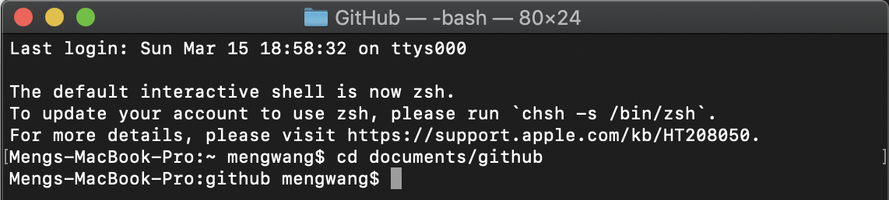

*Step 3:* Clone the repository:

git clone https://github.com/mingsongli/acycle.git

To clone the **dev** branch instead, use:

git clone -b dev https://github.com/mingsongli/acycle.git

**

*Step 4: Update Acycle when new commits are available:*

cd acycle

git pull

**

## **3.4 Mac stand-alone version**

### **3.4.1 Overview**

This is a stand-alone application for macOS, distributed as the AcycleX.X-Mac-green package.

### **3.4.2 *Acycle*X.X-Mac-green**

3.4.2.1 Download

Obtain *Acycle*X.X-Mac-green (See section 3.2).

**3.4.2.2 MatLab Runtime Installation**

**Step 1**: Download “MATLAB_Runtime_R2020b_Update_5_maci64.dmg.zip” from

<https://www.mathworks.com/products/compiler/matlab-runtime.html>

**Warning: Other MatLab Runtime versions may not be compatible!**

**Step 2**: Install on mac OS.

Double-click the downloaded .dmg.zip file to extract and mount it (see blue box in the left panel).

In the mounted volume, double-click InstallForMacOSX or right-click and choose Show Package Contents to locate and run InstallForMacOSX.

If prompted, grant permission and follow the installer instructions to complete the setup.

 

**Step 3**. [Optional] Configure the Runtime environment as detailed in **Box 1**.

Step 1: Drag “AcyclevX.X-Mac” file to “/Applications” folder.

**Box 1** [**How to set the MatLab Runtime environment variable DYLD_LIBRARY_PATH?**]

Here is a nice answer by Walter Roberson on 14 Jan 2016.

<https://www.mathworks.com/matlabcentral/answers/263824-mcr-with-mac-and-environment-variable>

Step 1: Go into the Terminal app (it is under /Applications/Utilities).

While you are at the Terminal command window, command

ls ~/.bashrc

If it says that the file does not exist, then in the Terminal window, command

touch ~/.bashrc

if it doesn’t work, you may try

nano ~/.bashrc

to create the file. If the file already exists or you have now created it, then at the terminal window command

open ~/.bashrc

This will open TextEdit. In TextEdit you can add the line

export DYLD_LIBRARY_PATH=/Applications/MATLAB/MATLAB_Runtime/v99/runtime/maci64:/Applications/MATLAB/MATLAB_Runtime/v99/sys/os/maci64:/Applications/MATLAB/MATLAB_Runtime/v99/bin/maci64:/Applications/MATLAB/MATLAB_Runtime/v99/extern/bin/maci64

to the end of the file, and then you can use the TextEdit File menu to Save the file.

If your SHELL showed up as csh or tcsh, or in any case if you just want to be more thorough, then you can use the same kind of steps as just above:

ls ~/.cshrc

and if it does not exist, "touch ~/.cshrc", and then once it exists, "open ~/.cshrc", and then in TextEdit, add the line they gave in the instructions,

setenv DYLD_LIBRARY_PATH

=/Applications/MATLAB/MATLAB_Runtime/v99/runtime/maci64:/Applications/MATLAB/MATLAB_Runtime/v99/sys/os/maci64:/Applications/MATLAB/MATLAB_Runtime/v99/bin/maci64:/Applications/MATLAB/MATLAB_Runtime/v99/extern/bin/maci64

and save.

These changes will not affect your current Terminal session, but they will affect the next time you start a Terminal session or anything else starts an interactive shell.

3.4.2.3 Startup *Acycle*X.X-Mac-green

*You only need to complete Steps 1-3 once; thereafter, only Step 4 is required.*

**Step 1**: Drag the *Acycle*X.X-Mac-green file to the **“/Applications”** folder.

**Step 2**: Go to the **“/Applications”** folder. Right-click “*Acycle*X.X-Mac-green” file and choose “Show Package Contents”.

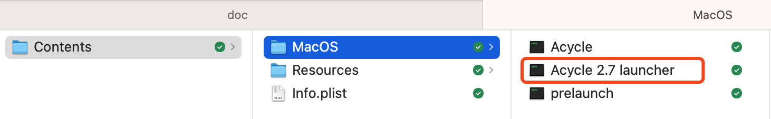

**Step 3**: Navigate to **“/Contents/MacOS”** folder, then drag the “Acycle 2.7 Launcher” file into the Dock.

**Step 4**: Click the “Acycle Launcher” icon in the Dock to start *Acycle*.

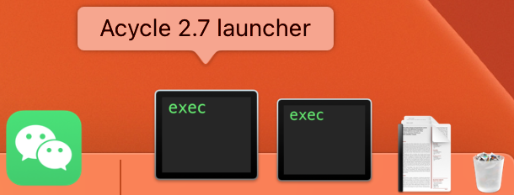

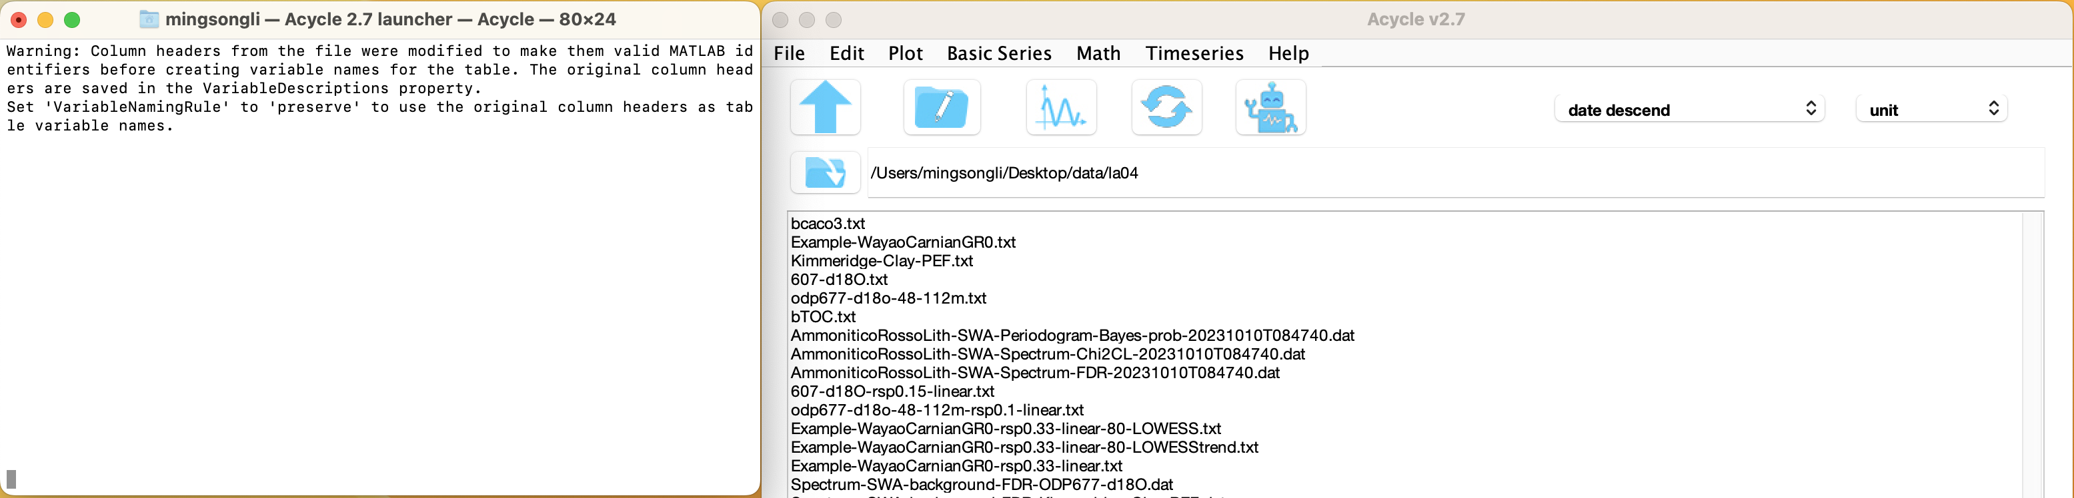

**Note: The first launch may be very slow (10-60 seconds)** as the program loads the MatLab Runtime libraries. Please ignore any warning messages and pardon my rudimentary programming.

**Warning:** The working directory should not contain SPACES or non-English characters.

Warning: NEVER close the Terminal window (left panel), as doing so will terminate *Acycle*.

## **3.5 Windows version**

### **3.5.1 Overview**

This version of *Acycle* is a stand-alone program, distributed as **AcycleX.X-Win-green**.

### **3.5.2 *Acycle*X.X-Win-green**

3.5.2.1 Obtain and unzip *Acycle*X.X-Win-green (See section 3.2).

3.5.2.2 Install MatLab Runtime 2020b from

<https://www.mathworks.com/products/compiler/matlab-runtime.html>

**Warning: Other versions of MatLab Runtime may not work!**

3.5.2.3 Double-click “*Acycle*.exe” to launch the software.

3.5.2.4 Change the working directory () to your desired folder.

## **3.6 Data Requirements**

The input file for data series can be in a variety of formats, including comma-, tab-, or space-delimited text (*.txt*), or comma-separated values (*.csv*) from spreadsheet software. A header row is allowed when it starts with “%”.

Data files usually contain two columns: the first column must be depth or time, and the second column is the data.

**

Warning: The file path must not contain SPACES or non-ENGLISH characters. If necessary, change the working directory () to another working folder.

If you are unfamiliar with data loading, **try this example:**

*1. Choose “Basic Series” 🡪 Examples 🡪 select any data or image file.*

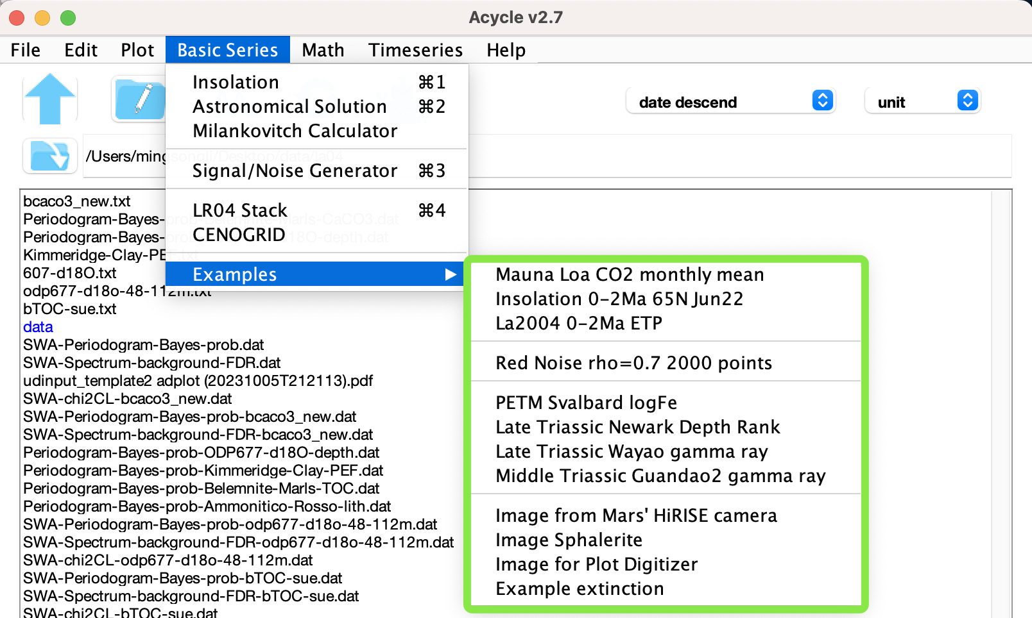

2. The sample data will be copied to the working directory.

3. All data files, plots, and folders will appear in the GUI list box.

# **4. *Acycle* Graphical User Interface (GUI)**

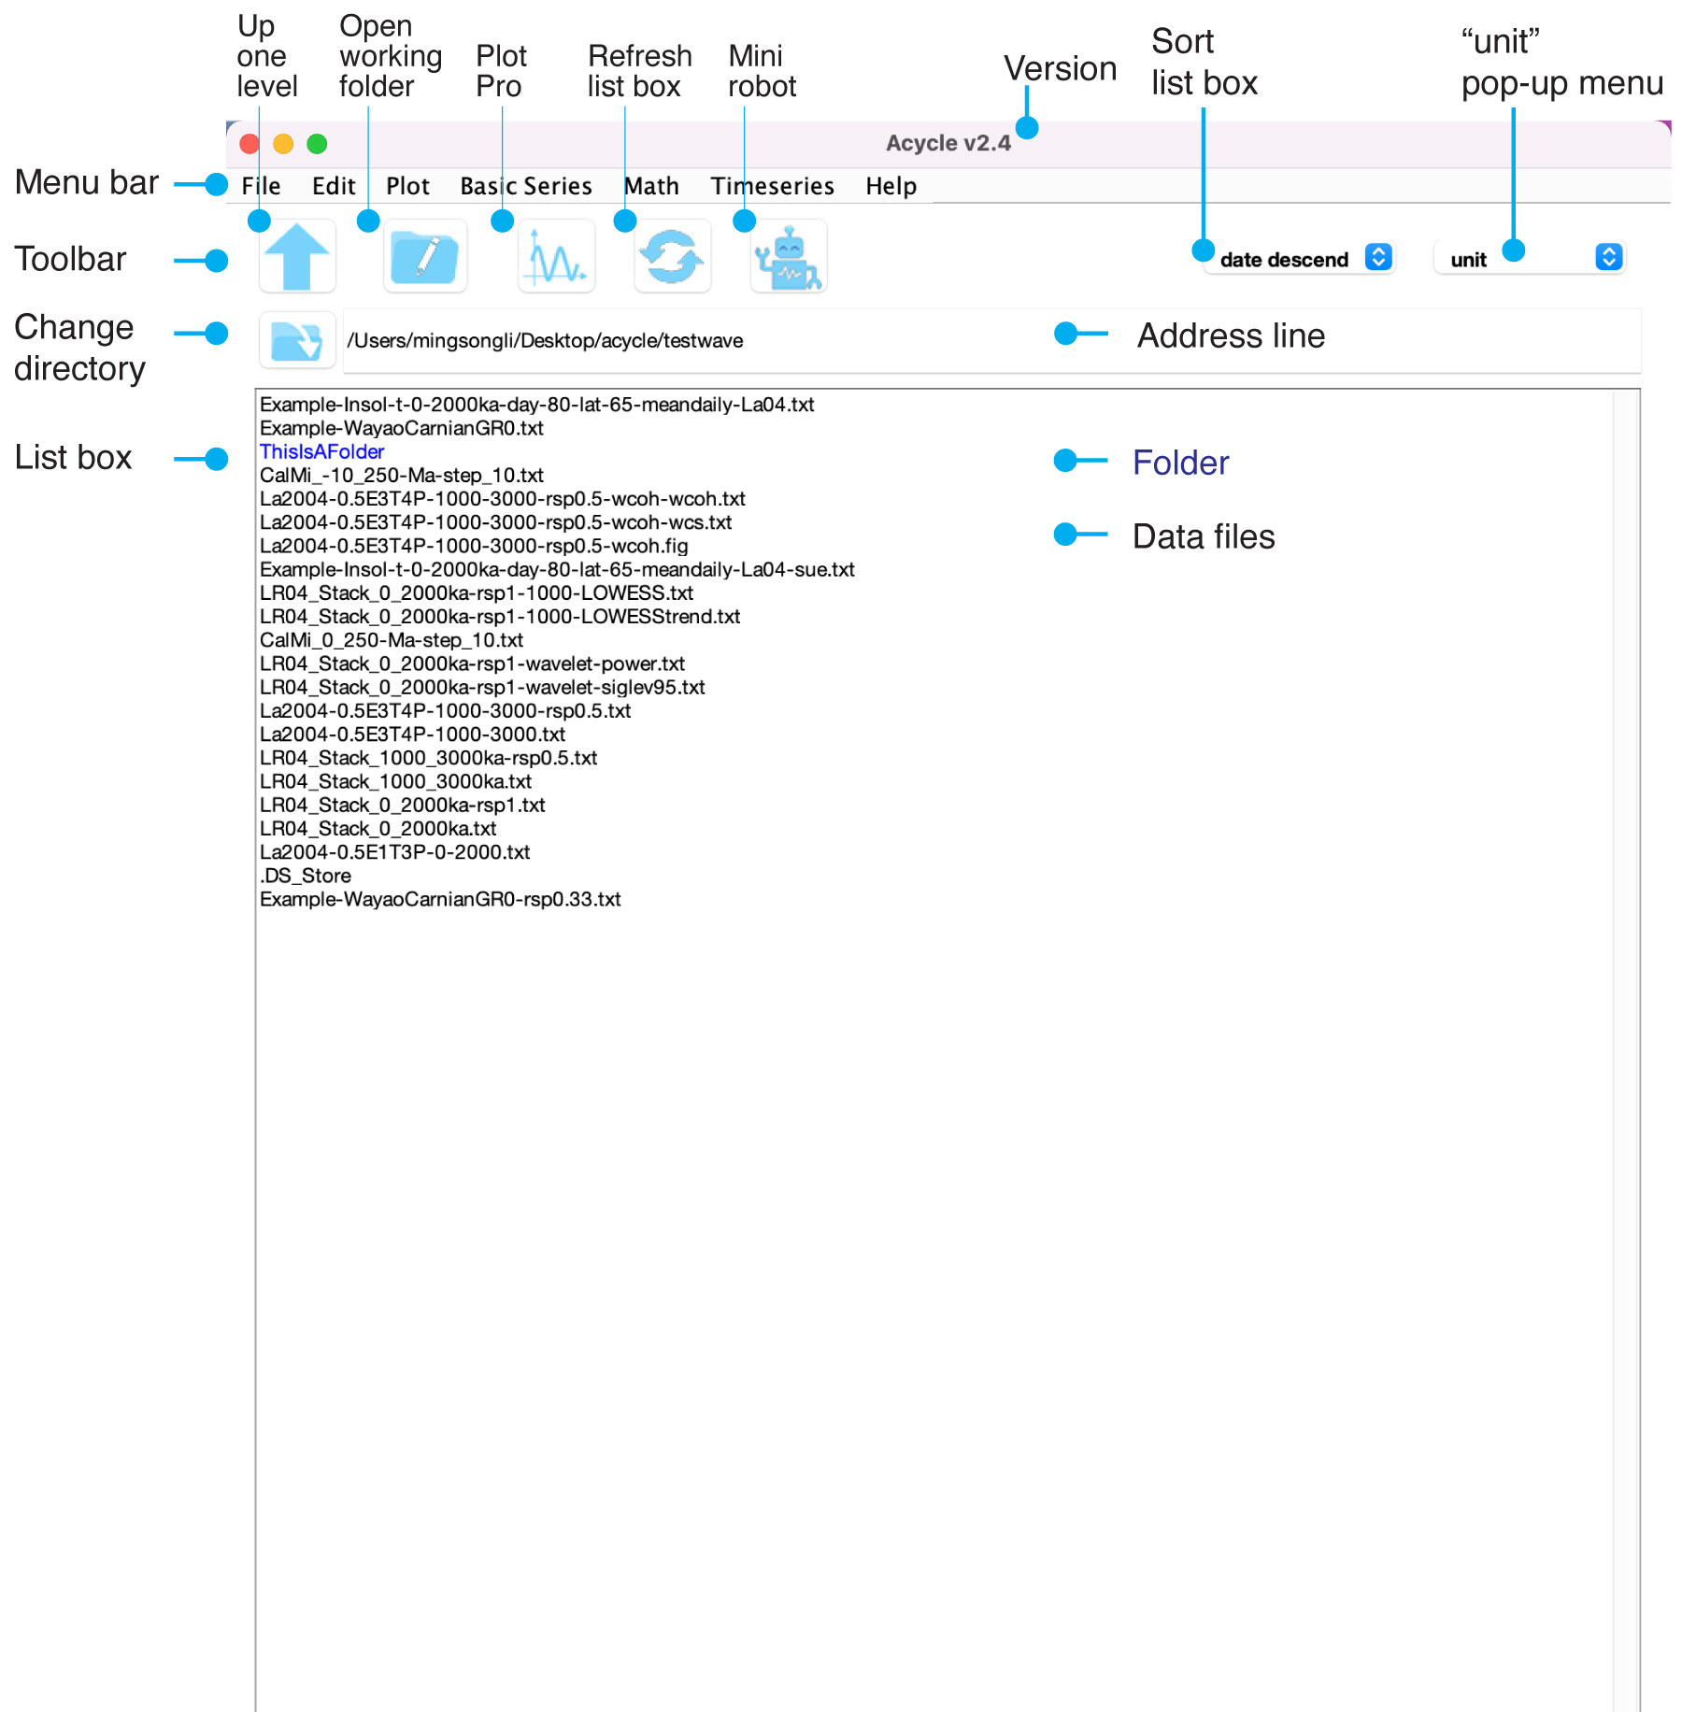

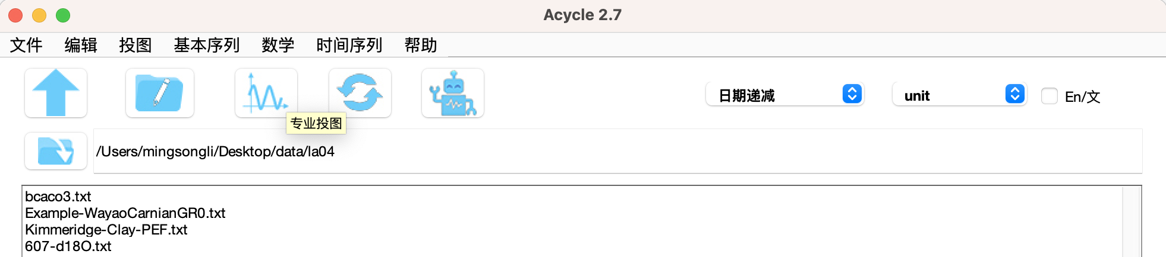

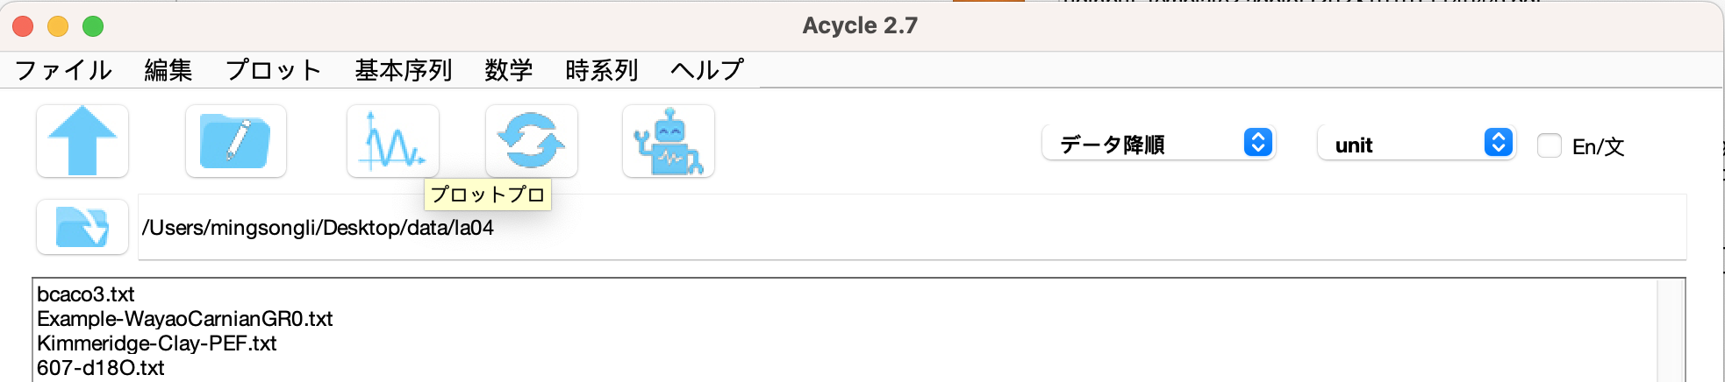

Screenshots of the GUI in English, Chinese, and Japanese

## **4.1 Menu and Functions**

**File**

New Folder

New Text File

Save *.AC.fig

Open Working Directory

Extract Data

**Edit**

Refresh

Rename

Cut

Copy

Paste

Delete

**Plot**

Plot

Plot Pro

Plot Advanced

Plot Standardized

Plot Standardized + 2

Sampling Rate

Data Distribution

Convert to Sound

**Basic Series**

Insolation

Astronomical Solution

Milankovitch Calculator

Signal/Noise Generator

LR04 Stack

CENOGRID

Examples (a couple of data series of data and images)

**Math**

Sort / Unique / Delete Empty

Interpolation

Interpolation Pro

Interpolation Series

Select Parts

Remove Parts

Add Gaps

Remove Peaks

Clipping

Column Manipulation

Merge Series

Multiply Series

Data Transformation

Simple Function

Derivative

Find Max/Min

Change Point

Principal Component

Image [Show Image, RGB to Grayscale; RGB to CIE Lab; Image Profile]

Plot Digitizer

**Time series**

Detrending | Curve Fitting

Smoothing [Bootstrap, Moving Average, Moving Median, Moving Gaussian]

Pre-whitening

Spectral Analysis

Spectral Analysis (SWA)

Evolutionary Spectral Analysis

Wavelet

Circular Spectral Analysis

Recurrence Plot

Coherence & Phase

Lead/Lag Relationship

Filtering

Dynamic Filtering

Empirical Mode Decomposition [Empirical Mode Decomposition (EMD), Ensemble Empirical Mode Decomposition (EEMD)]

Amplitude Modulation

Build Age Model

Sedimentary Rate to Age Model

Undatable

Age Scale | Tuning

Stratigraphic Correlation

Power Decomposition Analysis

Sedimentary noise model [Dynamic noise after orbital tuning (DYNOT); Lag-1 autocorrelation coefficient (*ρ*1)]

Correlation Coefficient (COCO/eCOCO)

Spectral Moments

**Help**

文A/语言选择(language)

What’s New

Manuals

Find Updates

Copyright

Contact

## **4.2 File**

**New Folder:**

Create a new empty folder with a user-defined name.

*Question: Why do you need this tool?*

*Answer: Helps keep your data files well-organized. For example, you can create a separate folder for each project.*

**New Text File:**

Create a new empty *.txt file with a user-defined name.

*Shortcut keys [Mac]: ⌘ + N; [Windows]: Ctrl + N*

**Save *.AC.fig file:**

Save the current figure as an *.ac.fig file. This allows users to resume a suspended project.

For example, after running the eCOCO (evolutionary correlation coefficient) analysis, users may want to revisit the results. Save the current figure as an *.AC.fig file, then double-click it to reopen the “ECOCO plot” at any time.

**Extract Data:**

Extract two columns from a multi-column data file.

For example, if your text file contains five columns and you want columns **2** and **3**, this creates a new two-column text file. This file ensures *Acycle* can properly read the data.

To use Extract Data: select the file, click **File** – **Extract Data**, enter **2** and **3** in the prompts, and click OK. The new file appears in the main window.

## **4.3 Edit**

**Refresh:** Refresh the main list box.

*Shortcut keys [Mac]: ⌘ + R; [Windows]: Ctrl + R*

**Rename:**

Select a file, then use the “Rename” function to change its name.

**Cut / Copy / Paste / Delete:** Standard file operations for managing selected items.

 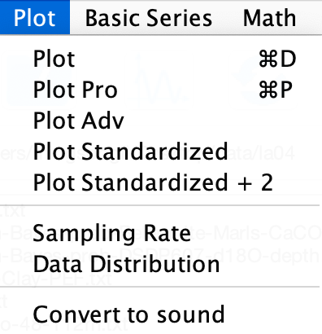

## **4.4 Plot**

**Plot:**

Create a quick plot of the selected data file.

*Shortcut keys [Mac]: ⌘ + D; [Windows]: Ctrl + D*

**Plot Pro:**

Open the advanced plotting dialog for the selected data file. Customize plot type, line and marker styles, and axis settings.

*Shortcut keys [Mac]: ⌘ + P; [Windows]: Ctrl + P*

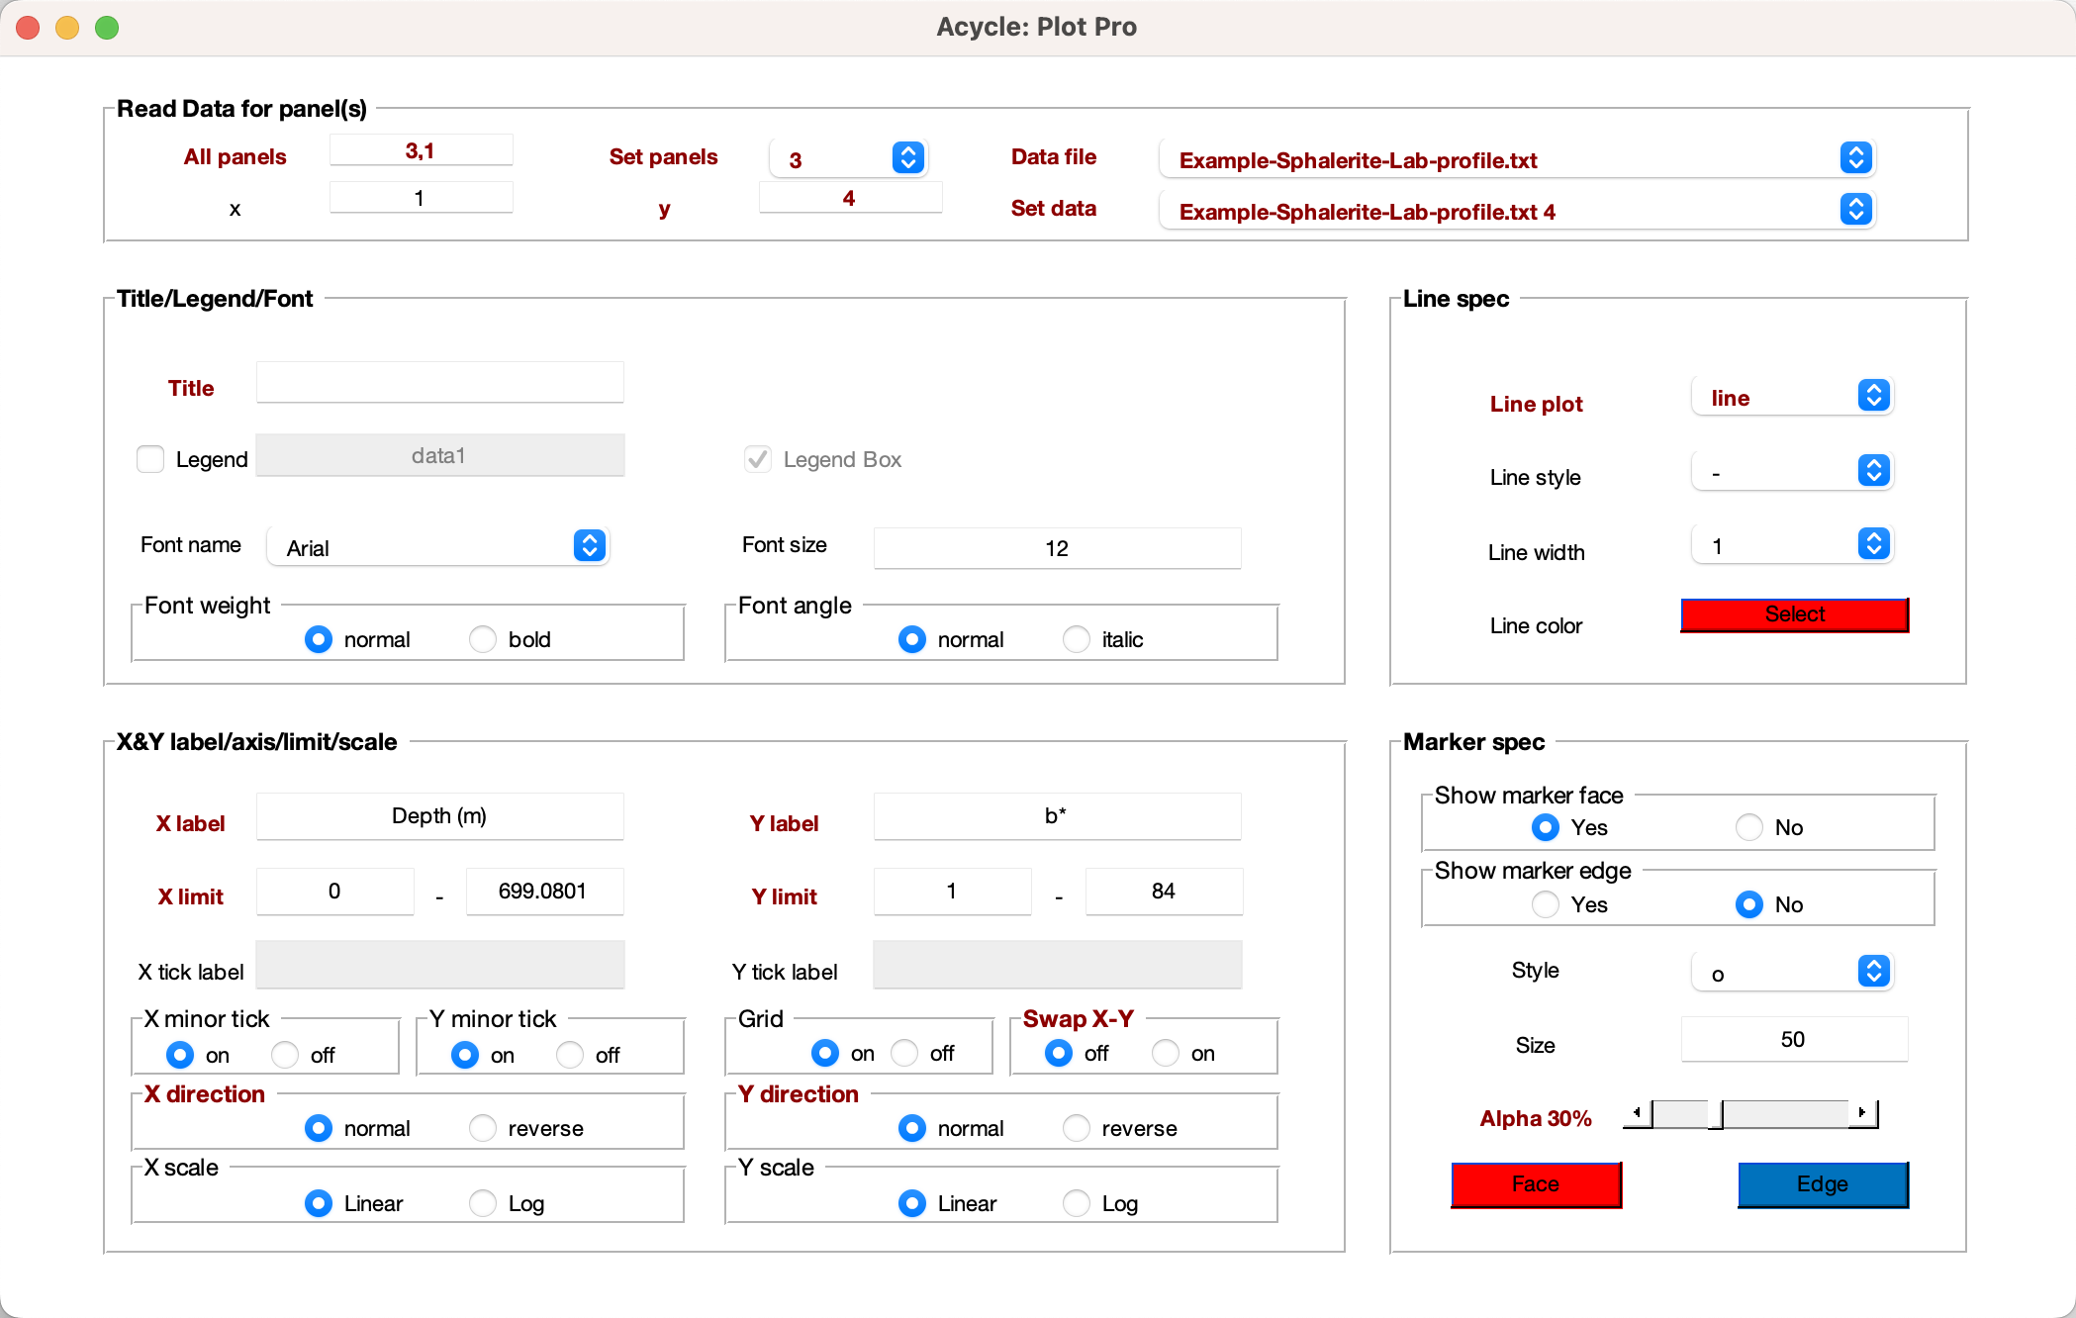

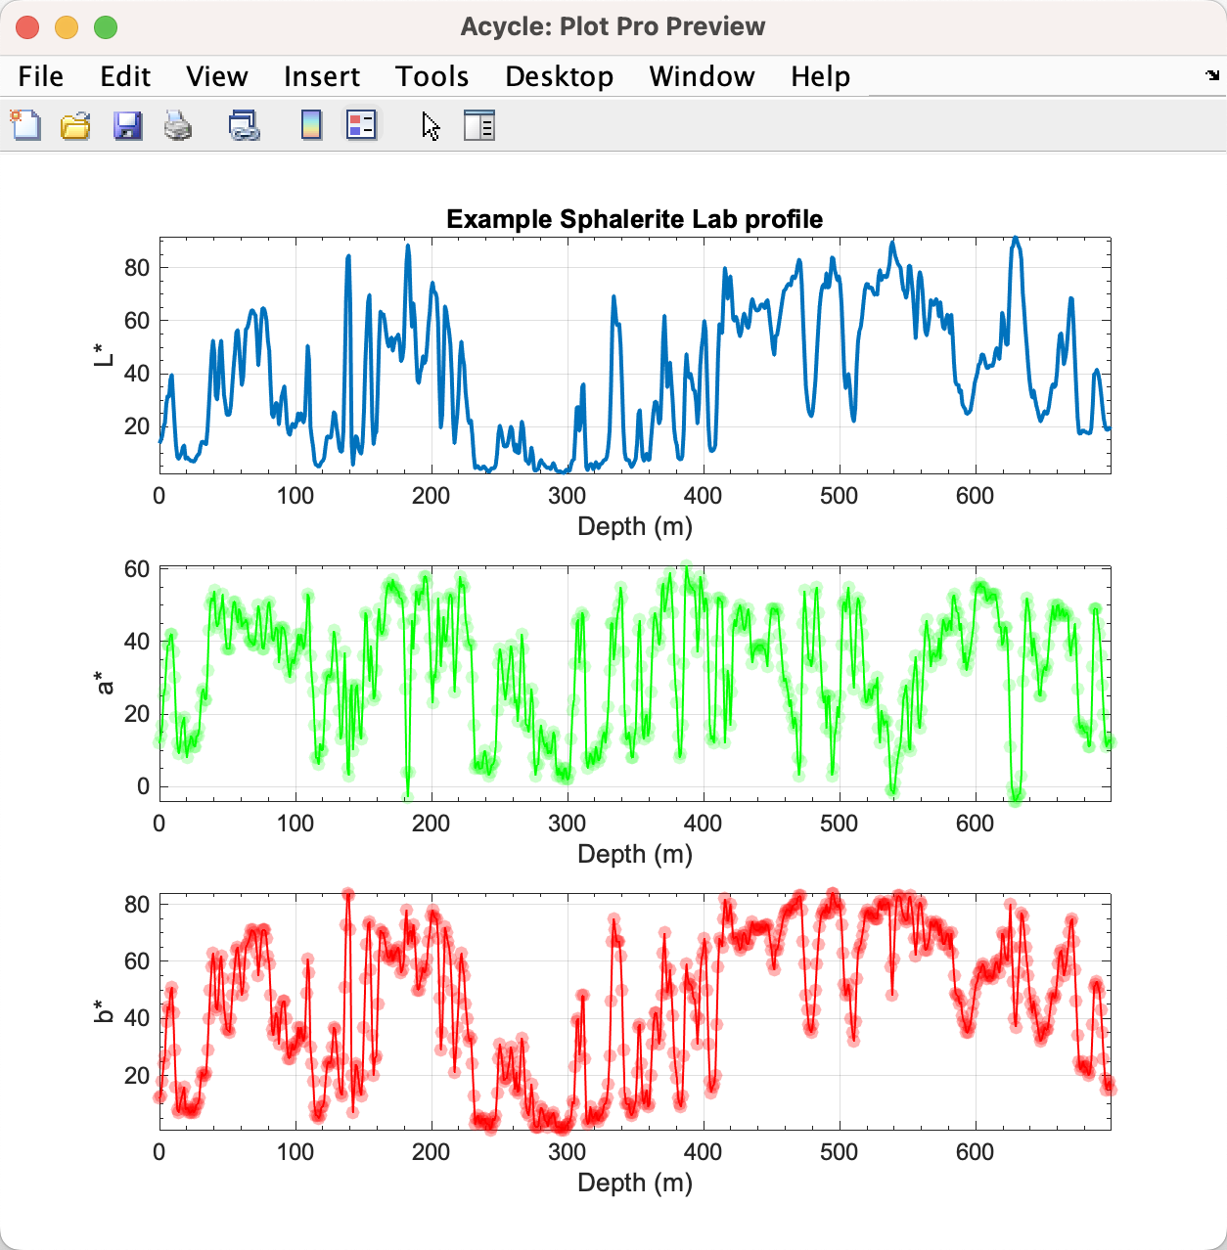

**Plot Advanced:**

Launches the advanced plotting GUI for the selected data file. You can:

* Choose plot type (line, scatter, etc.)
* Customize line and marker styles
* Edit x-label, y-label, and title
* Control axis limits, ticks, and grid

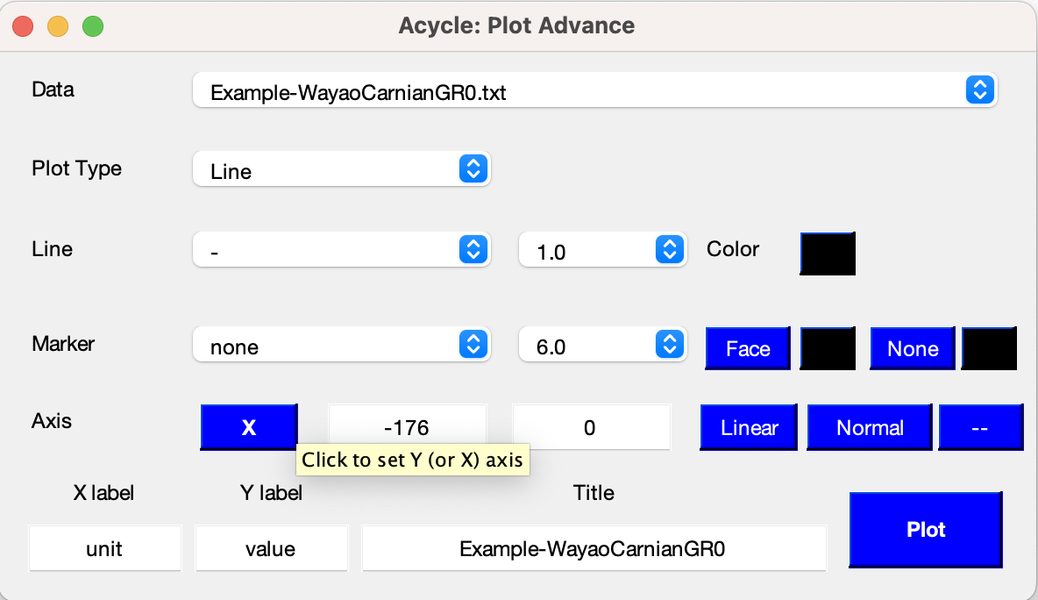

*or*

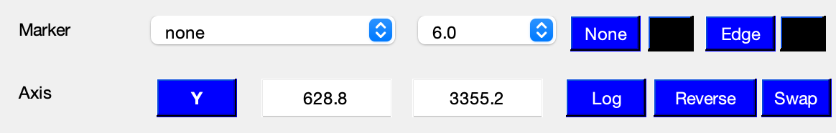

One example

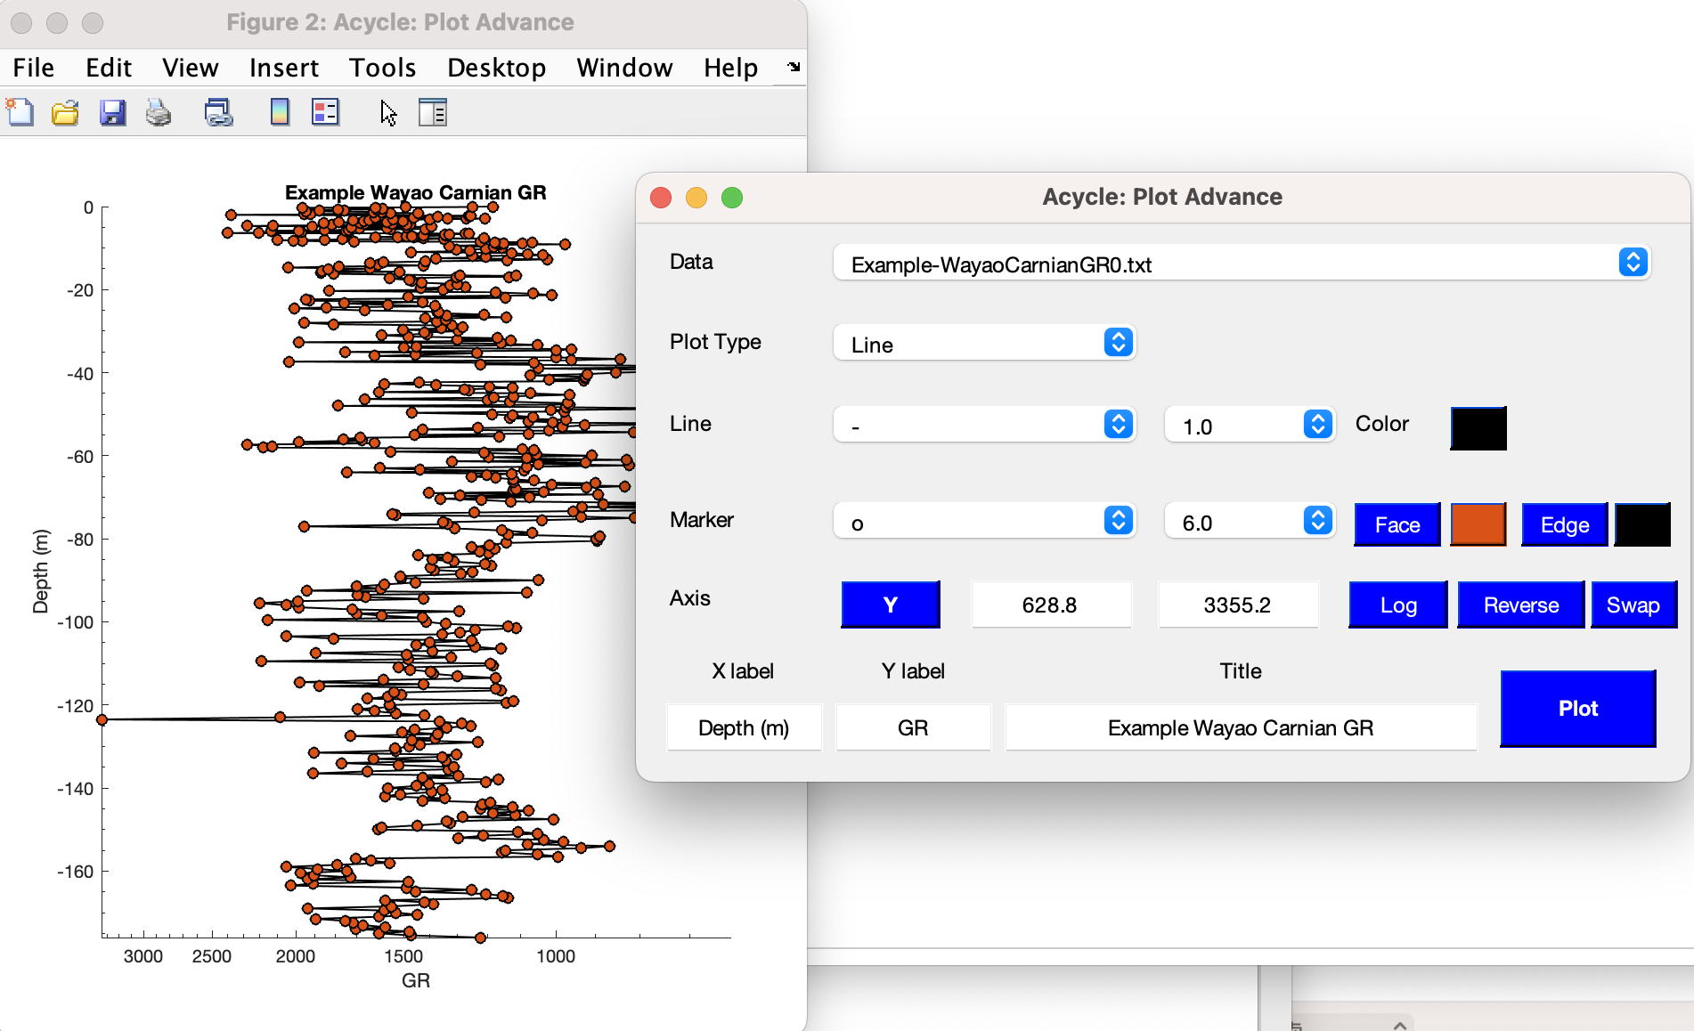

*Acycle (v2.1-2.4) allows users to define texts for x-label, y-label and title.*

**Plot Standardized:**

Quickly standardizes the data (zero mean, unit variance) and overlays one or more series for direct comparison.

**Plot Standardized +2:**

Same as **Plot Standardized**, but applies a vertical offset of +2 units between each series to prevent overlap.

**Sampling Rate:**

Plots the distribution of the first column (time or depth) to visualize how evenly your data are sampled.

**Data Distribution:**

Generates a histogram of the second column (data values) so you can assess its frequency distribution.

**Convert to Sound:**

Transforms a time series into an audio waveform and plays it. A new .wav file appears in the main window. Steps:

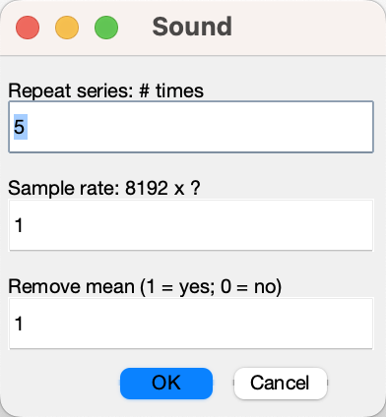

Step 1: Select a time-series data file (e.g., odp677-d18o-48-112m.txt).

Step 2: Choose Plot 🡪 Convert to Sound

Step 3: Adjust playback settings (repeat factor, sampling rate, etc.) and click OK.

Step 4: Listen as *Acycle* plays the sound. The generated file (e.g., odp677-d18o-48-112m_rep-5-rate-8192.wav) will be listed in the GUI.

## **4.5 Basic Series**

### **Insolation**

A GUI calculates insolation using various astronomical solutions, based on the MatLab script **insolationnjl.m** by Jonathan Levine (2001; Colgate University, <https://www.colgate.edu/about/directory/jlevine>), modified to **daily_insolation.m** (<https://eisenman-group.github.io/daily_insolation.m> ) by Peter Huybers (Harvard) and Ian Eisenman (UC San Diego), and adapted by Mingsong Li for the *Acycle* software. Only insolation series younger than 249,000 ka are available because the Laskar solutions cover 0-249,000 ka.

*Tip: If only the first calculation is saved, close the “Acycle-Insolation” GUI and repeat the calculation. Acycle will “forget” the previous run and save the data correctly.*

*Shortcut keys [Mac]: ⌘ + 1; [Windows]: Ctrl + 1*

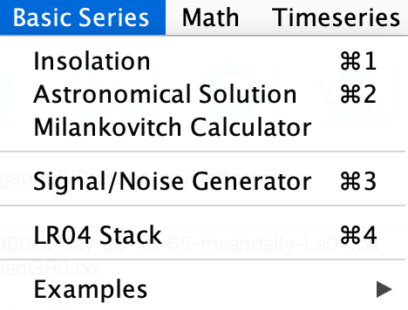 



*This GUI generates the mean daily insolation on March 21 for 1-1000 ka at 65°N using the La2004 solution with a solar constant of 1365 w/m2.*



*Mean insolation map from March 21 to September 23 for the past 100 kyr (1-100 ka) at 50-80°N using Laskar et al. (2004) solutions, with a solar constant of 1365 w/m2. See the animation at <https://github.com/mingsongli/acycleFig/blob/master/chapter4/Insol-t-1-100ka-day-80-264-lat-50-80-meandaily-La04.gif>*

### **Astronomical Solution**

A GUI generates astronomical solutions from Laskar et al. (2004); Laskar et al. (2011), [Zeebe (2017)](#_ENREF_34" \o "Zeebe, 2017 #5153), and Zeebe and Lourens (2019).

*Shortcut keys [Mac]: ⌘ + 2; [Windows]: Ctrl + 2*





*This GUI creates the ETP series (sum of standardized eccentricity, tilt, and precession weighted 1, 1, and -1) for the past 1 million years (1-1000 ka) using the La2004 solution* (Laskar et al., 2004)*.*

*To reduce the file size, ZB18a solution was included and ZB17 solutions removed in Acycle v2.1. Find more about ZB solutions at: <https://www.soest.hawaii.edu/oceanography/faculty/zeebe_files/Astro.html>*

### **Milankovitch Calculator**

A toolbox using Waltham (2015) and Laskar et al., (2004) models to generate deep-time astronomical parameters.

Waltham2015 model calculates astronomical parameters for a single time or series: Earth-Moon distance (unit: 1000 km), day length (hours), mean obliquity (°), axis precession period (kyr), main obliquity period (kyr), and climatic precession periods (kyr). One-sigma uncertainty can be shown.

La2004 model calculates length-of-day (LOD) and day-of-year (DOY) using a predefined time range and step.

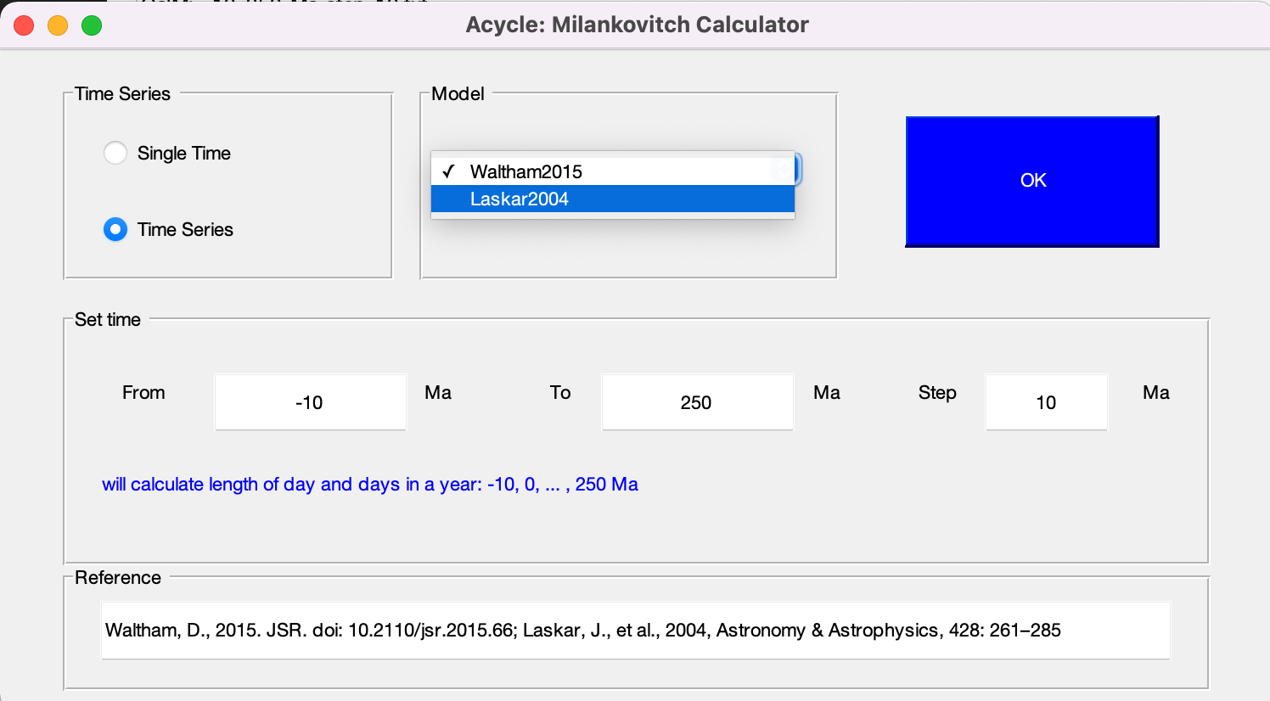

*Milankovitch Calculator GUI*

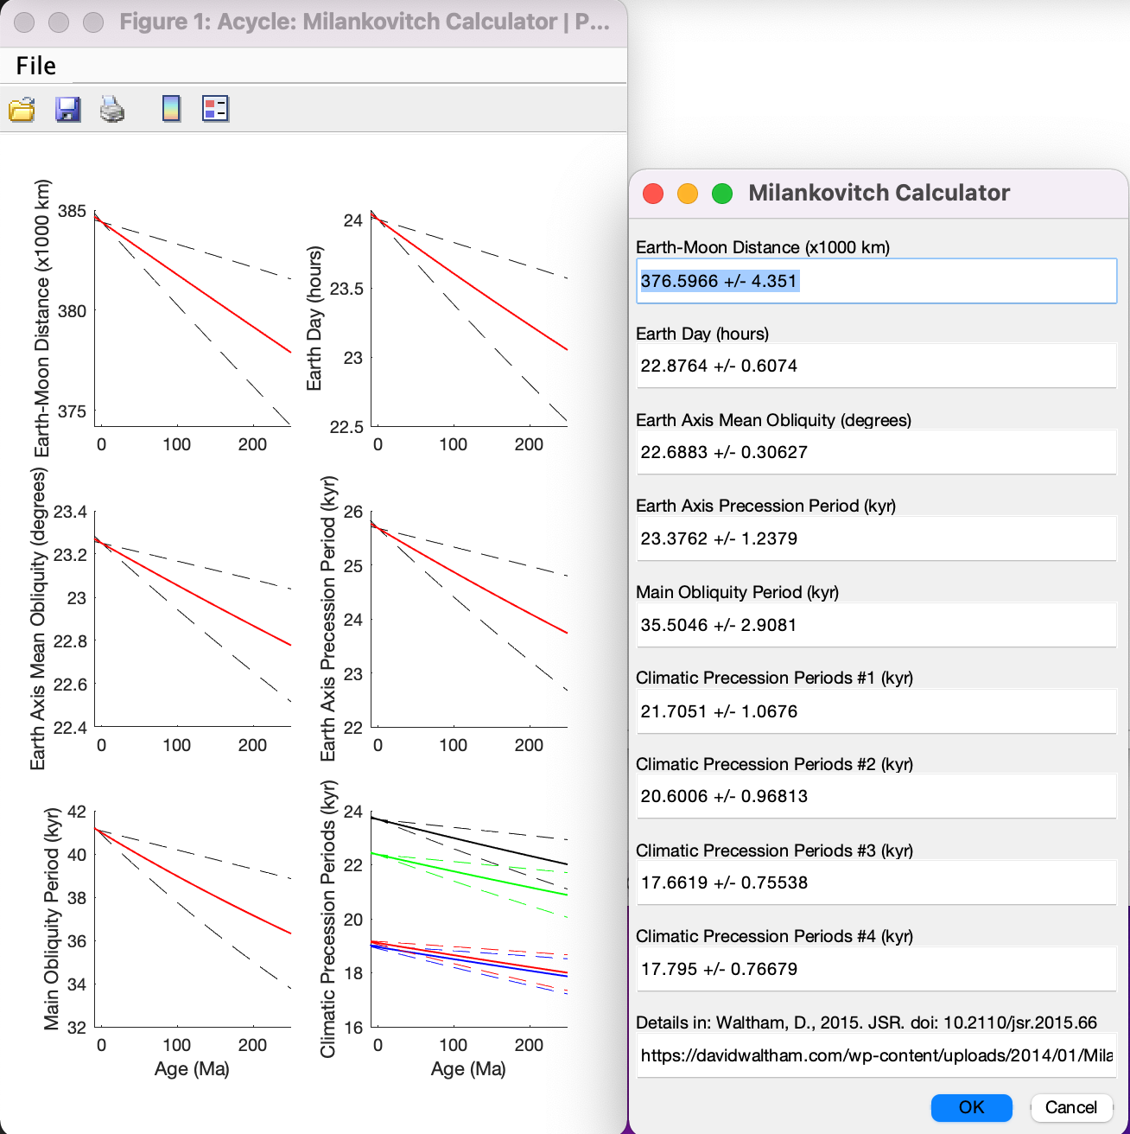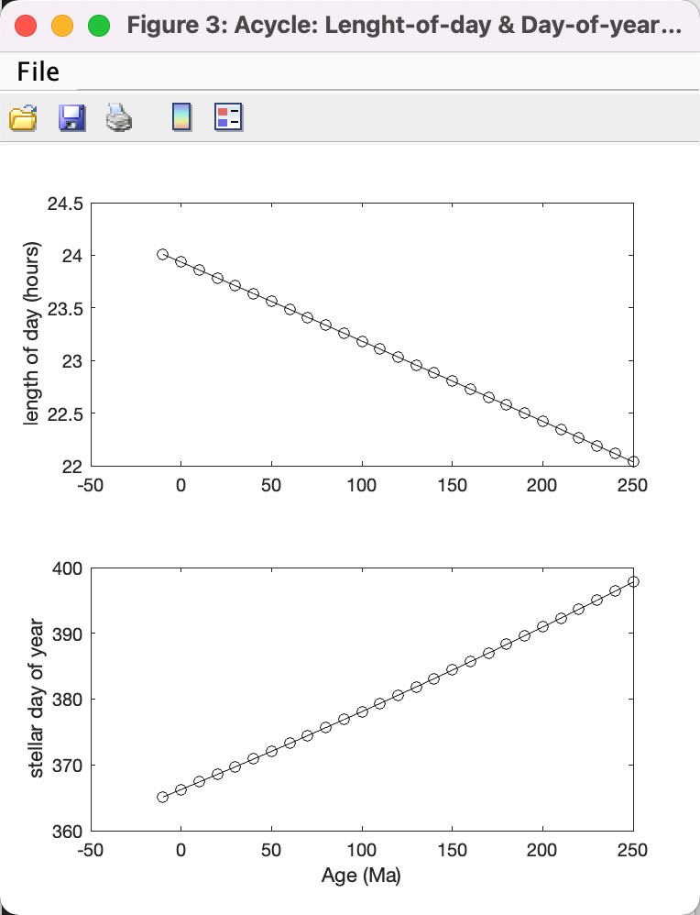

*Left: Waltham2015 model for astronomical parameters using pre-defined time range and step in the previous figure. Middle: Right: Waltham2015 model for astronomical parameters at 300 Ma. La2004 model for La2004 model of Length-of-day (LOD) and Day-of-year (DOY) using pre-defined time range and step in the previous figure.*

### **Signal/Noise Generator**

Generates a two-column time series of signal and noise using either a predefined first column or a user-defined column.

Models include polynomial, sine wave (or cosine wave), white noise, and red noise.

*Shortcut keys [Mac]: ⌘ + 3; [Windows]: Ctrl + 3*

**Polynomial**

Generate a polynomial using user-defined coefficients.

**Sine wave**

Generate a sine wave using the formula:

Y = A * sin(2π / T * X + Ph) + bias

Where A = amplitude, T = period, X is a time series from *t1* to *t2* with step dt, Ph is phase (radians), and bias is the offset.



*This GUI generates a sine wave from 1 to 1000 with dt = 1,amplitude = 1, period = 100, zero phase shift, and zero bias.*

**White Noise**

Generate white noise (normal or uniform distribution) with a user-defined mean and standard deviation.

**Red Noise**

Generate red noise with a user-defined mean, standard deviation, and autocorrelation coefficient *ρ* (0-1).



**1. Pre-defined first column**

Reads the selected file’s first column and generates the second column using the chosen model. Users cannot modify the first column.

Example:

Step 1: In the *Acycle* main window, select “Basic Series” 🡪 “Examples” 🡪 “Example-WayaoCarnianGR0.txt”.

Step 2: Select the new file “Example-WayaoCarnianGR0.txt” and choose “Basic Series” 🡪 “Signal/Noise Generator”.

Step 3: Select “Sine Wave”, set the period to 50 m. A sine wave will appear in the GUI.

Step 4: Click “Save Data”. The new file appears in the main window.



**2. User-defined first column**

Generates both columns based on user-selected parameters.

Example:

Step 1: In the *Acycle* main window, click the “Refresh” button () to deselect any currently selected data file.

Step 2: Click “Basic Series” 🡪 “Signal/Noise Generator”.

Step 3: Set X axis from 0 to 500 with a step of 1. Select “Red Noise”, set mean = 5, alpha = 0.5. A red-noise series will appear in the GUI.

Step 4: Click “Save Data”. The new file appears in the *Acycle* main window.



*A red noise series with lag-1 auto-correlation coefficient (ρ) = 0.5 resembles a climate time series!*

### **LR04 Stack**

This function generates the classical LR04 stack of the Plio-Pleistocene benthic δ18O record (Lisiecki and Raymo, 2005). The input time must be between 0 and 5320 ka.

*Shortcut keys [Mac]: ⌘ + 4; [Windows]: Ctrl + 4*

 

*This GUI generates LR04 stack from 0 to 3000 Ka.*

### **CENOGRID**

This function loads the Cenozoic Global Reference benthic foraminifer carbon and oxygen Isotope Dataset (CENOGRID; Westerhold et al., 2020).

New file name:

Example-cenogrid-d13c.txt - carbon isotope

Example-cenogrid-d18o.txt – oxygen isotope

### **Examples**

Loads various example data files into the working folder and displays them in Acycle. The included examples are:



**(1) Mauna Loa CO2 monthly mean:**

Monthly mean CO2measurements atMauna Loa Observatory, Hawaii (1958-2018).

Loads “Example-LaunaLoa-Hawaii-CO2-monthly-mean.txt”.

Ref: <https://www.esrl.noaa.gov/gmd/ccgg/trends/data.html>



**(2) Insolation 0-2Ma, 65**°**N on Jun22:**

Mean daily insolation at 65 °N on June 22 for 0-2 Ma in 1 kyr steps.

Loads “Example-Insol-t-0-2000ka-day-80-lat-65-meandaily-La04.txt”.

**(3) La2004 0-2Ma ETP:**

ETP (eccentricity, tilt, and precession) from Laskar et al. (2004) for 0-2 Ma in 1 kyr steps.

Loads “Example-La2004-1E.5T-1P-0-2000.txt”.

**(4) Red noise (ρ=0.7, 2000 points):**

Red-noise series with 2000 points and lag-1 autocorrelation ρ = 0.7.

Loads “Example-Rednoise0.7-2000.txt”.

**(5) PETM Svalbard log Fe:**

Log-transformed iron series for the Paleocene-Eocene thermal maximum, Svalbard (Charles et al., 2011).

Loads “Example-SvalbardPETM-logFe.txt”.



**(6) Late Triassic Newark depth rank:**

Depth-rank series from the Newark Basin, USA (Olsen and Kent, 1996).

Loads “Example-LateTriassicNewarkDepthRank.txt”.



**(7) Late Triassic Wayao gamma ray:**

Middle Carnian gamma-ray series from the Wayao section, South China (Zhang et al., 2015).

Loads “Example-WayaoCarnianGR0.txt”.



**(8) Middle Triassic Guandao2 gamma ray:**

Anisian gamma-ray series from the Guandao section, South China (Li et al., 2018b).

Loads “Example-Guandao2AnisianGR.txt”.



**(9) Mars HiRISE image:**

Image from Mars' HiRISE camera.

Shows and saves “Example-HiRISE-PSP_002733_1880_RED.jpg”.

Ref: <https://www.uahirise.org/PSP_002878_1880>

**(10) Sphalerite image:**

Demonstrates “Math 🡪 Image 🡪 Image Profile”.

Shows and saves “Example-Sphalerite.jpg”.

West Hayden orebody, Shullsburg, Wisconsin, USA (Li and Barnes, 2019).

**(11) Plot Digitizer image:**

Demonstrates the “Plot Digitizer” function.

Shows and saves “Example-PlotDigitizer.jpg”.

 

(Example #9) (Example #11)

**(12) Extinction (circular spectral analysis):**

Demonstrates “Timeseries 🡪 Circular spectral analysis”.

Loads “Example-CSA-extinction.txt”.

## **4.6 Math**

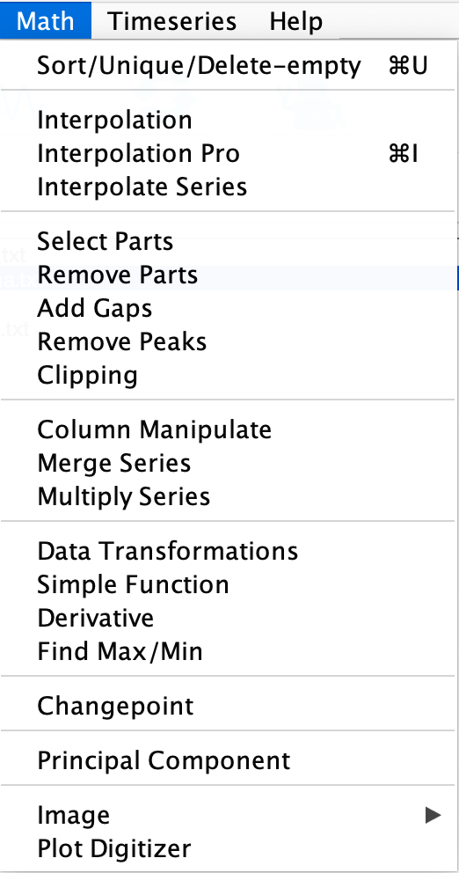

### **Sort / Unique / Delete Empty**

Sorts the selected data file, analogous to Excel’s SORT feature. If two or more data points share the same time or depth, they are replaced by their mean value.

***Shortcut keys [Mac]: ⌘ + U; [Windows]: Ctrl + U***

New file named *-sue.txt or *-s.txt or *-u.txt

### **Interpolation**

Performs linear interpolation using MATLAB’s interp1 function.

New file named *-rsp0.3.txt, where 0.3 is user-defined sampling rate (default: **median** sampling rate).

### **Interpolation Pro**

Allows interpolation with a user-defined sampling rate and method. Users can set values to NaN for gaps larger than n times the median sampling rate.

***Shortcut keys [Mac]: ⌘ + I; [Windows]: Ctrl + I***

New file named *-rspSAMPLING RATE-METHOD.txt, where METHOD is one of: linear, nearest, next, previous, pchip, cubic, v5cubic, makima, spline. New file name may look like:

Example-WayaoCarnianGR0-rsp0.33-nearest.txt

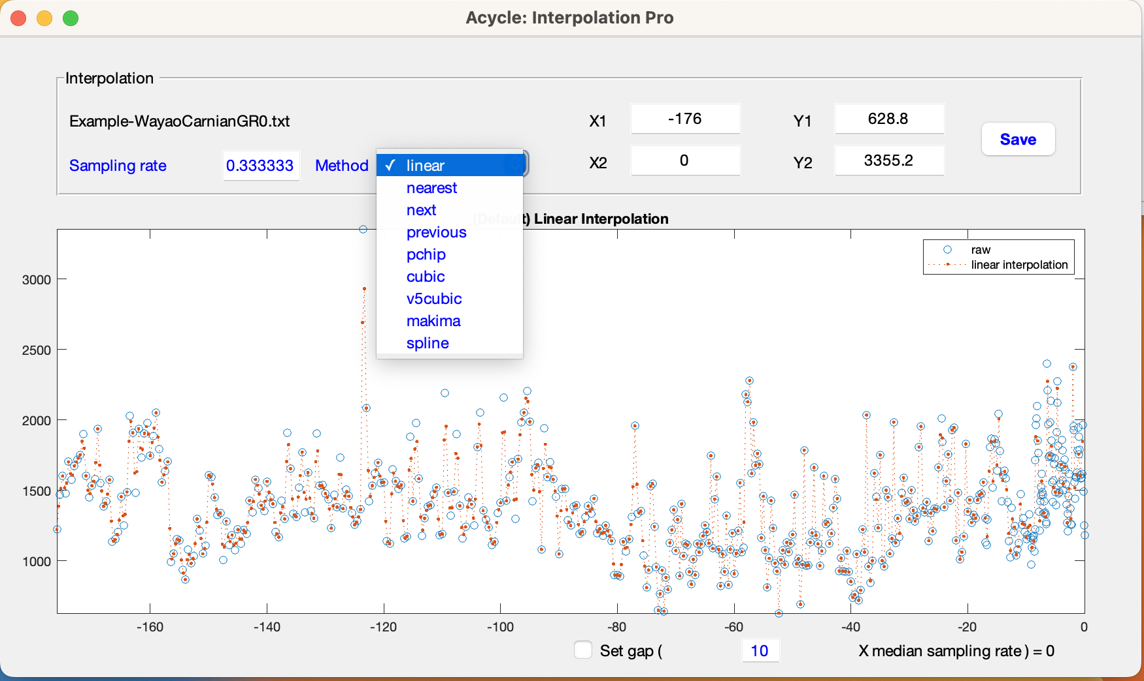

*Figure. Interpolation Pro GUI.*

### **Interpolation Series**

Resamples a target series to match a reference series’ sampling using MATLAB’s interp1.

Usage: Select a reference series, then a target series, and click Interpolation.

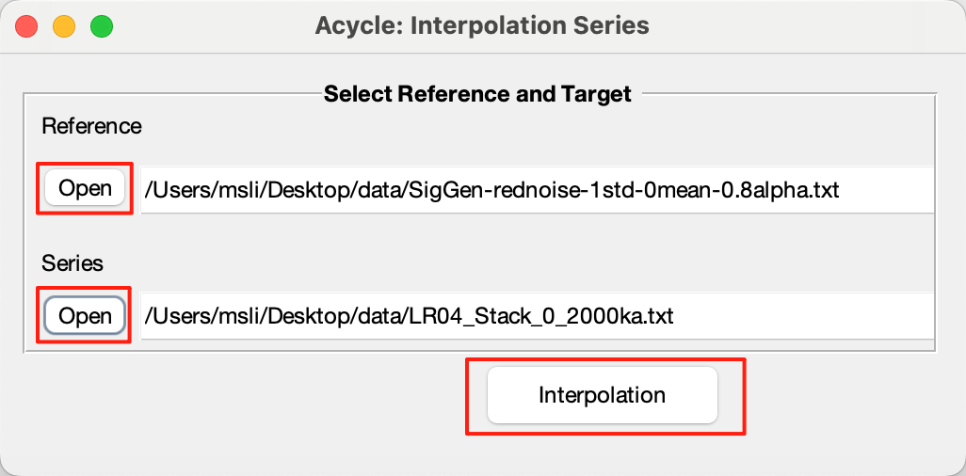



New file name: *TargetSeriesName*-*ReferenceSeriesName*.txt.

### **Select Parts**

Extracts a subset of the data between user-defined start and end values.

New file named *-a-b.txt, where a is the “start” and b is the “end”.

### **Remove Parts**

Removes data intervals defined by user-specified location and duration.

Format: comma-separated pairs, e.g.:

15, 3

*removes data from 15–18.*

15, 3, 20.2, 4

*removes data from 15 to 18 and remove the second interval of 20.2-24.2-unit.*

### **Add Gaps**

Inserts gaps into the data at specified locations and durations.

Format: comma-separated pairs, e.g.:

10.5, 3.2

*adds a 3.2-unit gap at 10.5.*

10.5, 3.2, 13.3, 1.5

*adds gaps at 10.5 (3.2 units) and 13.3 (1.5 units).*

### **Remove Peaks**

Caps data values above a user-defined maximum to that maximum and raises values below a minimum to that minimum.

### **Clipping**

Clips data outside a specified threshold. This function generates a new series based on the selected data file via clipping data higher or smaller than the user-defined threshold value.



*Example: Raw and clipped insolation series*

### **Column Manipulate**

Weighted Calculation

1. Select Data File

In the Acycle main window, click the data file you want to process.

2. Open Column Manipulate

Choose “Math” 🡪 “Column Manipulate”.

3. Select Columns

In the Column Manipulate dialog, check the column(s) you wish to weight.

4. Enter Weights

In the Column Manipulate, type a weight value for each selected column. The preview table and the Column Manipulate Plot window update automatically to show the weighted results.

5. Save Results

Click **OK** to apply the weights.

A new file (for example, *-ColManip-20250717T140538.txt) will be created with the weighted data.

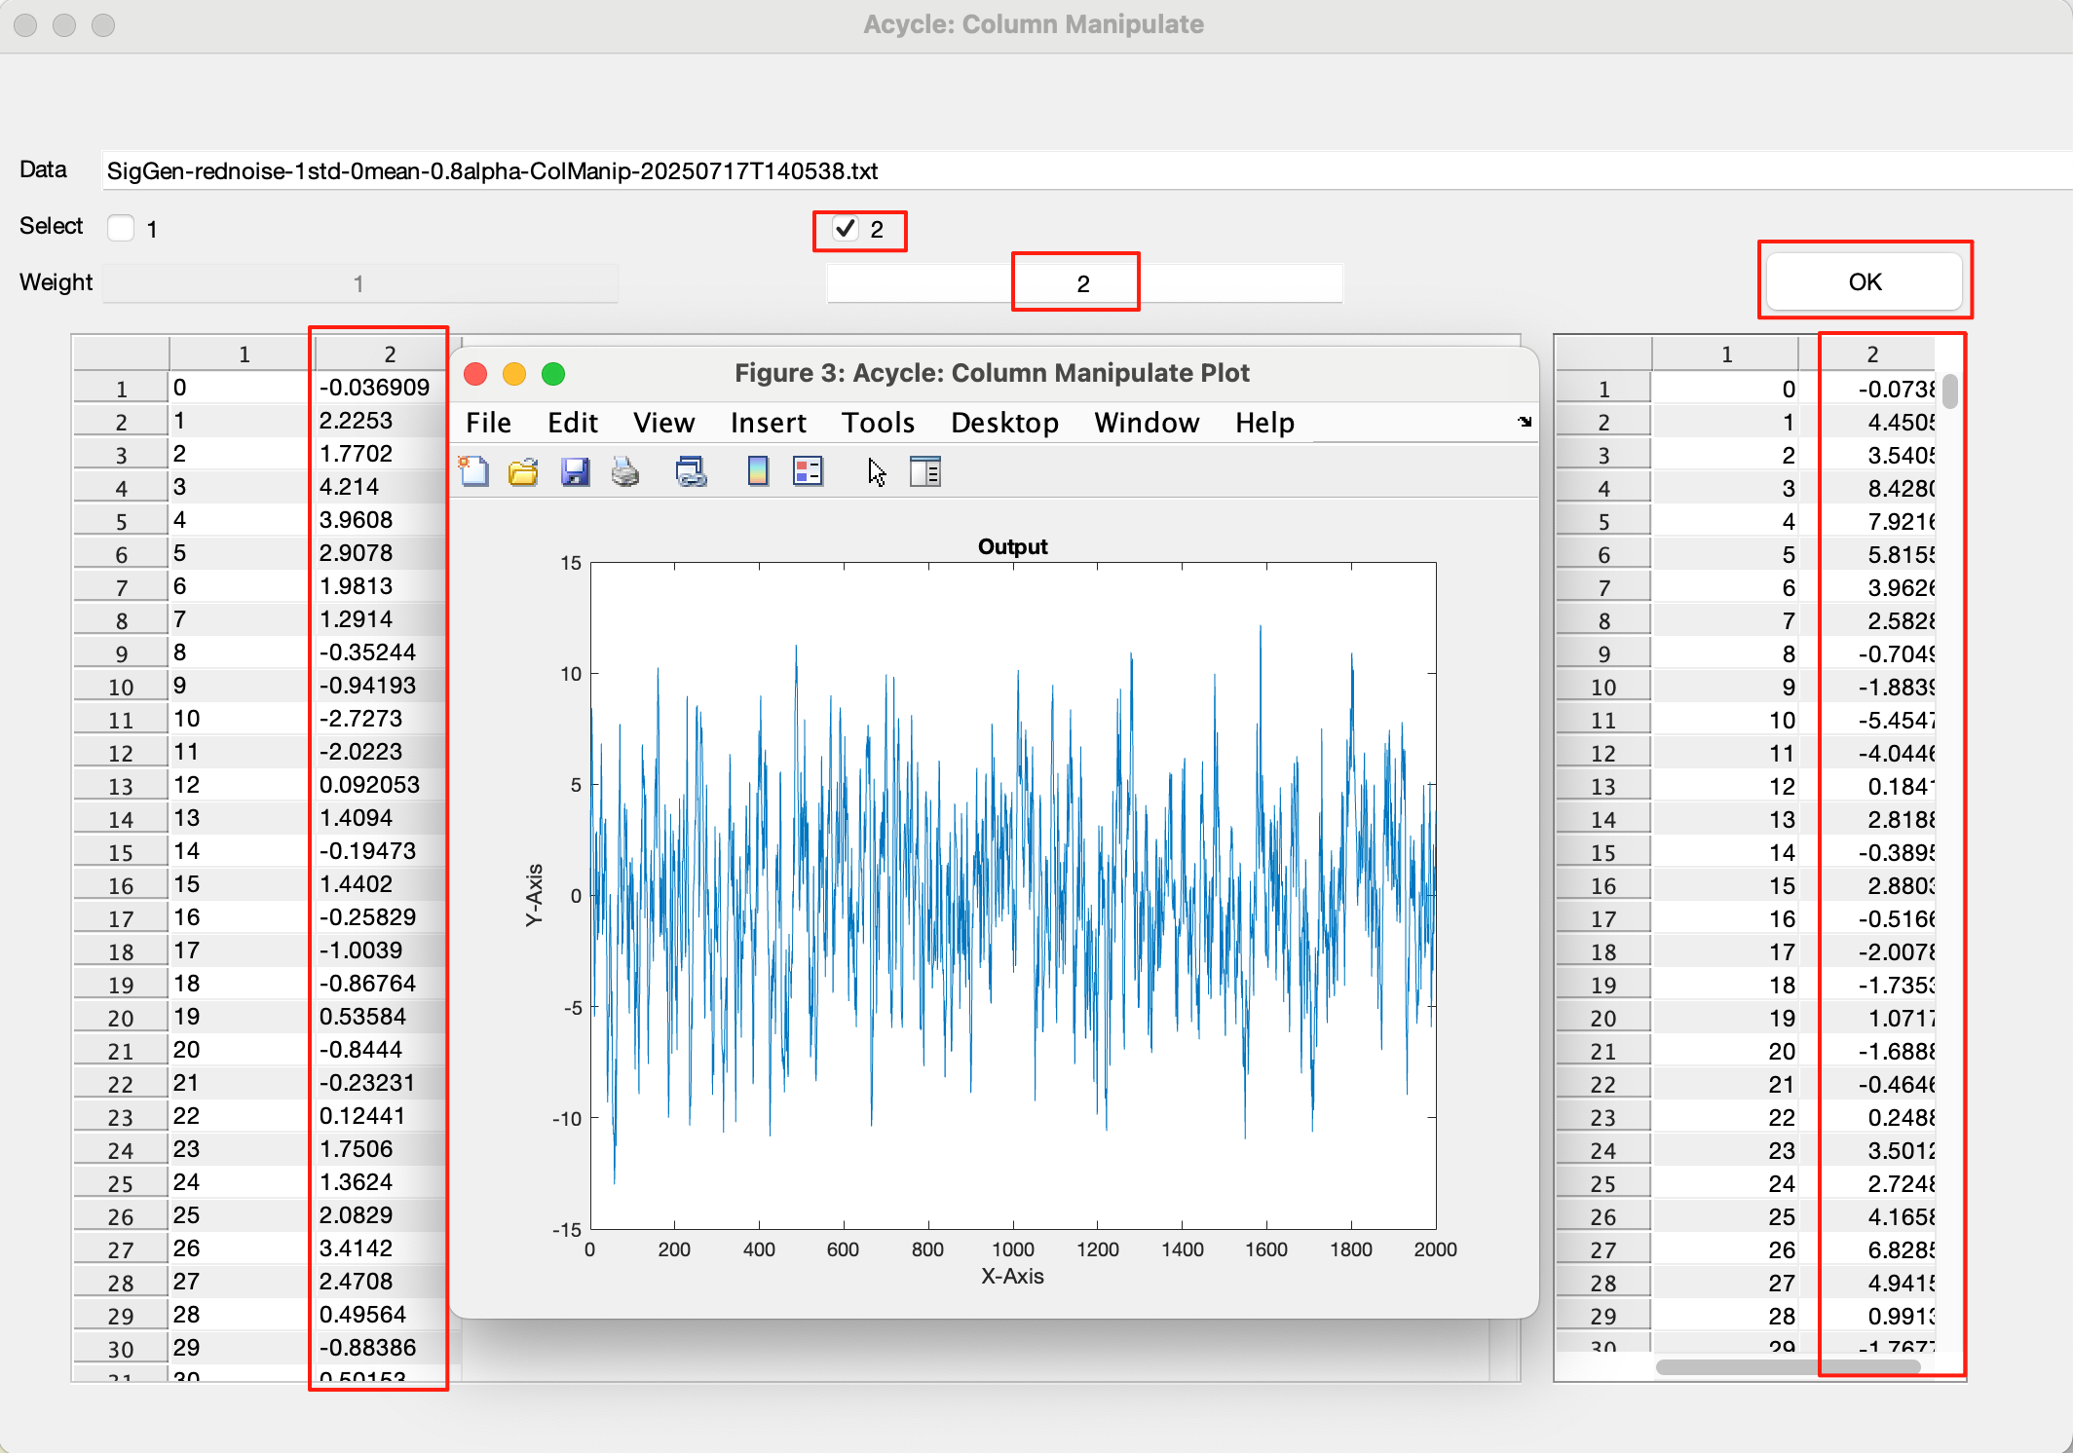

### **Merge Series**

Merges the second columns of two series if their first columns (time/depth) match exactly.

New file named mergedseries.txt.

### **Multiply Series**

Multiplies the second columns of two series if their first columns match exactly.

New file named multipliedseries1.txt and multipliedseries2.txt

### **Data Transformation**

1. Columns: Select either the first or second column.

2. Data Transformation: Choose Data Transformation Options or Angular Transformation Options. The selected transformation will be applied automatically and displayed in the Acycle: Data Transformation | Plot window.

3. OK and Save Data: Click OK and Save Data to export the results to the corresponding file.

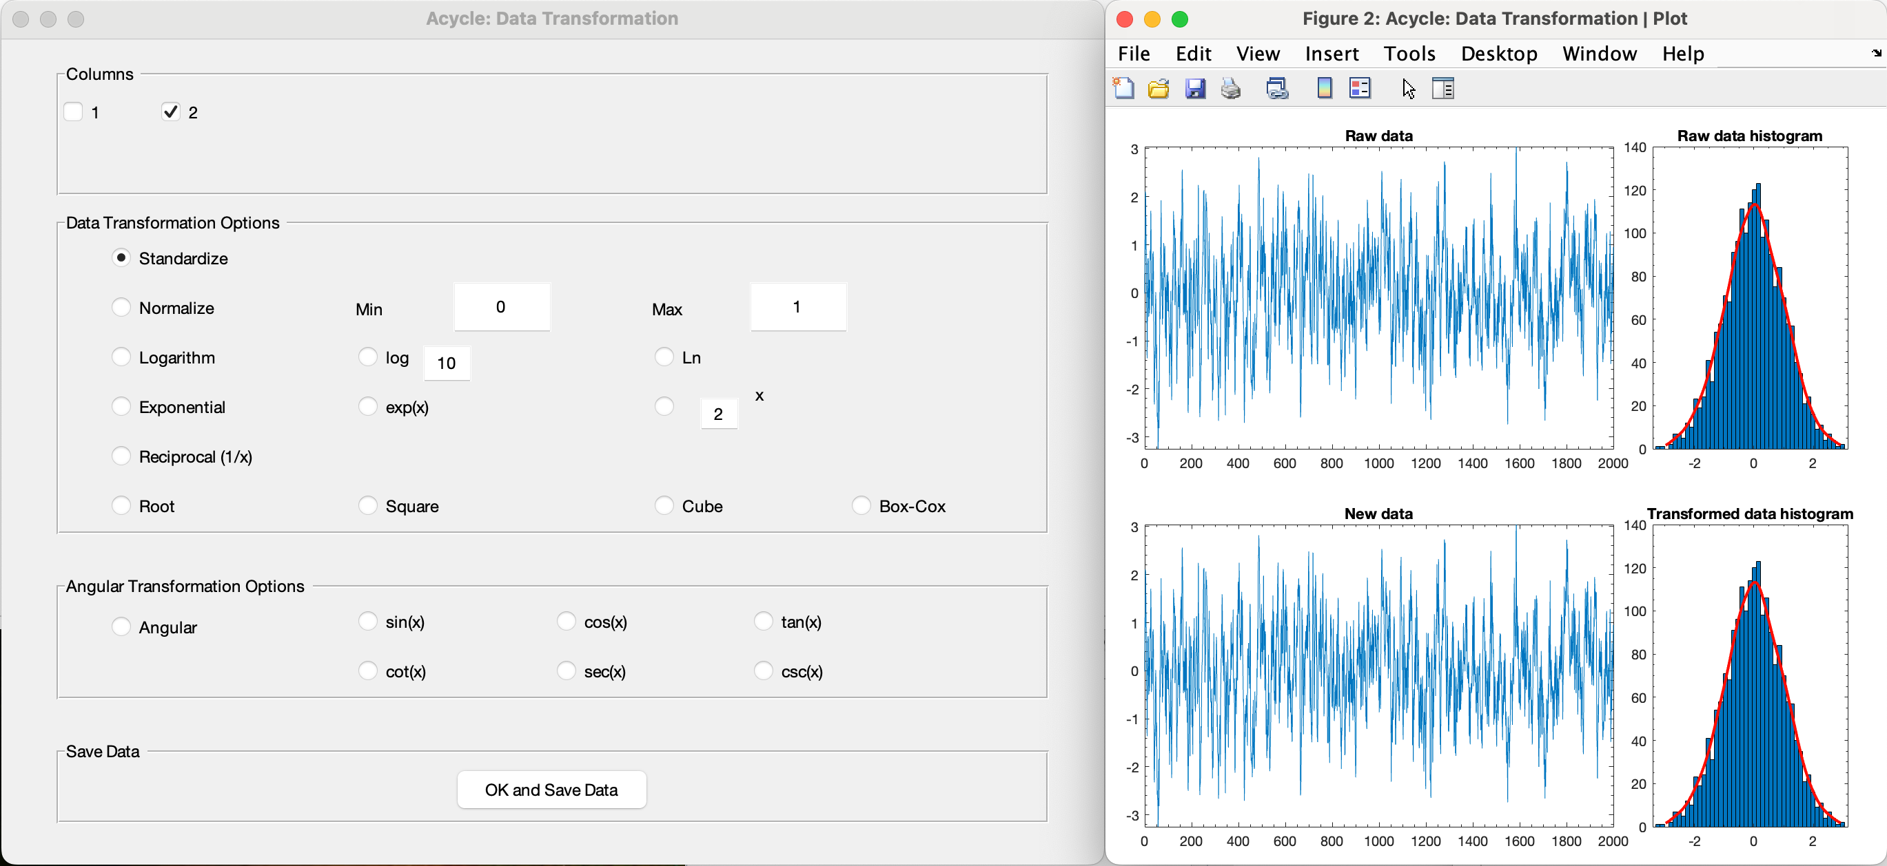

#### Standardize

Applies MATLAB’s zscore function:

Z = (X-u)/σ, where X is second-column data, u is the mean, and σ is the standard deviation.

New file named *-stand.txt

#### Normalize

Enter user-defined Max and Min values. The data will be scaled so that the original maximum maps to your specified max, the original minimum maps to your specified min, and all other values are converted proportionally within this range.

#### Logarithm

Applies log₁₀ to second-column data:

*Yi* = log10(*Xi*)

New file named *-log10.txt

#### Exponential

*exp(x) / ix*

#### Converts each value x to the exponential eˣ by default; if you specify a custom base i, this option computes iˣ for every data point.

#### Reciprocal

Converts each value x to its reciprocal, i.e. 1/x.

#### Root / Square / Cube

Converts each data value *x* by taking its root—either the square root (*√x*) or the cube root (*∛x*).

#### Box-Cox

Applies the Box–Cox power transformation. For a parameter λ:

$$y= \left\{\begin{aligned}\frac{x^{λ}-1}{λ}, λ ≠0 \\ \ln\left(x\right), λ =0\end{aligned}\right.$$

The software estimates λ to make the transformed data as close to a normal distribution as possible.

#### Angular: Sin(x) / cos(x) / tan(x) / cot(x) / sec(x) / csc(x)

Transforms each data value x using a trigonometric function—choose from sin(*x*), cos(*x*), tan(*x*), cot(*x*), sec(*x*), or csc(*x*).

### **Simple Function**

Transforms both columns using linear equations:

*X(i) = a * X(i) + b*

*Y(i) = c * Y(i) + d*

*For the selected data, all values in the first column will be transformed using the equation X(i) = 1.5 * X(i) + 1; and all values in the second column will be transformed using the equation Y(i) = 0.8 * Y(i) + (-3).*

New file named *-new.txt

### **Derivative**

Computes approximate derivatives (first, second, etc.).

New file named *-1derv.txt

### **Find max/min**

Finds the maximum or minimum within a specified interval. Results displayed in the Command Window only.

### **Changepoint**

Detects Bayesian change points in a time series using the algorithm of Ruggieri (2013).

Please acknowledge the program author on any publication of scientific results based in part on use of the program and cite the following article in which the program was described

Reference: E. Ruggieri (2013) "A Bayesian Approach to Detecting Change Points in Climatic Records," International Journal of Climatology, 33: 520-528. doi: 10.1002/joc.3447

Author: Eric Ruggieri, College of the Holy Cross, Worcester, MA. Email: [eruggier@holycross.edu](mailto:eruggier@holycross.edu)



*Use case: Identifies the “tipping” point at –157 m.*

### **Principal Component**

Performs principal component analysis on multi-column data. The first column may be time/depth.

New file named

*-PCA-coeff.txt (coefficients)

*-PCA-latent-explained-mu.txt (% variance explained and mean).

*-PCA-tsquared.txt (Hotelling's T2 statistic)

### **Image**

### **Show Image**

Displays the selected image file.

### **RGB to Grayscale**

Converts an RGB image to grayscale and saves as *-gray.tif

### **RGB to CIE LAB**

Converts an RGB image to CIE Lab and saves as <filename>-Lab.tif.

Steps:

1. “Bacis Series” 🡪 “Examples” 🡪 “Image Sphalerite” to load “Example-Sphalerite.jpg”.
2. Select the image, then “Math” 🡪 “Image” 🡪 “RGB to CIE LAB”.

New image named

Example-Sphalerite-Lab.tif

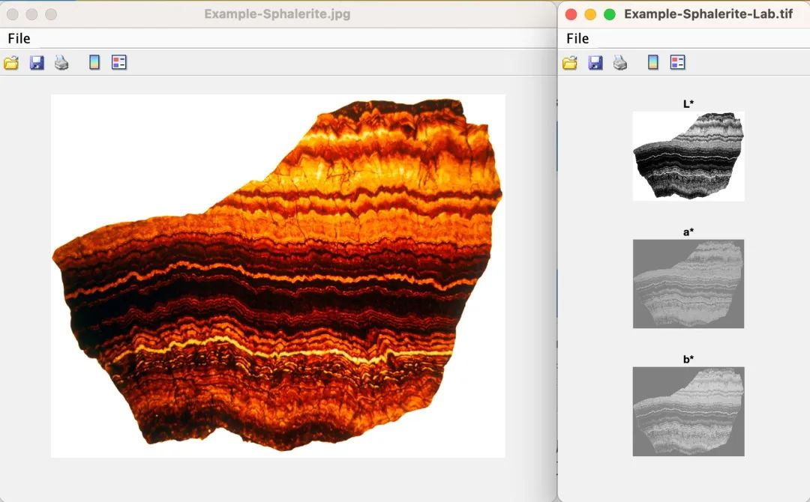

### **Image Profile**

Extracts grayscale intensity along a line defined by two points.

New file named

*-profile.txt (intensity profile)

*-controlpoints.txt (point coordinates)

*-controlpixels.txt (pixel indices)

Steps:

1. Load “Example-Sphalerite-Lab.tif”. “Math 🡪 Image 🡪 Image Profile”.

2. Click the Data Cursor tool (**1**) and press ALT while clicking two points.

3a. (**MatLab** version): Press the Enter key. The grayscale profile data will be captured and saved along the green line.

3b: (**Stand-alone version**): In the macOS Terminal or Windows Command Prompt, press the Enter key.

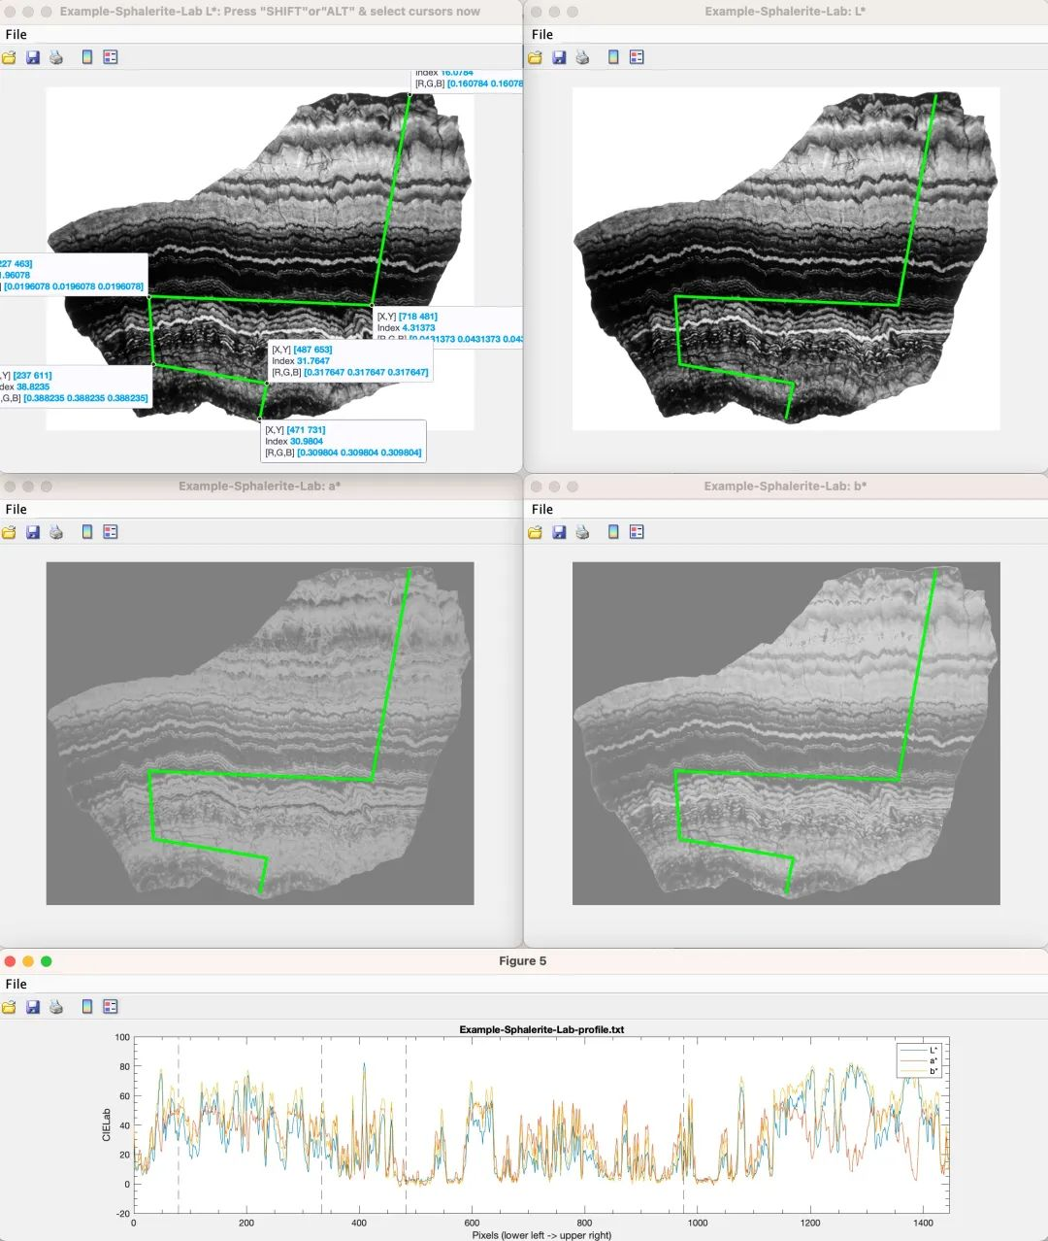

### **Plot Digitizer**

Digitizes data points from a plot image.

Steps:

1. “Basic Series” 🡪 “Examples” 🡪 “Image for Plot Digitizer” to load “Example-PlotDigitizer.jpg”.

2. Select the image file and choose “Math” 🡪 “Plot Digitizer”.



 

3. In the “*Acycle*: Plot Digitizer” pop-up window (top panel), follow the instructions in **blue text** (bottom left corner):

**1) Calibrate Axis:** Click the “Calibrate axis” button

**2) Pick up axis limits:** In the displayed plot, click four points in this order: x‑axis minimum, x‑axis maximum, y‑axis minimum, y‑axis maximum.

**3) Set axis values:** Return to the “*Acycle*: Plot Digitizer” window, enter the numeric limits for the x- and y- axes, then select “Linear” or “Log” scaling.

**4) Digitize:** Click “Digitize”, then click on the plot to select data points. Points will appear in the Data Extra tab. Right‑click to stop; click Digitize to continue.

**5) Save Data:** Click “Save Data” to export the digitized points to a text file.

**6) Undo:** Click “Undo” to remove the last data point.

## **4.7 Time series**

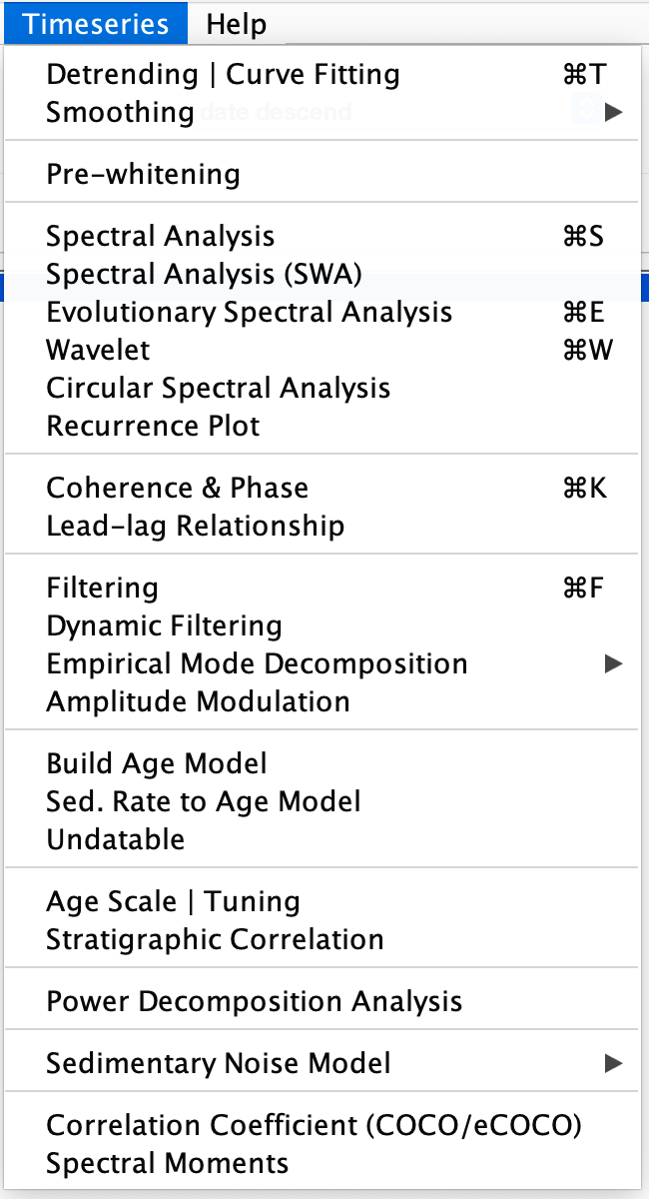

### **Detrending | Curve Fitting**

Generates two new files—a trend series and its detrended counterpart—based on your selected data and parameters. Steps:

(1) Select Data

In the Main Window, select your data file, then choose Time Series → Detrending.

(2) Set Window

Enter a window length (units) or percentage (%) or adjust the slider. The default is 35% of total length (e.g. 35 m for a 100 m record).

(3) Choose Method

Tick one or more detrending methods (LOWESS, rLOWESS, LOESS, rLOESS, Polynomial Fit 1st Order, 2nd Order, … nth Order).

(4) Plot

Click PLOT and wait (seconds to a minute). A new figure appears showing your raw data and the computed trend(s).

(5) Save Model

In Select & Save detrending Model, pick the trend you prefer. Both the trend and detrended files are saved and listed in the Main Window.

Tip: Change the window length or percentage and click Plot again—trend lines update automatically.

***Shortcut keys [Mac] ⌘ + T; [Windows] Ctrl + T***

Output files:

*-<window>-<method>.txt (detrended)

*-<window>-<method>trend.txt (trend)

e.g. mydata-80-LOWESS.txt and mydata-80-LOWESStrend.txt

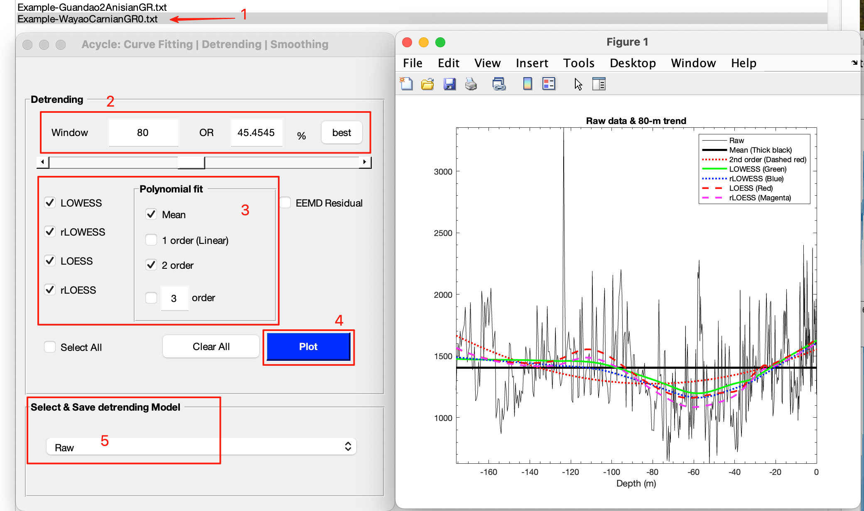

### **Smoothing**

Creates smoothed versions of your data using different algorithms.

#### Bootstrap Smoothing

Generates two files with bootstrap confidence intervals:

New file named

*-<window>-<method>-<n>-bootstrap-meanstd.txt

|  |  |  |  |  |  |
| --- | --- | --- | --- | --- | --- |
| column 1 | column 2 | column 3 | column 4 | column 5 | column 6 |
| depth/time | mean - 2σ | mean - σ | mean | mean + σ | mean + 2σ |

*-<window>-<method>-<n>-bootstrap-percentile.txt

|  |  |  |  |  |  |  |  |  |  |
| --- | --- | --- | --- | --- | --- | --- | --- | --- | --- |
| column 1 | 2 | 3 | 4 | 5 | 6 | 7 | 8 | 9 | 10 |
| depth/time | 0.5% | 2.275% | 5% | 25% | 50% | 75% | 95% | 97.725% | 99.5% |



*Bootstrap Smoothing is useful estimating confidence intervals of the dataset.*

#### Moving Average

Applies an *n*-point moving average.

Output: *-<n>ptsm.txt (e.g. mydata-3ptsm.txt)

#### Moving Gaussian

Applies an n-point Gaussian smoothing window.

#### Moving Median

Applies an *x*% median filter (default *x* = 20%).

Output: *-<x>%-median.txt (e.g. mydata-20%-median.txt)

### **Pre-whitening**

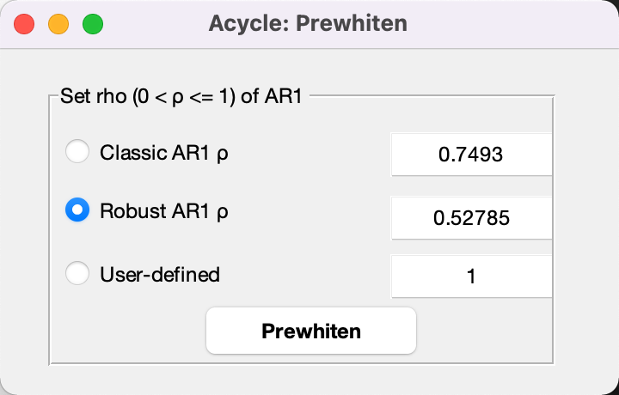

Removes autocorrelation from a time series using one of three methods:

1. Classic AR(1): Estimates *ρ* via the standard AR(1) model.

2. Robust AR(1): Estimates *ρ* using the Mann & Lees (1996) approach.

3. User‑Defined *ρ*: Enter a custom *ρ* value:

If *ρ* = 1, Acycle applies first differences:

*Y = diff(X)* (computes differences between adjacent elements).

Output: *-prewhiten-1.txt

### **Spectral Analysis**

Computes power spectra using one of three methods—Multi‑Taper Method (MTM) (Thomson, 1982), Lomb-Scargle (Lomb, 1976; Scargle, 1982), or MatLab’s periodogram. All three methods require evenly spaced data; Lomb–Scargle also accepts unevenly spaced series.

Steps:

(1) Select Data

In the Main Window, choose your data file.

(2) Open Menu

Select **Timeseries** 🡪 **Spectral Analysis**

(3) Choose Method

– **MTM:** Thomson (1982) multi‑taper.  
– **Lomb–Scargle:** Lomb (1976), Scargle (1982).  
– **Periodogram:** MATLAB’s built‑in.

(4) **MTM Parameters** (if MTM selected)

– **NW:** Tape­r bandwidth parameter (default NW = 3)  
– **Tapers:** 2·NW – 1 (rounded down)  
– **Zero‑Padding:** On/Off

(5) Plot Settings

– **Max Frequency:** Set the highest frequency to display.  
– **Axis Scale:** Choose Linear or Log for X and Y.

(6) Red Noise Model

– **Classic AR(1):** RedNoise.m by [Husson (2014)](#_ENREF_3" \o "Husson, 2014 #4143), corrected by Linda Hinnov.  
– **Robust AR(1):** Mann and Lees (1996)  
– **Smoothed Window Averages (SWA):** (Weedon et al., 2019), Jiang et al., (2025).  
– **Power Law** (P.L.) **& Bending Power Law** (B.P.L.)**:** Vaughan et al. (2011)

(7) Run & Save

Click Run or Run & Save to compute the spectrum. Acycle saves both the spectrum and the AR(1) background series.

***Shortcut keys [Mac] ⌘ + S; [Windows] Ctrl + S***

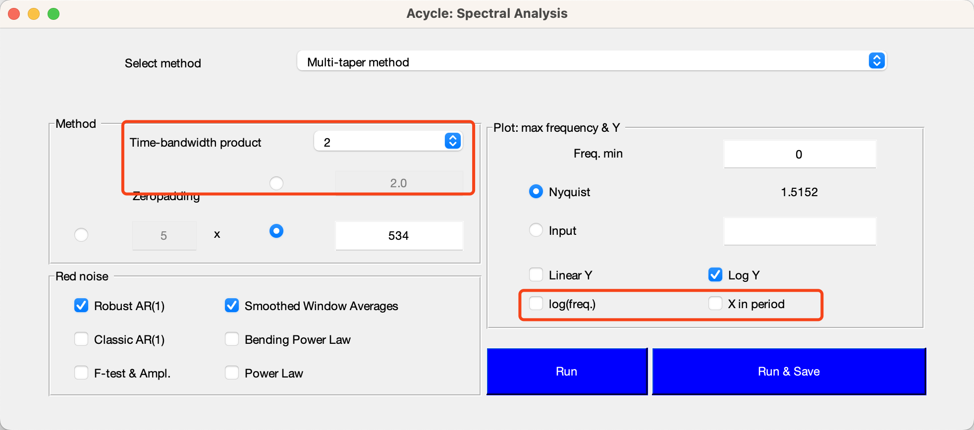 

*A smoothing parameter of “0.2” indicates a 20% median smoothing applied to the frequency axis.*



*2π Multitaper Power Spectrum*

*Computes the Thomson (1982) 2π multitaper power spectrum for the same dataset.*

*Example parameters: interpolation = 0.33; detrend = 80 m LOWESS.*



*Amplitude and F-test significance spectra*

*Displays the amplitude spectrum alongside F‑test significance levels for the Wayao Carnian gamma‑ray series.  
Example parameters: interpolation = 0.33; detrend = 80 m LOWESS.*

Example Outputs (MTM, NW = π):

*-?piMTM-ClassicAR1.txt, – frequency, spectrum, AR(1) model, 90%, 95%, 99%, 99.9% confidence levels

*-?piMTM-RobustAR1.txt – same as above using robust AR(1)

*-?piMTM-RobustAR1-Med-smooth.txt – median‑smoothed spectrum.

*-?piMTM-amp.txt – frequency vs. amplitude

*-?piMTM-fsig.txt – frequency vs. F‑test significance.

*-?piMTM-ftest.txt – frequency vs. F‑test statistic.

*-?piMTM-Faz-Sig-Noi-Dof.txt – frequency, harmonic phase, signal (F‑ratio numerator), noise (F‑ratio denominator), and adaptive‑weighted degrees of freedom.

*-?pi-MTM-SWA-Spectrum-FDR-20231010T094056.dat –frequency; period/wavelength; real power; Smoothed Window Averages (SWA) background; false discovery rate (FDR) levels. Note: <YYYYMMDDTHHMMSS> is the timestamp of file generation. Format: YearMonthDayTHourMinSecond.

*-?pi-MTM-SWA-Spectrum-Chi2CL-20231010T094056.dat - multiplication factors, frequency, real power, SWA background, χ2 confidence levels. Note: <YYYYMMDDTHHMMSS> is the timestamp of file generation.



**Interactive Period‑Domain Plot**

Since v2.1, you can display the power spectrum in the period domain by enabling “X in period” domain. The x‑axis will show period (rather than frequency), and clicking any spectral line or peak will display its period value next to “X”.

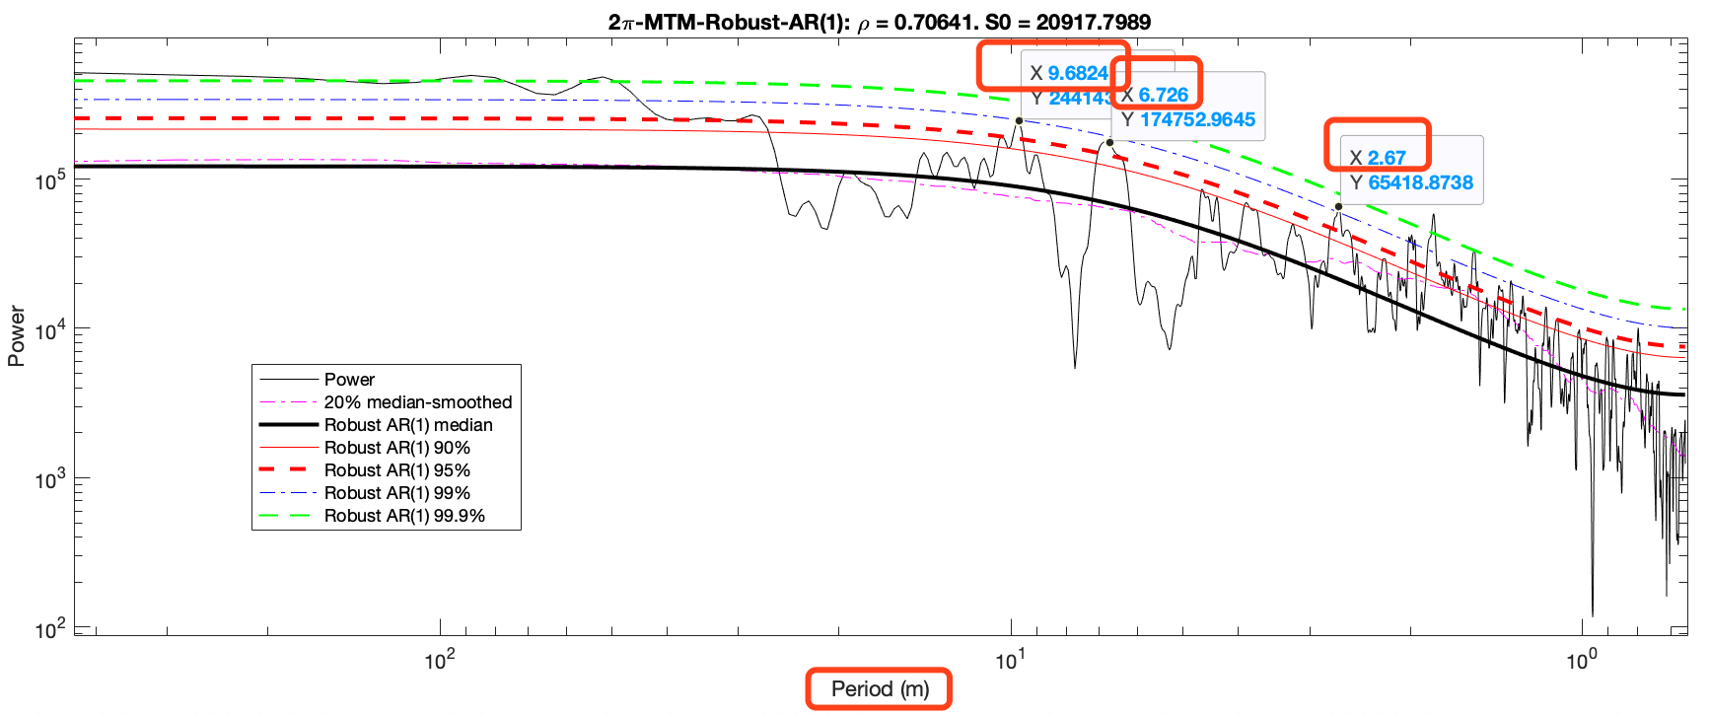

*In period-domain mode, the power spectrum is displayed with period on the x‑axis; clicking a peak immediately reveals its period value.*

### **Spectral Analysis (SWA)**

Performs spectral analysis using the Smoothed Window Averages (SWA) model (Weedon et al., 2019). The underlying Lomb–Scargle algorithm handles non‑uniformly spaced time series.

Steps:

1. Select Time Series.

In the Main Window, choose your file (e.g. LR04_Stack_0_5320ka.txt via **Basic Series → Examples**).

1. Open SWA Analysis

Select “Timeseries 🡪 Spectral Analysis (SWA)”. Key parameters and progress will appear in the terminal.

1. View GUI

After a few seconds, a three‑panel figure and the **Acycle: Smoothed Window Averages (SWA)** dialog will open.

1. Confidence Levels

In the SWA dialog, check the confidence level(s) you wish to display in each panel (e.g. 90%, 95%, 99%).

**Output Files**  
All filenames include a timestamp (YYYYMMDDTHHMMSS):

LR04_Stack_0_5320ka-SWA-Periodogram-Bayes-prob-20231010T095324.dat – Columns: frequency; period; periodogram power; Bayesian probability.

LR04_Stack_0_5320ka-SWA-Spectrum-Chi2CL-20231010T095324.dat - – Columns: multiplication factors; frequency; real power; SWA background; χ² confidence levels.

LR04_Stack_0_5320ka-SWA-Spectrum-FDR-20231010T095324.dat - – Columns: multiplication factors; frequency; period; real power; SWA background; false discovery rate (FDR) level(s).

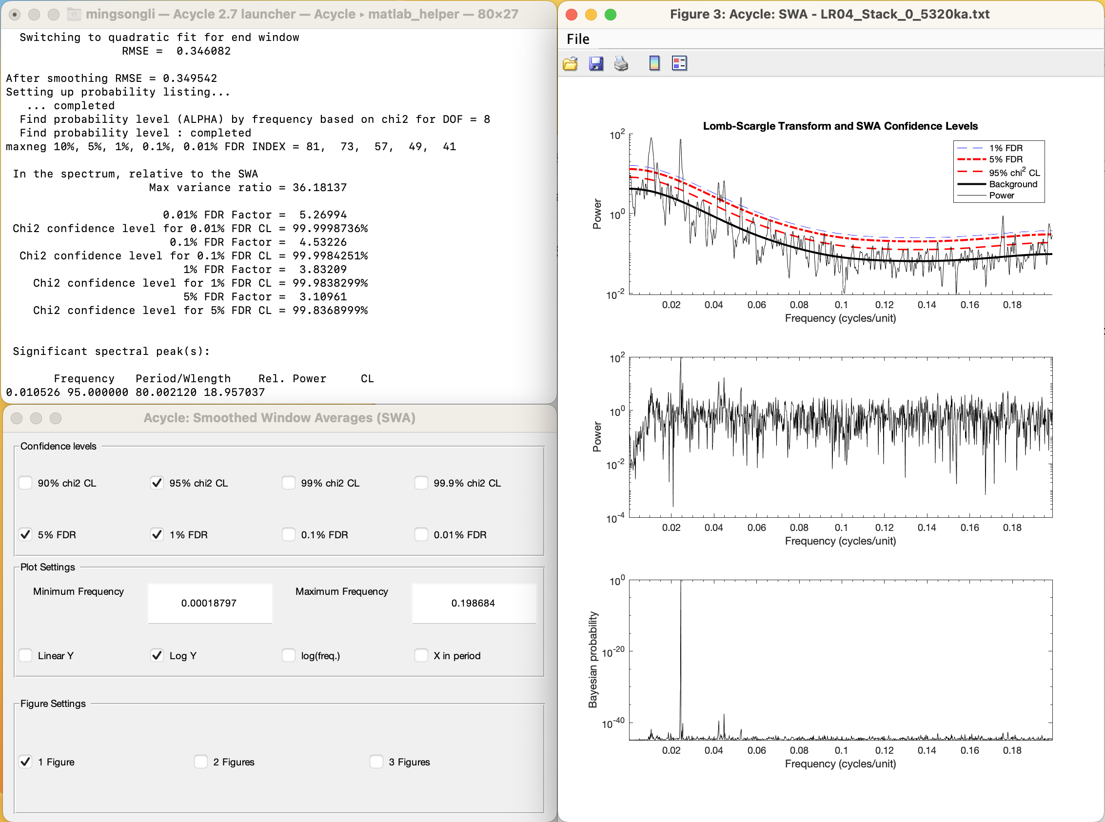

### **Evolutionary Spectral Analysis**

Computes time‑varying spectra via sliding‑window FFT or alternative methods.

Steps:

(1) Prepare Data

Ensure your series is evenly spaced:

Load (e.g.) “Basic Series” 🡪 “Examples” 🡪 “Late Triassic Wayao gamma ray”. This loads “Example-WayaoCarnianGR0.txt”.

Apply “Math” 🡪 “Sort/Unique/Delete-empty” and “Interpolation” (e.g. rsp0.2) to produce Example‑WayaoCarnianGR0‑rsp0.2.txt.

*Warning: Input must be uniformly sampled.*

(2) Open Menu

Select **Timeseries** 🡪 **Evolutionary** **Spectral Analysis**

(3) Choose Method.

- **LAH FFT:** Linda A. Hinnov’s FFT (Kodama and Hinnov, 2015) (default)

- MatLab Fast Fourier transform

- MTM: Multi-taper method (Thomson, 1982)

- Lomb-Scargle (Lomb, 1976; Scargle, 1982).

(4) Frequency Range

Set the plot’s frequency axis from 0 to the Nyquist frequency, defined as *f*nyq = 1 / (*N* * *Δt*), where *N* is the total number of data points and *Δt* is the sampling interval.

(5) Window Step

Define the step size for sliding windows (default is suitable for most datasets).

(6) Window Length: **very important!**

Enter the sliding‑window length as % of total (default 35%).

*Tip: If your series is dominated by ~35 m cycles, set the sliding‑window length to about* ***2–4×*** *that cycle (i.e.* ***70–140 m****) to optimize spectral resolution. Shorter windows improve detection of high‑frequency components but may miss low‑frequency signals; longer windows capture low frequencies but can overly smooth high‑frequency details.*

(7) Overlay Options

Choose to display the original time series and its 2π MTM spectrum with robust red‑noise background.

(8) Plot Dimensions

Select 2D or interactive 3D (with rotation).

(9) Flip Y-axis

Toggle vertical inversion.

(10) Zero Padding

Enable to pad series at both ends, recovering half‑window data—may introduce spurious frequencies.

(11) Colormap & Grid

Select a colormap or leave blank for a smoothed appearance; set contour levels if desired.

(12) Run

Click OK to generate the evolutionary spectrum figure. **Note:** No files are saved automatically.

***Shortcut keys [Mac]: ⌘ + E; [Windows]: Ctrl + E***

 

*Evolutionary FFT of the La2004 astronomical solutions using a 400 kyr sliding window and 3.2 kyr step*

### **Wavelet**

Performs continuous wavelet transform, wavelet coherence, and cross‑spectral analysis using (Torrence and Compo, 1998) methods.

**Requirements:** Input must be evenly spaced; otherwise, Acycle interpolates using the mean *Δt*.

#### Wavelet transform:

Steps:

(1) **Select Data**: In the Main Window, choose your evenly spaced series.

(2) **Open Menu**: **Timeseries** 🡪 **Wavelet**.

(3) **Configure Parameters** (pop‑up dialog updates plot in real time):

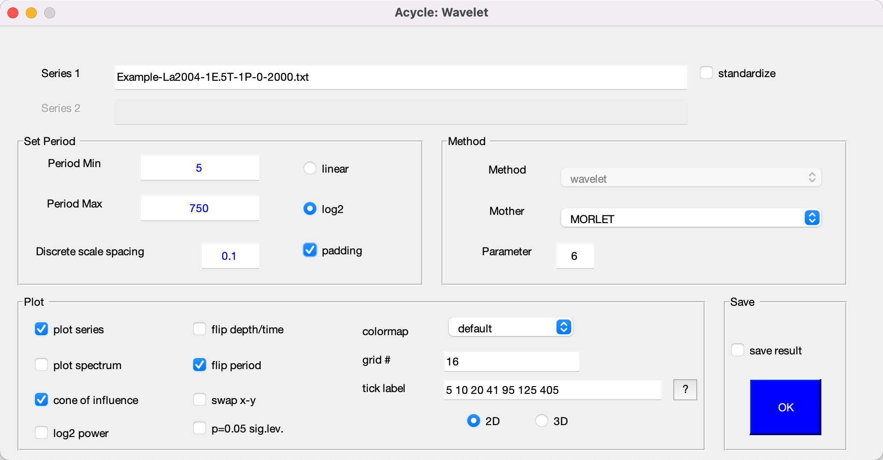

*Wavelet GUI*

**Series 1**: your selected file.

**Series 2**: disabled unless two files are selected (for coherence/cross‑spectrum).

**Standardize**: apply z‑score normalization.

**Period Range**:

**Min**: = 2 * *Δt* (default)

**Max** = ½*L (L = total length).

**Discrete scale spacing**: fractional step (default 0.1) — smaller → finer resolution, longer compute time.

**Axis Scale: Linear** or **Log2** for period.

**Padding**: zero‑pad to the next power of two for faster FFTs and to avoid edge wrap‑around (Torrence and Compo, 1998).

**Mother Wavelet Settings**

**Method**: Disabled (uses the default implementation).

**Mother**: Select the wavelet function:

“MORLET” (default wavenumber *k₀* = 6)

“PAUL” (order *m* = 4)

“DOG” (derivative order *m* = 2)

**Parameter**: Adjusts the selected mother wavelet (*k₀* for MORLET; *m* for PAUL/DOG).

**Plot:**

**Plot Options**

**Plot series**: Overlay the original time/depth series.

**Plot spectrum**: Display the global wavelet spectrum with confidence levels.

**Cone of influence**: Show the Cone-of-Influence (COI) contour (periods outside this are subject to edge effects) (Torrence and Compo, 1998).

**Log2 power**: Render power values on a log₂ scale.

**Flip depth/time**: Invert the x‑axis.

**Flip period**: Invert the y‑axis (period axis).

**Swap X-Y**: Exchange the horizontal and vertical axes.

**P=0.05 sig.lev.**: Overlay the 95% significance contour.

**Colormap**: Choose from multiple palettes (default: **parula** for color‑blind accessibility).

**Grid #**: Specify the number of grid intervals (e.g. 16).

**Tick label**: Enter custom period ticks (space‑delimited, e.g., 5 10 20 40 80).

**2D**: Toggle between 2D and rotatable 3D plots.

**3D**: Toggle between 2D and rotatable 3D plots.

**Save result**: Exports three files:

*-wavelet.fig — MATLAB figure

*-wavelet-power.txt — matrix (first column = time/depth; first row = period; rest = power)

*-wavelet-siglev.txt — same format with significance levels

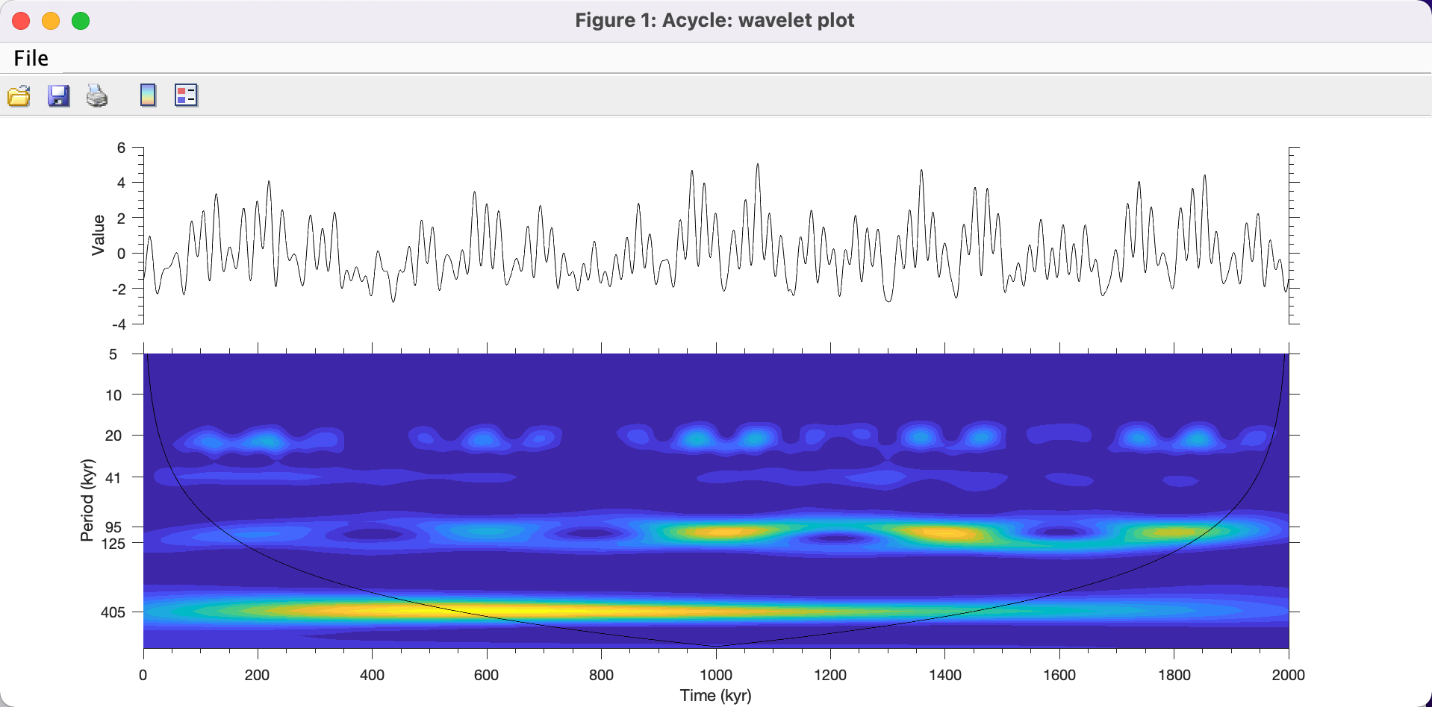

*Wavelet analysis of the eccentricity–tilt–precession (ETP) series using the parameters illustrated in the previous figure.*

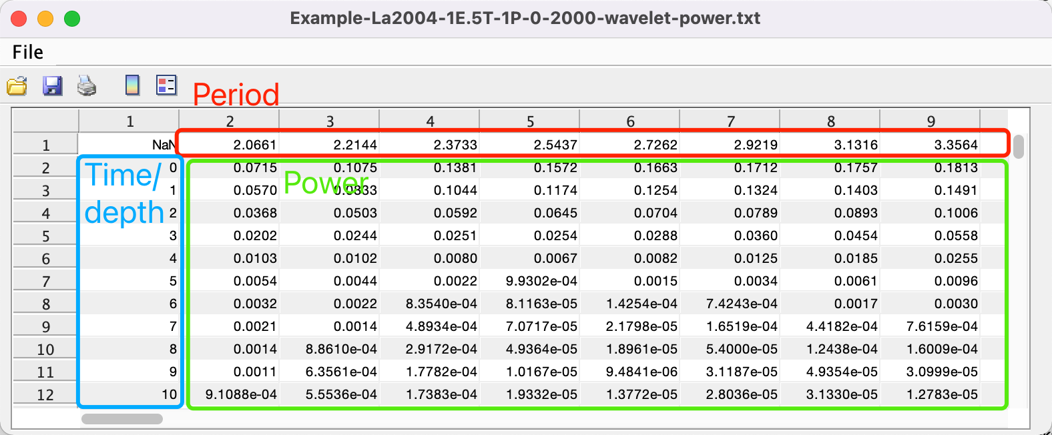

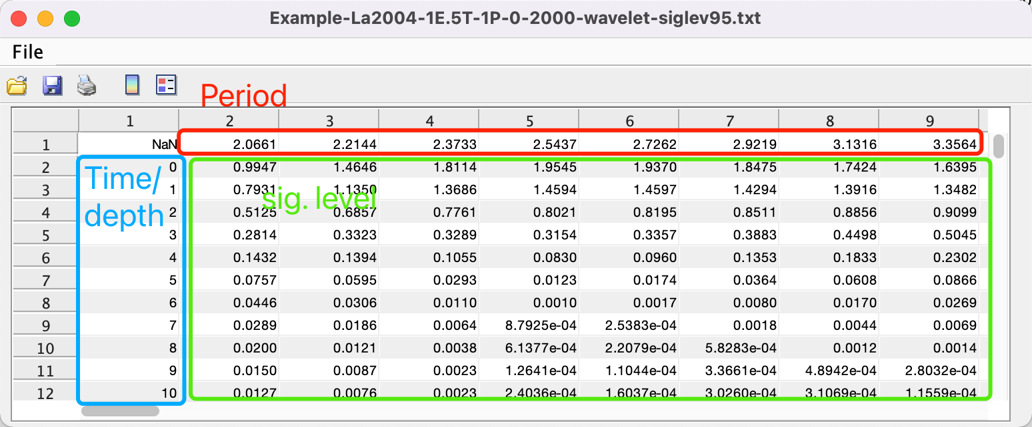

#### Wavelet coherence and cross-spectrum:

Computes the cross‑wavelet transform and coherence between two uniformly sampled time series to reveal shared power and phase relationships.

Steps:

(1) Prepare Data

Select two data files in the Main Window.

*Warning: Both must be evenly spaced and share the same sampling rate and start time/depth.*

***Tip:*** *If they differ, use* ***Math*** 🡪 ***Interpolation Series*** *(Chapter  4.6) to resample one onto the other’s grid.*

(2) Open Analysis

Go to **Timeseries** 🡪 **Wavelet**.

(3) Configure Parameters

The **Wavelet Coherence** dialog adds these controls to the standard wavelet GUI:

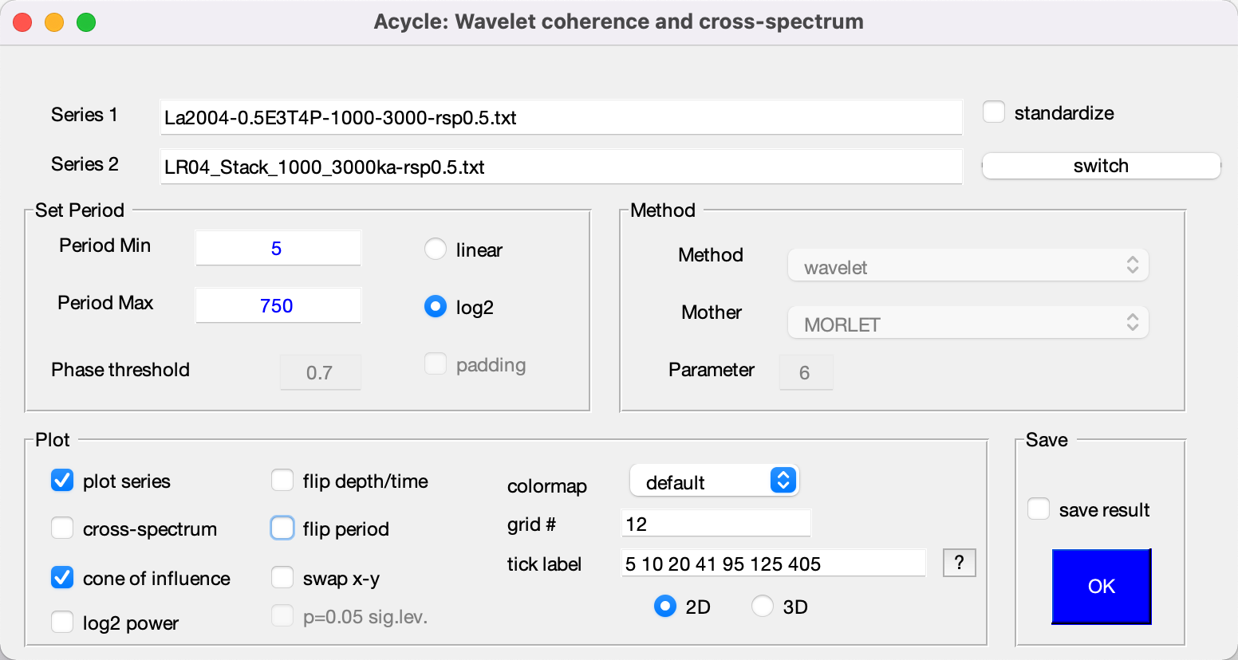

*Wavelet coherence and cross-spectrum GUI*

**Series 2**: Choose the second series.

**Switch**: Swap Series 1 and Series 2.

**Cross-spectrum**: Tick to compute and display the cross‑spectrum (shows lead–lag).

**Phase threshold**: When **Cross‑Spectrum** is on, sets the minimum coherence for plotting phase arrows.

**All other wavelet settings** (period range, mother wavelet, padding, colormap, etc.) remain available.

(4) Run & View

Click **OK**. Two figures appear: one for coherence, one for cross‑spectrum, each with the cone of influence and significance contours.

(5) Save results

If **Save Results** is enabled, *Acycle* writes:

*-wcoh.fig — the MATLAB figure.

*-wcoh-wcoh.txt — coherence matrix (first column = time/depth; first row = period).

*-wcoh-wcs.txt — complex cross‑spectrum matrix (phase indicates relative lag).

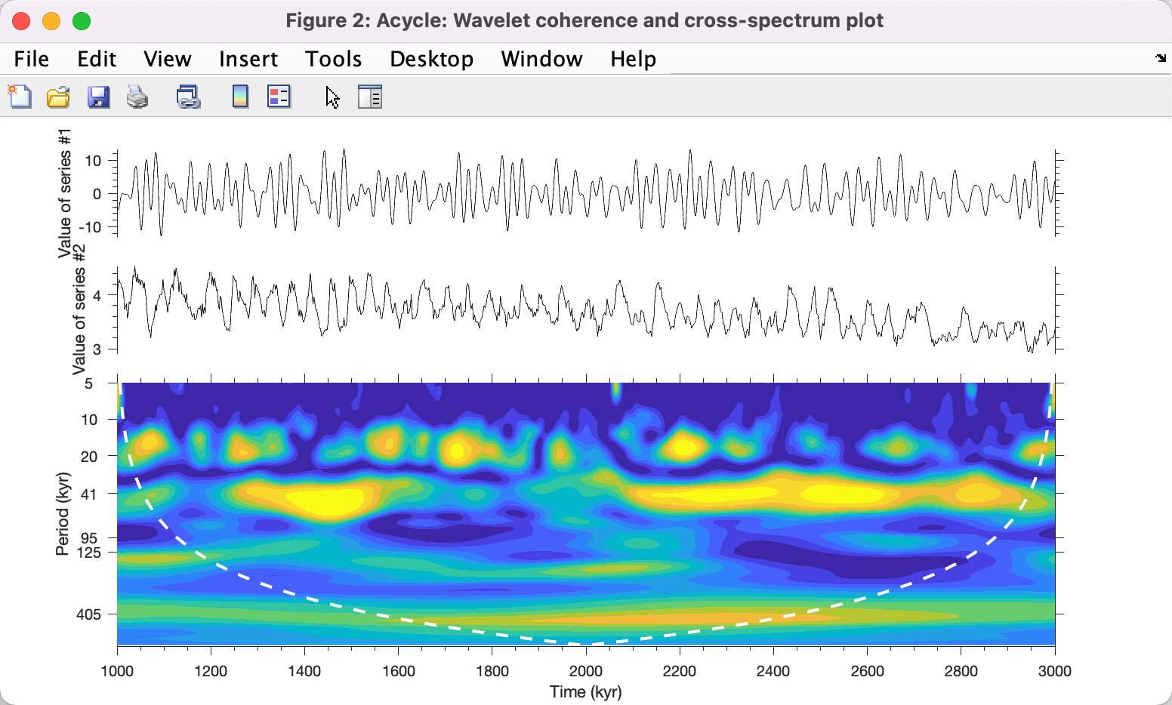

*Wavelet coherence*

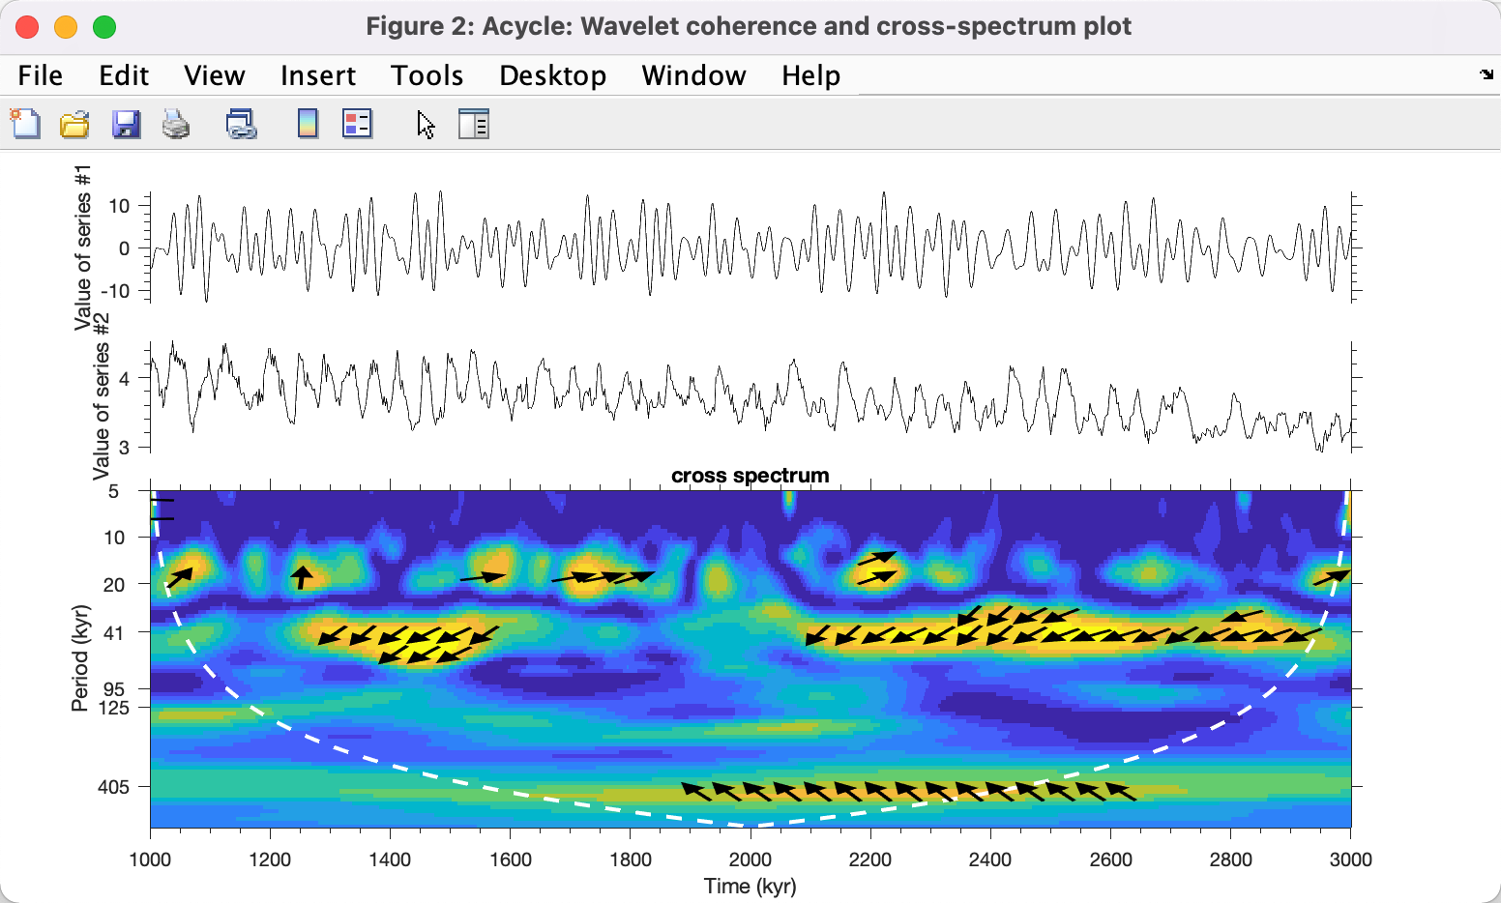

*Wavelet coherence and cross spectrum*

*About the Algorithm*

*Based on the cross‑wavelet and coherence code by Aslak Grinsted (University of Copenhagen):*

*Citation: Grinsted, A., J. C. Moore, S. Jevrejeva (2004), Application of the cross wavelet transform and wavelet coherence to geophysical time series, Nonlin. Process. Geophys., 11, 561566.*

*Please acknowledge with a citation and link: http://www.glaciology.net/wavelet-coherence*

*Most of the package is licensed under the MIT license, see individual files for exceptions.*

### **Circular Spectral Analysis**

Tests for periodicity in a series of discrete events without requiring amplitude information (Lutz, 1985; Stothers, 1991). This method has been applied to impact‑crater ages and marine‑extinction records (Rampino et al., 2021; Zhang et al., 2023). Only the first column (event time or depth) is used.

1. **Select Data**  
   In the Acycle Main Window, choose your file whose first column lists event ages (e.g., extinction.txt).
2. **Open Analysis**  
   Go to **Time Series** 🡪 **Circular Spectral Analysis**.
3. **Configure Parameters**

Period Resolution: Enter the period range and the number of test periods. Choose Linear or Log scaling for how periods are sampled.

Significance Test: Specify the number of Monte Carlo iterations and select either Random Distance or Fixed Distance as the null model.

Save Data: Tick to automatically export the spectrum to file.

Flip X‑Axis: Tick to display larger periods on the left side of the plot.

1. **Run**  
   Click **OK**. A new figure appears showing spectral amplitude versus test period.

If **Save Data** is ticked, Acycle creates a file named *-CSA-fixed.txt containing two columns:

Period (units per cycle) and Spectral Power.

1. **Information**

In the Terminal, you’ll see a message such as:

>> saved data: Example-CSA-extinction-CSA-fixed.txt

Col #1 #2 #3 #4 #5 #6 #7

period, power, 50%, 90%, 95%, 99% Conf.Level

**Example:** The file extinction.txt records ten non‑marine tetrapod extinction episodes (Rampino et al., 2020). Use circular spectral analysis to evaluate whether these extinctions follow a regular periodicity.

The file Example-CSA-extinction-CSA-fixed.txt contains columns for period, spectral power, and confidence levels at 50%, 90%, 95%, and 99%.

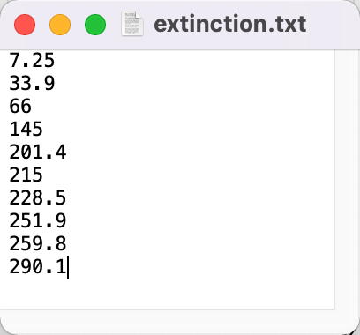 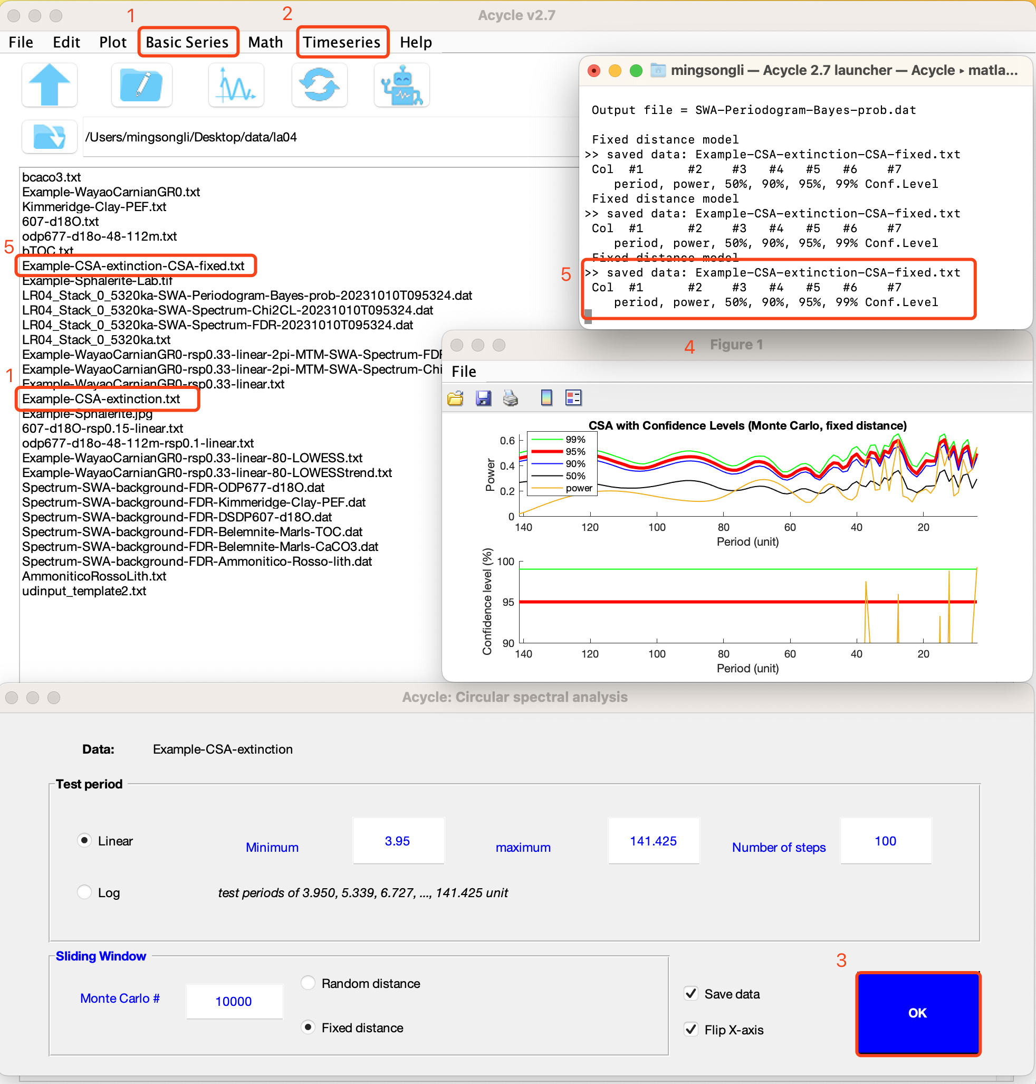

*Power spectrum of the ten extinction episodes for periods from 5 to 50 Myr, computed using Circular Spectral Analysis.*

### **Recurrence Plot**

Recurrence analysis identifies repeating patterns in a time series, revealing nonlinear dynamics, transitions, and interrelationships (Marwan et al., 2007). It helps evaluate whether the underlying process is stochastic, regular, or chaotic (Westerhold et al., 2020).

Steps:

1. Load data

In the Main Window, select “Basic series” 🡪 “CENOGRID”. This loads “Example-cenogrid-d13c.txt” (δ¹³C) and “Example-cenogrid-d18o.txt” (δ¹⁸O).

1. Configure Parameters

Open the **Acycle: Recurrence Plot** dialog. Adjust settings such as unit, Show DET, and recurrence threshold to suit your data.

1. Generate Plot

A new window will display the recurrence plot (recurrence matrix) for your series.

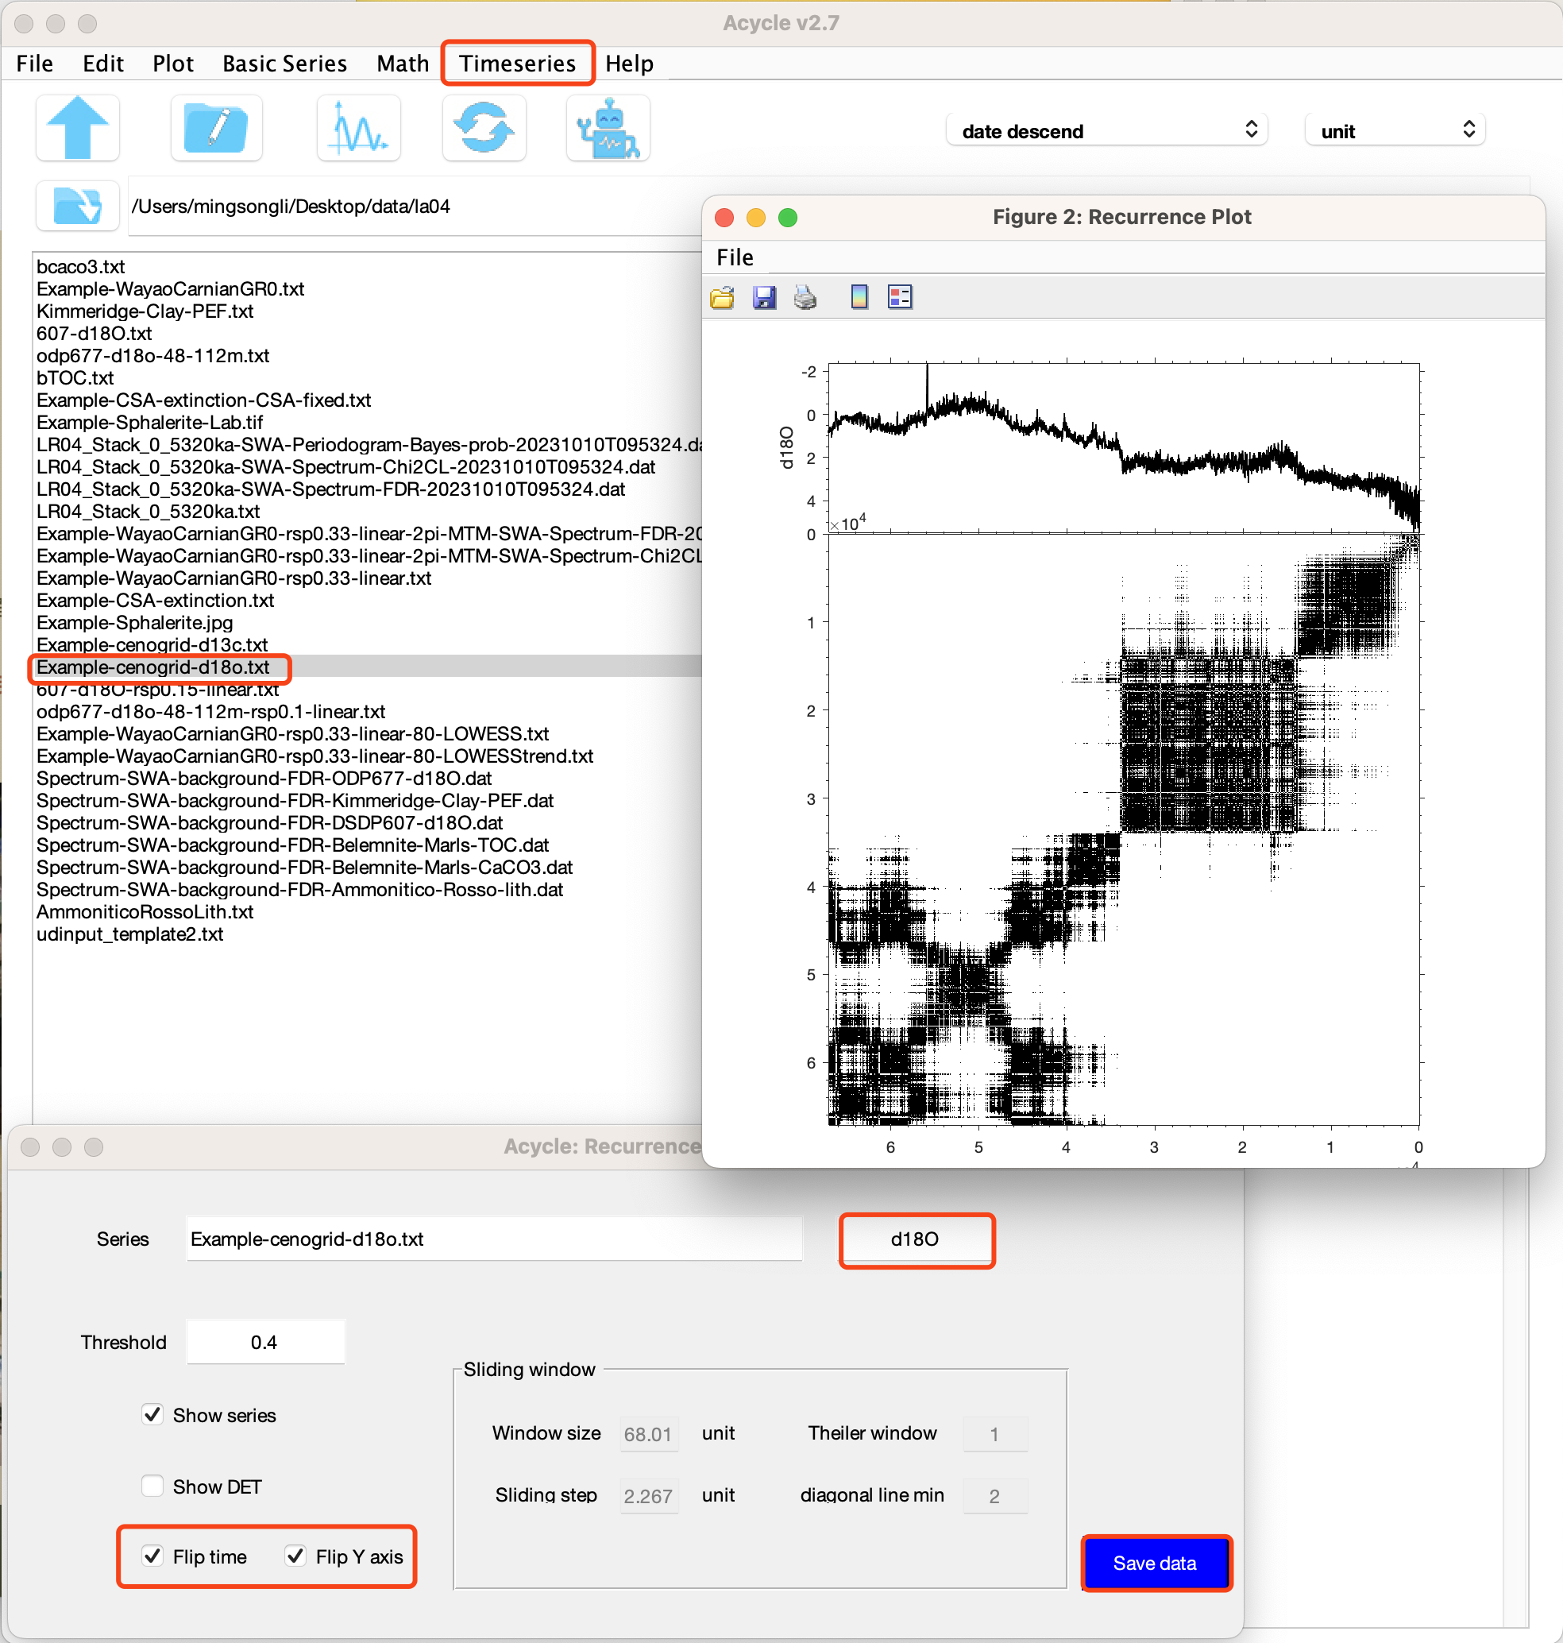

### **Coherence & Phase**

Estimates the magnitude‐squared coherence and phase angle between a reference series and a target series.

1. Select Reference & Series

In the main window, click the ‘🡺’ button to designate one file as ‘Reference’ and another as ‘Series’. Both must reside in the same folder.

1. Set depth/time Orientation

Choose how to interpret the first column of the Series:

“Smaller time = younger time” (default)

“Smaller time = older time”

1. Adjust Analysis Parameters (blue panel)
   1. Coherence Threshold: A value between 0 and 1.
   2. Window Size: Default = 50% of the combined time span; **Number of Overlaps:** Default = 50% of the window size.
   3. Plot X Range: Select **Frequency** or **Period** on the horizontal axis.
   4. Plot Style: Choose line/marker settings for the coherence plot.
2. Generate Plot

Click ‘Coherence Plot’. A new figure will display coherence magnitude and phase angle across the chosen frequency/period range.

1. Refine & Refresh

Modify any blue‑panel parameter and the plot will update automatically.

How it works:

The Reference series is interpolated to its own time grid.

The Series is interpolated to the Reference’s time points.

Only the overlapping time interval is retained for analysis.

Coherence and phase are then computed and rendered in the plot.



### **Lead/Lag Relationship**

Estimates the optimal time shift between a reference and a target series by computing the root‑mean‑square error (RMSE) over a range of lags.

1. Select Reference & Target

In the Acyle: **Lead/Lag Relationship** Window, designate one file as **Reference** and another as **Target**.

2. Set Time Orientation

Choose how to interpret the first column of each series:

“Smaller time = younger time” (default)

“Smaller time = older time”

3. Configure Test Range

Test limit: Defines the maximum lead/lag in your time units. The full test window is ±Test Limit (e.g., –17.589 to +17.589).

Step: The increment between successive shifts. Default = half the median sampling rate.

Defaults: Test Limit = 10% of the total time span; Step Size = ½ median Δt. Adjust as needed for your data.

4. Run Analysis

Click OK. Acycle will:

* Compute root-mean-square-error (RMSE) at each lag step
* Display two figures (RMSE vs. lag and optionally aligned series)
* Save results to TargetName-LeadLag-ReferenceName.txt, containing columns: lag shift and corresponding RMSE.

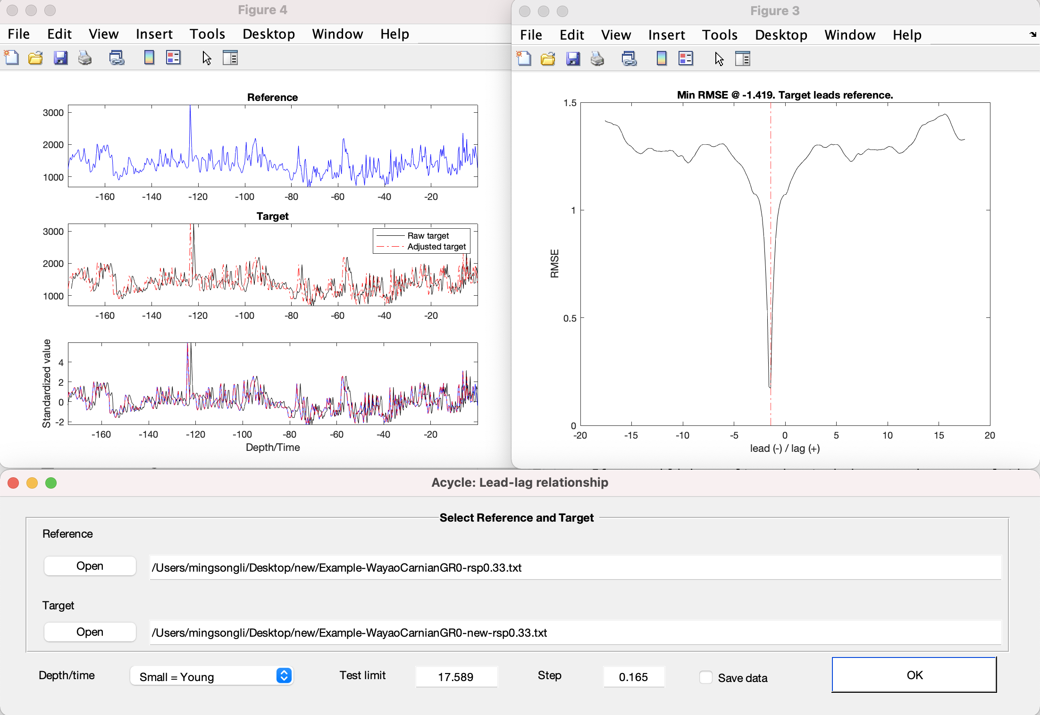

*Lead–lag relationship analysis of the Wayao Carnian gamma‑ray series, interpolated at a 0.33 m sampling rate.*

### **Filtering**

Generates a filtered output series from your selected data using user‑defined cutoff frequencies. Steps:

(1) Select data:

In the Main Window, click your *data file. It ill be demeaned automatically.*

*Warning: The file* ***must*** *be an evenly spaced depth/time series—otherwise a warning will appear.*

(2) **Open Menu:** Choose **Timeseries** 🡪 **Filtering**

(3) **Band-pass filter:** very important!

In the **Bandpass Filter** panel, enter the **lower** and **upper** cutoff frequencies (cycles/unit). The **center frequency** is shown in blue.

Select your filter type: **Butterworth**, **Cheby1**, **Ellip**, **Gaussian**, or **Taner–Hilbert**.

Tip: The Gaussian and Taner-Hilbert filters are recommended. Codes by Linda Hinnov (Kodama and Hinnov, 2015).

*Tip: The Taner–Hilbert option also computes instantaneous amplitude, frequency, and phase.*

Click Save Data. The filtered series will appear in the Main Window.

(4) **High-pass and low-pass** filter:

Switch to the Highpass / Lowpass panel.

Enter the cutoff frequency and choose Butterworth or Ellip.

Click Save Data to export the result.

(5) Power spectrum plot:

Enable the **Power Spectrum** option on the right side of the GUI to view the spectral density of your filtered output.

***Shortcut keys [Mac] ⌘ + F; [Windows] Ctrl + F***

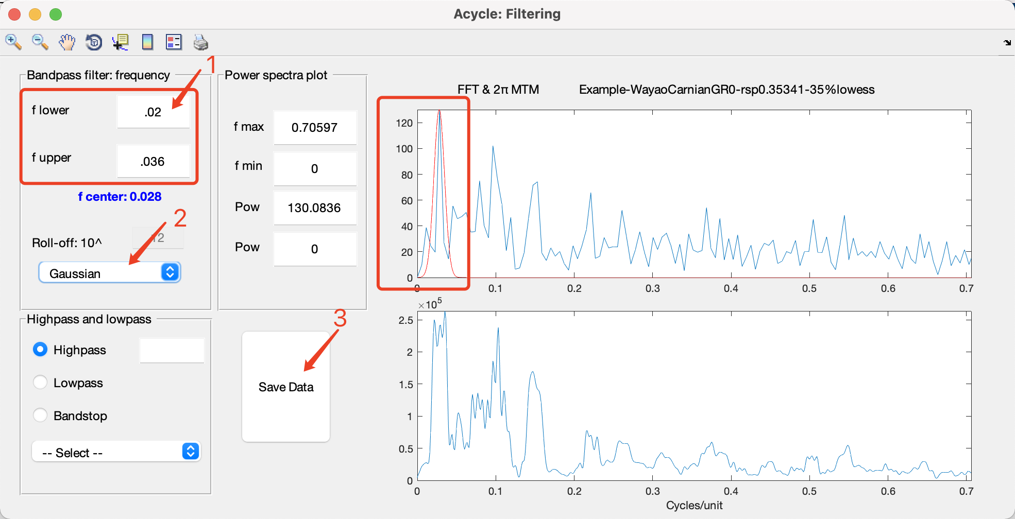

*Gauss filter*

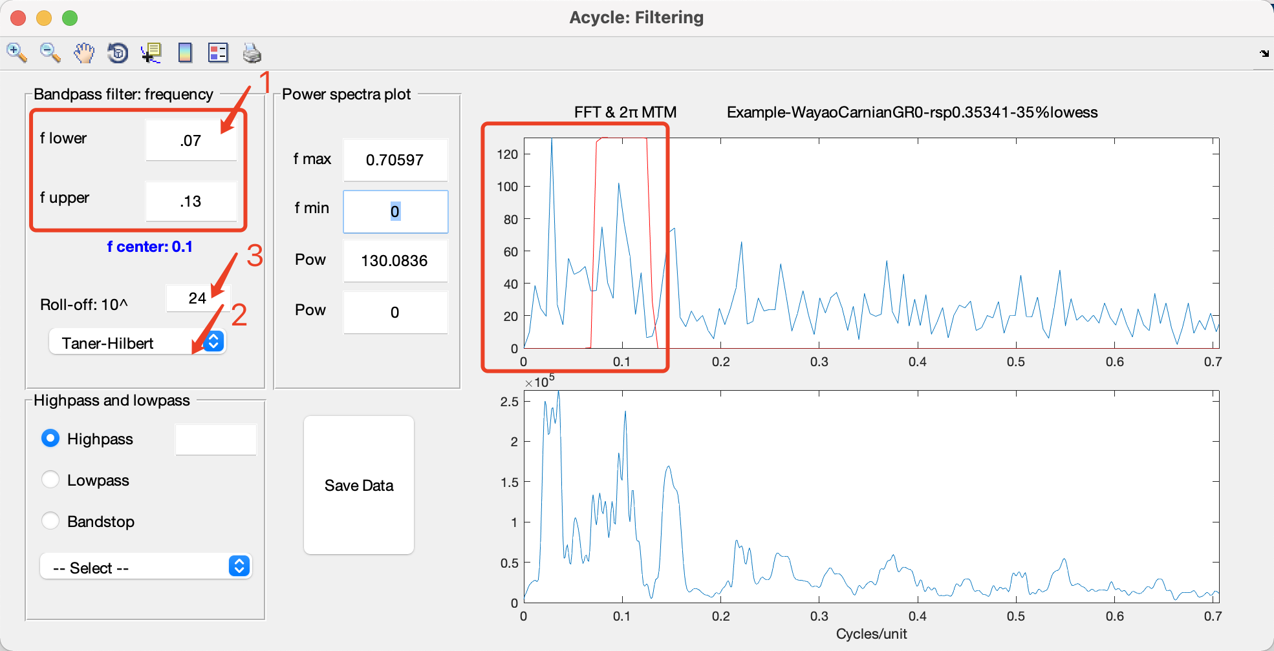

*Taner filter*

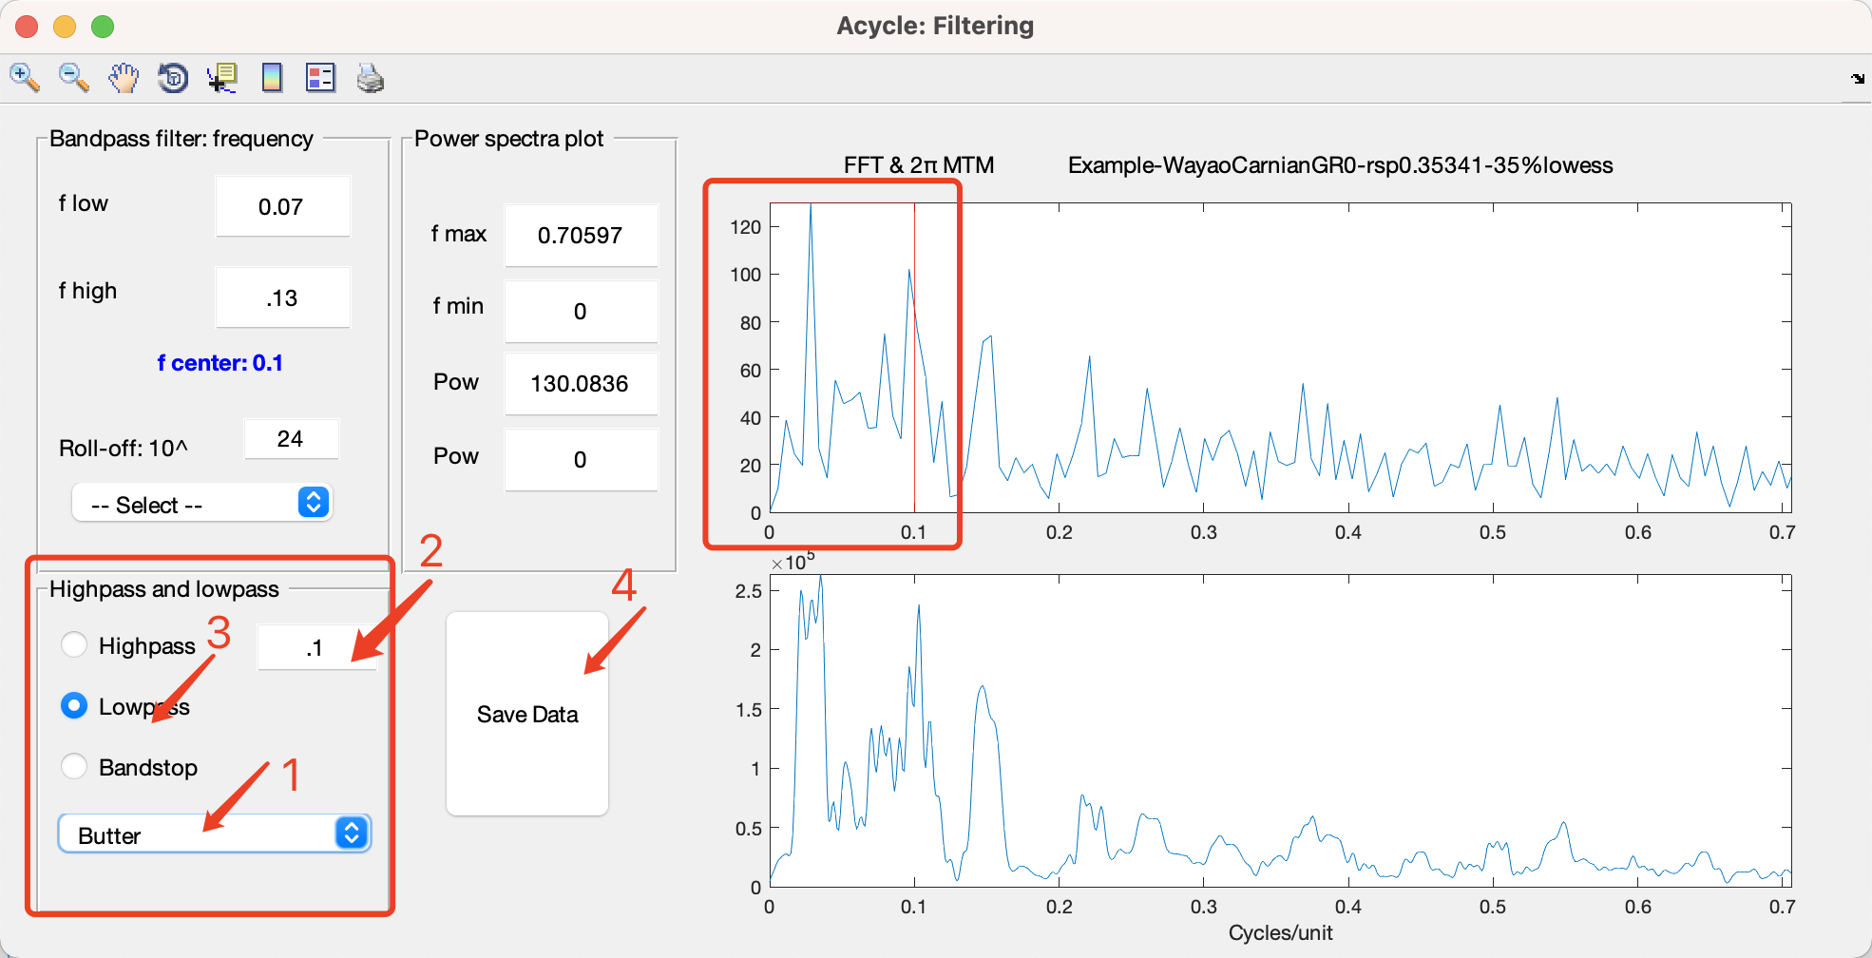

*Lowpass filter*

Output File Naming Examples:

*-gaus-flow-0.02-fhigh-0.036.txt

Gaussian band‑pass filter, f_low = 0.02, f_high = 0.036

*-Tan-flow-0.07-fhigh-0.13.csv

Taner band‑pass filter, f_low = 0.07, f_high = 0.13

*-Tan- flow-0.07-fhigh-0.13-AM.csv

Taner–Hilbert filter with amplitude‑modulation output

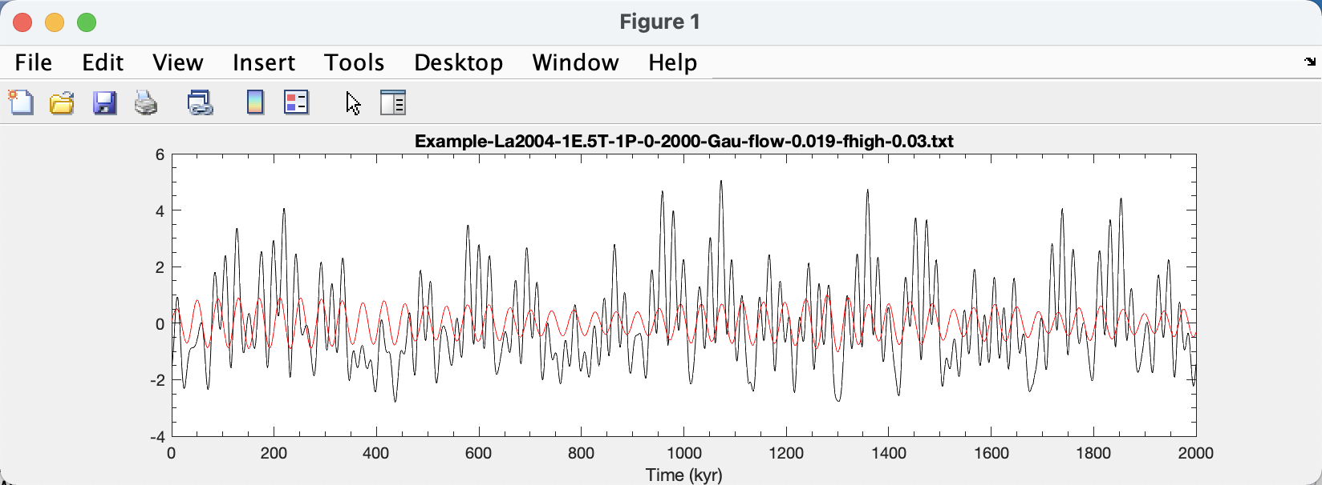

*Filtering the La2004 ETP series to isolate the 41 kyr cycles.*

### **Dynamic Filtering**

Applies a time‐varying bandpass filter by letting you pick evolving frequency limits directly from an evolutionary FFT plot. Originally written by Nicolas Thibault and Giovanni Rizzi, this tool is ideal when sedimentation rates—or sampling intervals—vary through your record.

Steps:

1. Select Time Series

In the Main Window, click your uniformly sampled data file.

2. Open Dynamic Filtering

Go to Timeseries 🡺 Dynamic Filtering

3. Configure Window & Step

In the **Dynamic Filtering** dialog, set:

**- Sliding Window Length** and **Step Size** (see Evolutionary Spectral Analysis, § 4.8).

- **Initial Frequency Range** (lower and upper cutoffs) to guide your selection.

4. Generate EvoFFT

Click OK. A new evolutionary FFT figure appears, showing power as a function of time and frequency.

5. Select Frequency Boundaries

After the EvoFFT appears, **follow the prompts shown in its title bar** to select your frequency boundaries:

a. Lower Boundaries: Click on the color map to mark each lower‐frequency limit along the time axis. Right‑click to finish.

b. Upper Boundaries: Click again to mark each upper‐frequency limit. Right‑click to complete selection.

6. View & Save Results

Acycle updates the EvoFFT display and overlays the filtered time series. Click **Save Data** (if present) or close the window to export outputs.

Output Files:

‘**-DynFilter.fig’ —EvoFFT figure annotated with your selected boundaries.

‘**-DynFilter.txt’ —Filtered time series (first column = time/depth; second column = filtered values).

**

*Dynamic Filtering GUI*



*Dynamic filtering*

### **Empirical Mode Decomposition**

#### Empirical Mode Decomposition (EMD)

Decomposes a non‑stationary time series into intrinsic mode functions (IMFs) and a residual trend.

1. **Select Data**  
In the Main Window, select your data file, then choose **Time Series** 🡺 **Empirical Mode Decomposition** 🡺 **Empirical Mode Decomposition (EMD)**.

2. **Configure Parameters**

* **Goal (Number of IMFs):** Maximum number of intrinsic mode functions to extract.
* **Maximum number of extrema in the residual signal:** Stopping criterion based on the number of local extrema remaining in the residual.
* **Interpolation method for envelope construction:** Choose how upper and lower envelopes are constructed (e.g. spline, pchip, linear).

3. **Run Decomposition**  
Click **OK**. Acycle will iteratively sift the data and produce each IMF.

4. **Save Results**  
The output is saved as *-emd.txt, containing columns for the original time/depth and each extracted IMF plus the final residual.

% Empirical Mode Decompostion (EMD)

%

% Raw data: LR04_Stack_0_2000ka-rsp2-linear-emd.txt

%

% Number of Intrinsic Mode Functions: 4

% Maximum number of extrema in the residual signal: 1

% Interpolation method for envelope construction: pchip

%

% Time IMF1 IMF2 IMF3 IMF4 Residual

0.000000000 0.038124091 -0.487706917 -0.092434494 -0.360095710 4.132113030

2.000000000 -0.036814748 -0.527397287 -0.061512361 -0.325323135 4.131047531

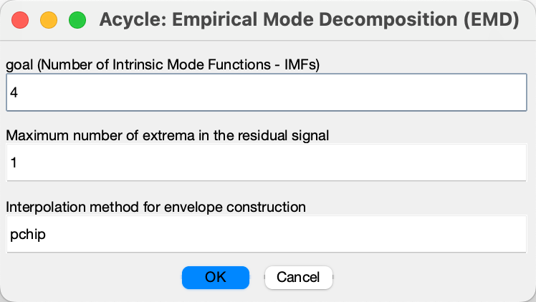

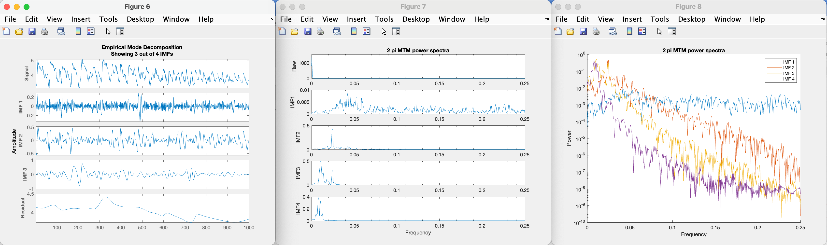

#### Ensemble Empirical Mode Decomposition (EEMD)

Applies EEMD to reduce mode‑mixing by adding white noise across multiple ensemble members and averaging the resulting IMFs.

1. **Select Data**  
In the Main Window, select your data file, then choose **Time Series** 🡺 **Empirical Mode Decomposition** 🡺 **Ensemble Empirical Mode Decomposition (EEMD)**.

2. **Configure Parameters**

* **Goal (Number of IMFs):** Maximum number of intrinsic mode functions to extract.
* **Ens (Number of Ensemble Members):** Number of noise‑added realizations.
* **Nos (Amplitude of Added Noise):** Standard deviation of added white noise (relative to data).

3. **Run Decomposition**  
Click **OK**. Acycle will perform EEMD over the specified ensemble and compute averaged IMFs.

4. **Save Results**  
The output is saved as *-eemd.txt, containing columns for the original time/depth and each extracted IMF plus the final residual.

% Acycle: Ensemble Empirical Mode Decompostion (EEMD)

%

% Raw data: LR04_Stack_0_2000ka-rsp2-linear-eemd.txt

% goal (Number of Intrinsic Mode Functions - IMFs): 4

% ens (Number of Ensemble Members): 100

% nos (Amplitude of Added Noise): 0.200000

%

% Time IMF1 IMF2 IMF3 IMF4 Residual

0.000000000 -0.002822821 0.493088625 -0.186492955 -0.381933653 3.308160804

2.000000000 -0.042184290 0.213615965 -0.203740387 -0.239841610 3.452150323

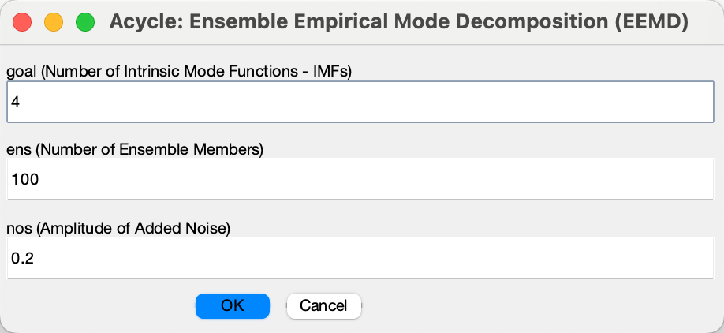

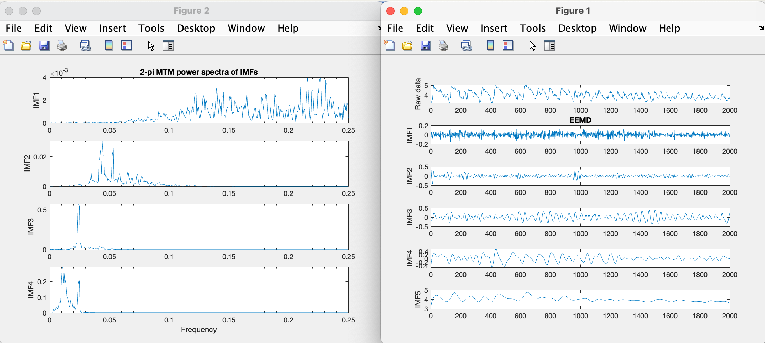

### **Amplitude Modulation**

Extracts the instantaneous amplitude envelope of a time series by applying a Taner bandpass filter followed by a Hilbert transform. The second column is first interpolated to the median sampling rate and demeaned.

Steps:

1. **Select Data:** In the Main Window, click the time‑series file you wish to analyze.
2. **Open Tool:** Go to Time Series → Amplitude Modulation.
3. **Process:** Acycle will remove the mean, apply the Taner filter to the demeaned data, then compute the Hilbert transform.
4. **View & Save:** The results appear in the Main Window.

Output Files:

*-AMf.txt – Taner‑filtered time series.

*-AM.txt – amplitude modulation (instantaneous envelope) of the filtered output.

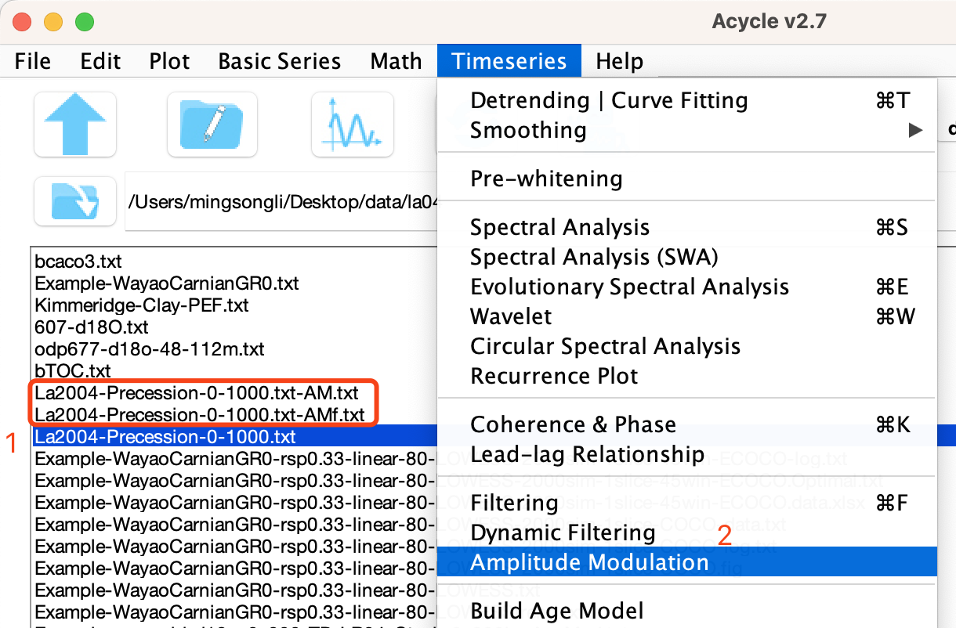

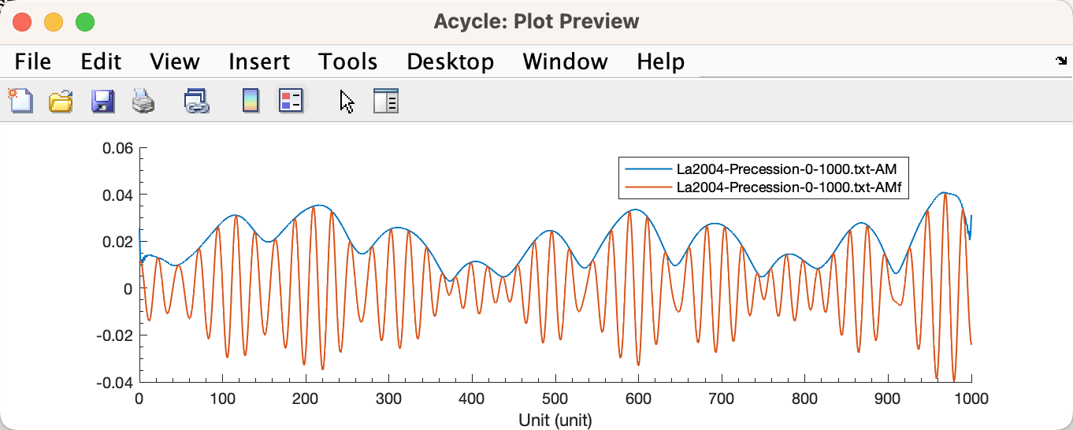

### **Build Age Model**

Creates an age–depth model by anchoring cycle peaks to a known (astronomical) period.

Steps:

(1) Select Filtered Series

In the Main Window, choose a band‑pass–filtered series (e.g., a 35 m cycle file). The 35 m intervals represent 405 kyr eccentricity cycles.

(2) Open Menu

Go to **Timeseries** 🡪 **Build Age Model**

(3) Set Parameters

In the pop-up, enter:

Cycle Period: 405 (kyr)

Use 1 = peak; 0 = trough: 1

(4) Run

Click OK. Acycle will assign each 35 m peak to successive 405 kyr ticks.

Output:

*-agemodel-405-max.txt

(e.g., mydata-agemodel-405-max.txt – age model using 405 kyr anchors).

### **Sedimentation Rate to Age Model**

Converts a two‑column sedimentation‑rate file (depth, rate) into an age model.

- Input: 2‑column text: depth and sedimentation rate.

- Menu: Time Series 🡪 Sedimentation Rate to Age Model

- Output: Age–depth file compatible with Acycle’s other tools (e.g., tuning, correlation).

### **Undatable**

Integrates the Undatable age–depth modeling package (Lougheed and Obrochta, 2019) to produce rapid, deterministic age models with depth uncertainty. For a detailed description, see Lougheed, B. C. and Obrochta, S. P. (2019), "A rapid, deterministic age depth modeling routine for geological sequences with inherent depth uncertainty." Paleoceanography and Paleoclimatology, 34, pp. 122-133. <https://doi.org/10.1029/2018PA003457>.

Details can be found in the Undatable User Manual for Version 1.0 of the software (<https://github.com/mingsongli/acycle/blob/master/doc/Undatable%20User%20Manual.pdf>).

A data file is needed for the calculation. Template files can be found at:

<https://github.com/mingsongli/acycle/blob/master/code/package/undatable/udinput_template.txt>

or

<https://github.com/mingsongli/acycle/blob/master/code/package/undatable/udinput_template2.txt>

Note that:

For deep-time applications, the unit of the age and age error should be in kyr.

New file name:

* adplot (20231010T113818).pdf – result figure

* admodel (20231010T114047).txt – age model series

* inputfile (20231010T114047).txt – input file

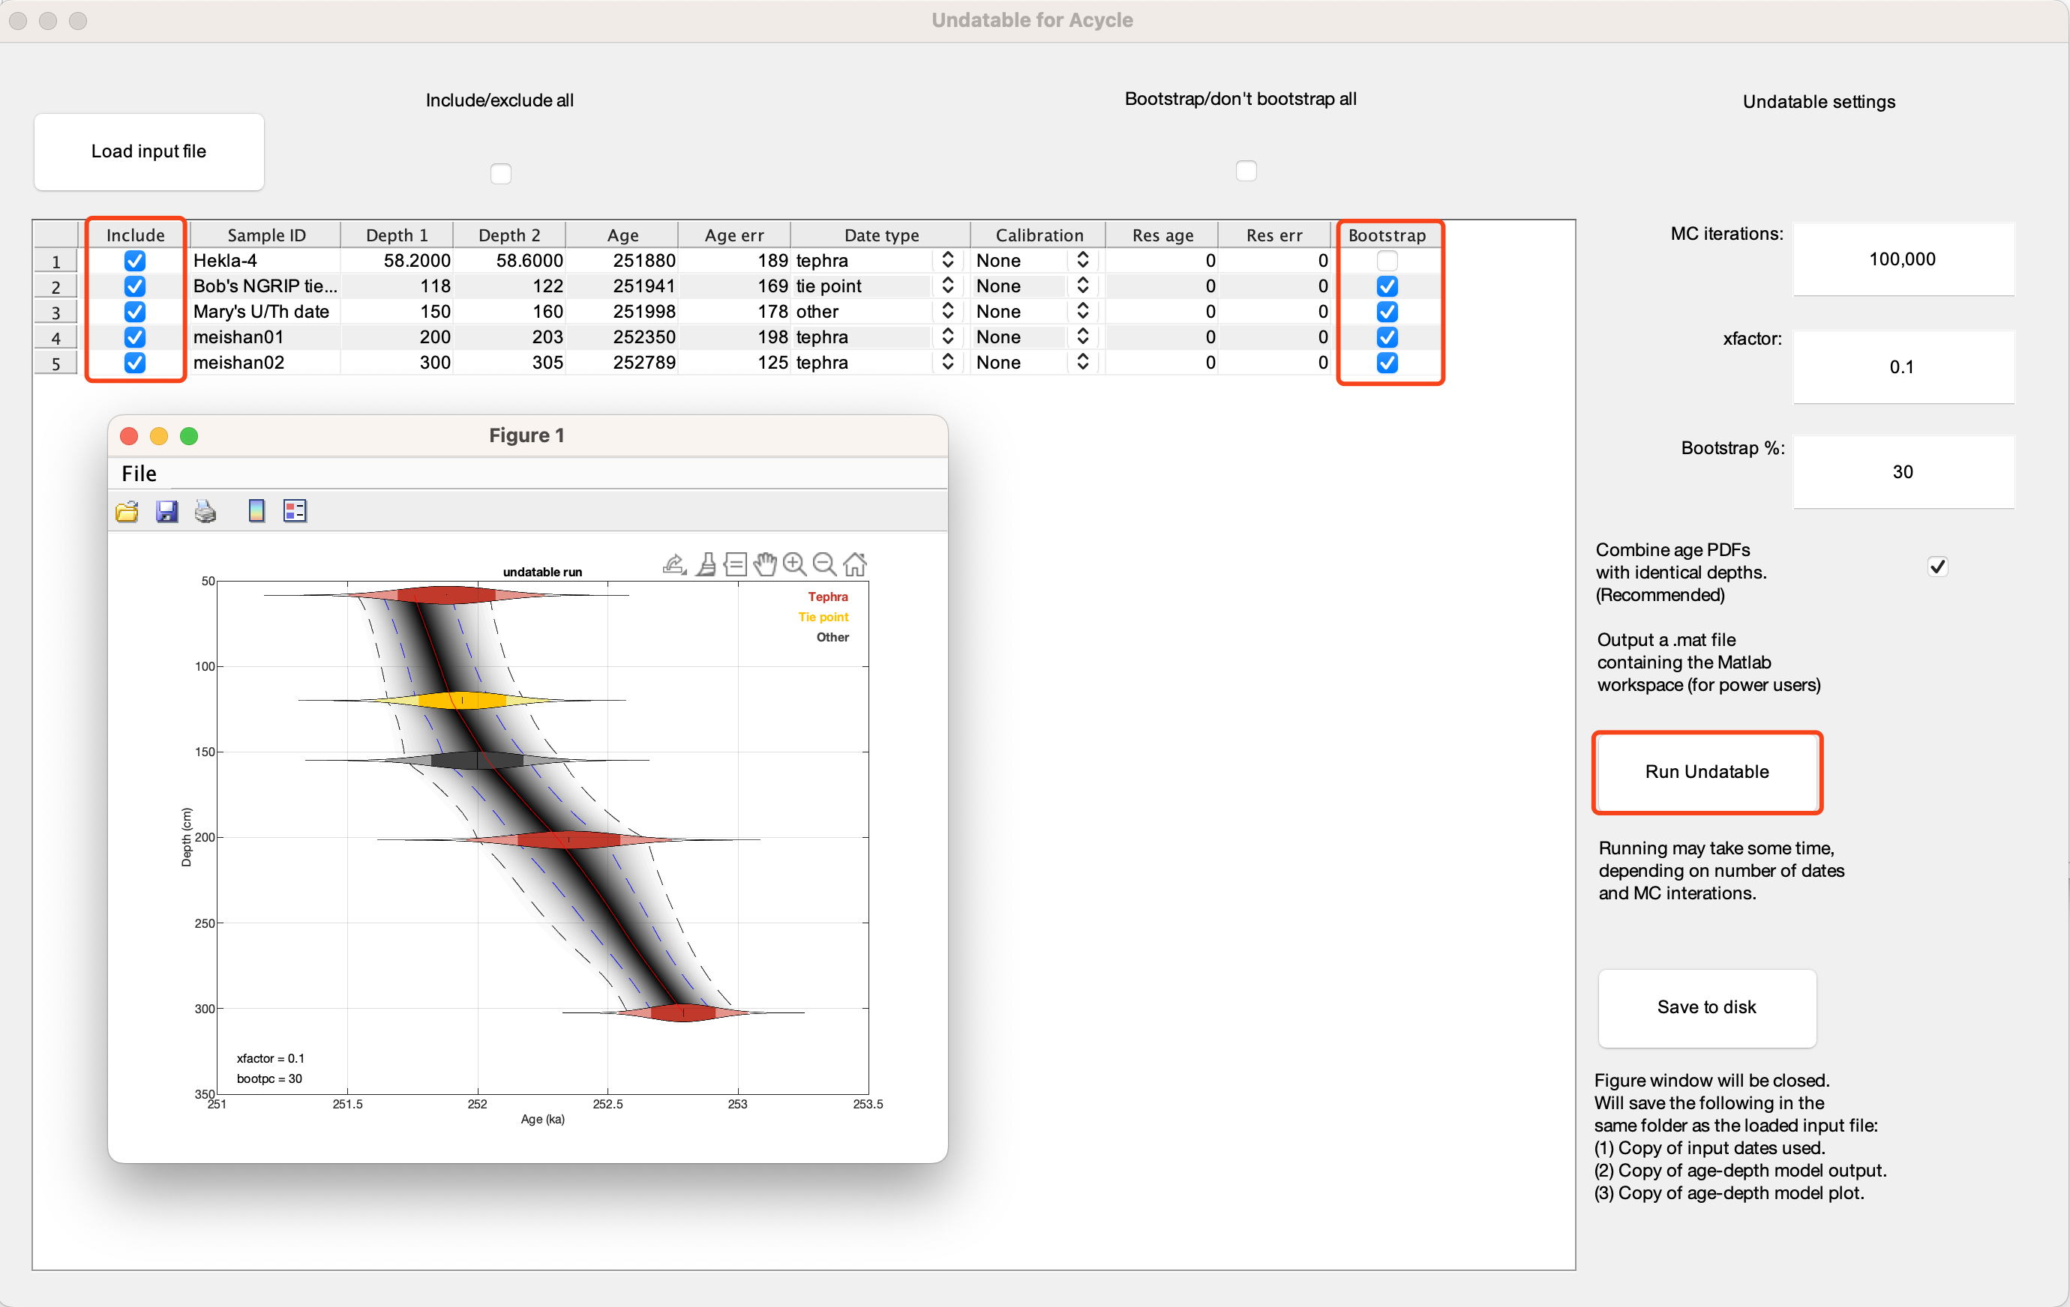

### **Age Scale | Tuning**

Performs depth‑to‑time conversion using a standalone GUI.



(1) Select Age Model

In the left file list, click one **age model** file.

(2) Record Age Model

Click the upper ==> button to move it into the **Age Model** box.

(3) Confirm Selection

The chosen file appears under **Age Model**.

(4) Show Age Model

Click **Show Age Model** to plot the age–depth curve.



*Age model*

(5) Select Series to Tune

In the left list, click one or more **data** files.

(6) Record Series

Click the lower ==> button to move them into the **Series** box.

(7) Confirm Selection

The selected series appear under **Series**.

(8) Preview Tuning

Click **Tuning Preview Time** to compare evenly spaced depth (top) vs. time (bottom).

Or click **Tuning Preview Depth** to compare time (top) vs. depth (bottom).



*Tuning Preview in Time Domain*

*Top panel: Data plotted against an evenly spaced depth axis. Bottom panel: The same data remapped onto an evenly spaced time axis.*



*Tuning Preview in Depth Domain (first axis)*

*Top panel: Data plotted against an evenly spaced time axis. Bottom panel: The same data remapped onto an evenly spaced depth axis.*

(9) Execute Tuning

Click Tuning. The tuned series are displayed and saved.

Output: *-TD-name-of-agemodel-file.csv

*Tip: Use the ← and → buttons above the file lists to change directories.*



*Original vs. tuned data*

### **Stratigraphic Correlation**

Allows interactive, manual alignment of two time‑series (or depth‑series) by picking tie points.

Steps:

1. Select Reference & Target

In the Main Window, choose one file as **Reference** and another as **Target**.

1. Open Correlation Tool

Go to **Time Series** 🡪 **Stratigraphic Correlation**.

1. Configure & Run

Adjust any parameters (e.g., interpolation method) in the pop‑up dialog, then click **OK**.

1. Pick Tie Points

In the **Acycle: Stratigraphic Correlation** figure:

**Upper panel:** Click a point on the Reference series.

**Lower panel:** Click the corresponding point on the Target series.

Repeat until you’ve defined all ties; then right‑click to finish.

1. View Results

Two new figures appear:

Sedimentation/Accumulation Rate vs. depth or time.

**Integrated Age Model** for the Target series.

1. Saved Outputs

Acycle writes three files (using your Target and Reference names):

Target-TD-Reference.txt – tuned Target series aligned to Reference.

Target-TD-Reference-SAR.txt – sedimentation/accumulation rates.

Target-TD-Reference-AgeMod.txt – age‑depth model for the Target series.

Example Files:

Example-cenogrid-d18o_0_800-TD-LR04_Stack_0_800ka.txt

Example-cenogrid-d18o_0_800-TD-LR04_Stack_0_800ka-SAR.txt

Example-cenogrid-d18o_0_800-TD-LR04_Stack_0_800ka-AgeMod.txt

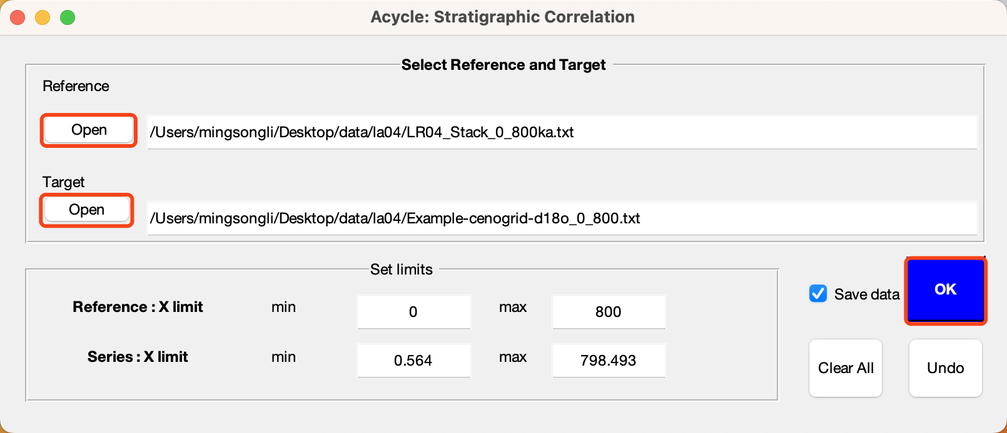

*Acycle: Stratigraphic Correlation GUI.*

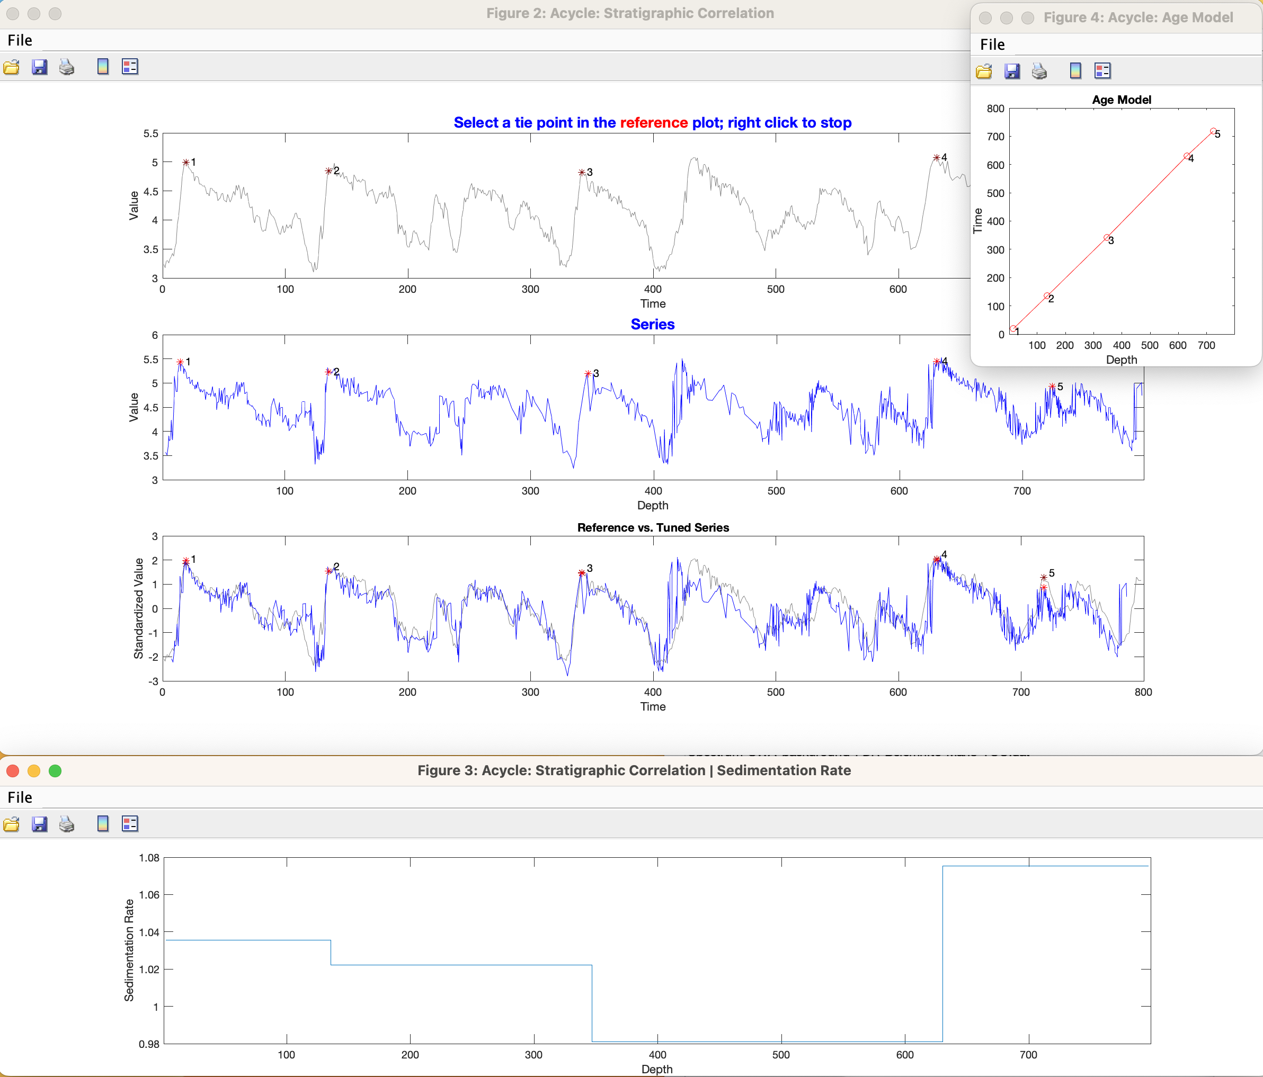

*Acycle: Stratigraphic Correlation results.*

### **Power Decomposition Analysis**

This function subtracts power/variance within a user-defined frequency band. The code written by Mingsong Li and Linda Hinnov was published in [Li et al. (2016)](#_ENREF_10" \o "Li, 2016 #4054). Time-dependent amplitude modulations in the obliquity component were obtained from 2π multi-taper variance (power) spectra calculated along a sliding time window using the Matlab script *pda.m* (also available at <https://doi.pangaea.de/10.1594/PANGAEA.859147)>.

Steps:

(1) Select the original data file and the Power Decomposition Analysis tool.

Warning: The data must be evenly spaced data in the first column. And the unit must be in kyr.

(2) Type paired frequency bands; space delimited. If a dominated frequency is 1/33, then a 1/45 1/25 frequency band is used.

(3) Sliding window in kyr, a 500 kyr is used in [Li et al. (2016)](#_ENREF_10" \o "Li, 2016 #4054).

(4) Time-bandwidth product, ‘2’ (means 2π prolate tapers) is used.

(5) Lower cutoff frequency. The default frequency = 0.

(6) Upper cutoff frequency. The default frequency is 0.08 for the past several million years. For the Triassic, 0.06 is used because the precession cycles are shorter.

(7) Step of calculations. The default step for the sliding window is 1. The unit is kyr.

(8) Zero-padding number. The default value is 5000. If the dataset has more (>5,000) rows, a large number (e.g., 10,000, 15,000, 20,000, etc.) should be used.

(9). Save results. 1 = yes (save result) or 0 = no (not saving).

(10). Padding depth. To the beginning and the end of the time vector (the first column) of the data). For the second column:

0 = None

1 = Zero padding [recommended]

2 = Mirror padding

3 = Mean padding

4 = Random padding

### **Sedimentary Noise Model**

#### Dynamic noise after orbital tuning (DYNOT)

**Detects** non‑orbital **variance** from a tuned series. See **Chapter 5.** **DYNOT model Description**. See [Li et al. (2018a)](#_ENREF_8" \o "Li, 2018 #5893) for details about this method.

#### Lag-1 autocorrelation coefficient (ρ1)

This function conducts either a single run or Monte Carlo simulations of lag-1 autocorrelation coefficient (***ρ*1**) using a sliding window. It works with both depth series and time series.

The “Single run” requires the input of “window” and “interpolation sampling rate”.

The “Monte Carlo” requires several parameters: Number of Monte Carlo simulations (default is 1000), sliding window ranges from *win1* to *win2*, sampling rates from *sr1* to *sr2*, and plot settings (interpolation and shift grid).

See [Li et al. (2018a)](#_ENREF_8" \o "Li, 2018 #5893) for details about these parameters and their significance.

### **Correlation Coefficient (COCO/eCOCO)**

This function addresses two fundamental issues in cyclostratigraphy and paleoclimatology: identification of astronomical forcing in sequences of stratigraphic cycles, and accurate evaluation of sedimentation rates. This technique considers these issues part of an inverse problem and estimates the product-moment correlation coefficient between the power spectra of astronomical solutions and paleoclimate proxy series across a range of test sedimentation rates. The number of contributing astronomical parameters in the estimate is also considered. This procedure tests the hypothesis that astronomical forcing had a significant impact on proxy records. The null hypothesis of no astronomical forcing is evaluated using a Monte Carlo simulation approach. Details are included in (Li et al., 2018c). This technique was inspired by the average spectral misfit procedure by Meyers and Sageman (2007), which is provided in the asm function of the *Astrochron* R Package.

Ensure the unit is selected as m. Note the data series must have units in “meter”.



Select a depth series (interpolated, detrended), select **Timeseries --> Correlation Coefficient (COCO/eCOCO)** menu

**Step 1: Select model**: COCO

**Step 2: Data: zero padding** (default value is usually enough).

***\* Show periodogram****. Max frequency is Nyquist frequency. This is for plot use only.*

**Step 3**: Split series: 1 (default), 2, 3. If a number of “2” is used, the series will be split into 2 or more slices.

**Step 4: Choose “remove red noise model”**

Unselect = no removing red noise (if the conventional AR1 noise model doesn’t fit to the power spectrum, COCO may not work. Therefore, remove noise = 0 might be a solution);

Else, removing red noise has **3 options**:

(1) classic AR1 [*f* = (Periodogram / Power of AR1 red noise) – 1, if *f*<0, *f* =0];

(2) classic AR1[ *f* = (Freq – Freq of AR1 red noise), if *f*<0, *f* =0] (**Default**, the best option for the time series with a “red” spectrum).

(3) Robust AR1 [*f* = (Freq – Freq of robust AR1 red noise), if *f*<0, *f* =0] (experimental).

**Step 5:** **Settings for test sedimentation rate**

Minimum sedimentation rate: This default value may represent the detection limit of COCO.

Maximum sedimentation rate: This default value may represent the detection limit of COCO.

Step sedimentation rate: tested sedimentation rates range from *fMIN* to *fMAX*, with a step of *STEP* cm/kyr. In the following example, the tested sed. rates are 4.29, 4.49, …, and 29.89 cm/kyr (129 test sedimentation rates).

  

**Step 6: Median age of data.** Type the approximate age for the depth series, the unit is million years ago (Ma).

**Step 7. Target frequency.** It ranges from 0 cycle/kyr to the given “MAX frequency”. Default values are recommended for the depth series with age less than 250 Ma.

For the depth series older than 250 Ma, the **MAX frequency will be set to 0.08**. This is because the precession cycle can be shorter than 16 kyr.

**Step 8: Astronomical solution [optional]**

Three astronomical solutions are available:

1. Berger89 frequencies (Berger et al., 1989),

2. Laskar 2004 solution (Laskar et al., 2004),

3. User-defined solution. The input box should be filled by 7 astronomical periods.

Online resource for user-defined astronomical parameters may be found at <http://nm2.rhul.ac.uk/wp-content/uploads/2015/01/Milankovitch.html> (Waltham, 2015).

**Step 9: Correlation method [Default = Pearson]**

**Step 10: Number of Monte Carlo simulations.** 200-600 simulations are suggested for an initial run. And 2000 simulations generate publication quality results, however, 5000 or 10000 simulations will generate even better results.

**Step 11. Run.** Click the OK button, Monte Carlo simulation steps can be displayed in the Command Window of MatLab/Terminal. A log file will be generated recording all parameters used in the correlation coefficient analysis.

**New file name:**

*-2000sim-1slice-COCO-log.txt - # of simulations - # of slice - COCO - log file

*-2000sim-1slice-COCO-data.txt – test sedimentation rate, correlation coefficient, H0-SL, Number of orbits

*-2000sim-1slice-COCO.fig – A MATLAB fig file.

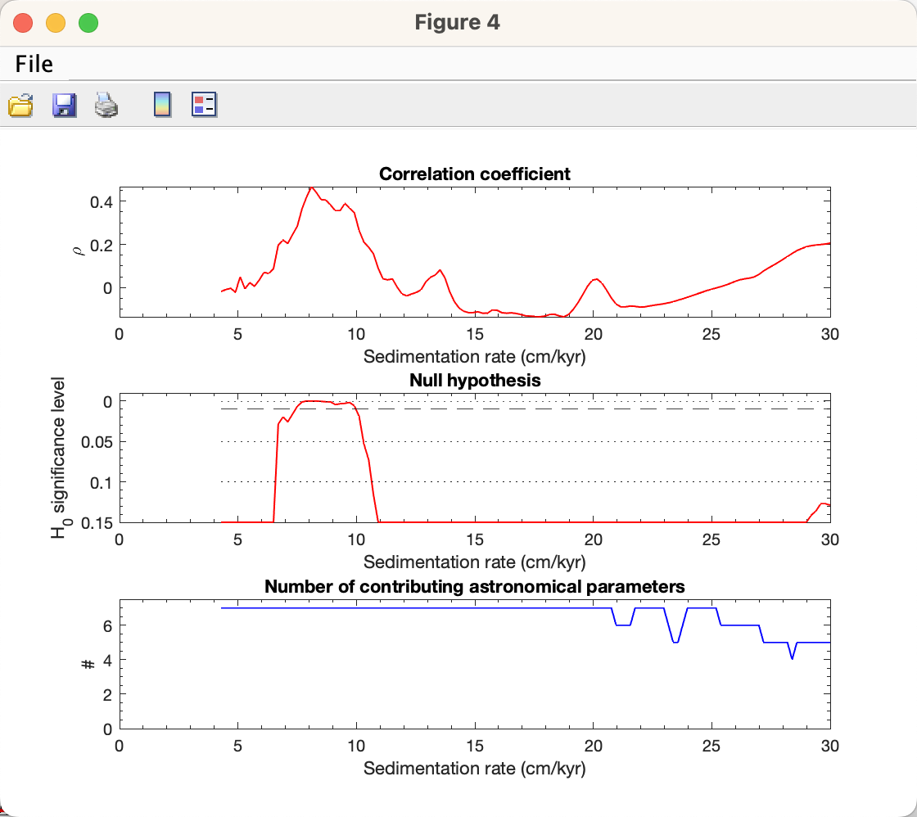

COCO analysis results show that the optimal sedimentation rate is 8.1 cm/kyr (joint maxima of *ρ* and H0‑SL), which is comparable to the sedimentation rate of 8.6 cm/kyr estimated by Zhang et al. (2015).

### **Evolutionary Correlation Coefficient (eCOCO)**

The method is applied using a sliding stratigraphic window to track variable sedimentation rates along the proxy series, in a procedure termed “eCOCO” (evolutionary correlation coefficient) analysis (Li et al., 2018c).

Warning: The data series must use **meter** units.

**Step 1: Select model**: eCOCO

**Step 2: Data: zero padding** (default value is usually enough).

**Step 3**: **Zero padding edge**: This option will zero pad the data series at both ends. The resulting evolutionary COCO will display the missing half‑window created by the sliding‑window method. This newly added option is to add back the missed half-window due to the sliding window methods. However, this might introduce incorrect estimation of sedimentation rate (for example, when a series with trend at one or both ends).

***\* Show periodogram:*** *Max frequency is the Nyquist limit (for display only).*

**Step 4: Choose “remove red noise model”**

Unselect = no removing red noise (if the conventional AR1 noise model doesn’t fit to the power spectrum, COCO may not work. Therefore, remove noise = 0 might be a solution);

Else, removing red noise has **3 options**:

(1) Classic AR1 [*f* = (Periodogram / Power of AR1 red noise) – 1, if *f*<0, *f* =0];

(2) Classic AR1[ *f* = (Freq – Freq of AR1 red noise), if *f*<0, *f* =0] (**Default**, best for “red” spectra).

(3) Robust AR1 [*f* = (Freq – Freq of robust AR1 red noise), if *f*<0, *f* =0] (experimental).

**Step 5:** **Settings for test sedimentation rate**

Minimum sedimentation rate: This default value may represent the detection limit of COCO.

Maximum sedimentation rate: This default value may represent the detection limit of COCO.

Step sedimentation rate: tested sedimentation rates range from *fMIN* to *fMAX*, with a step of *STEP* cm/kyr.

 

**Step 6: Median age of data series.** Type the approximate age for the depth series, the unit is million years ago (Ma).

**Step 7. Target frequency.** It ranges from 0 cycle/kyr to the given “MAX frequency”. Default values are recommended for the depth series with age less than 250 Ma.

For the depth series older than 250 Ma, the **MAX frequency will be set to 0.08**. This is because the precession cycle can be shorter than 16 kyr.

**Step 8: Astronomical solution [optional]**

Three astronomical solutions are available:

1. Berger89 frequencies (Berger et al., 1989),

2. Laskar 2004 solution (Laskar et al., 2004),

3. User-defined solution. The input box should be filled by 7 astronomical periods.

Online resource for user-defined astronomical parameters may be found at <http://nm2.rhul.ac.uk/wp-content/uploads/2015/01/Milankovitch.html> (Waltham, 2015).

**Step 9: Correlation method [Default = Pearson]**

**Step 10: Number of Monte Carlo simulations.** 200-600 simulations are suggested for an initial run. And 2000 simulations generate publication quality results, however, 5000 or 10000 simulations will generate even better results.

**Step 11: Running window (m) and step size**: default window is 35% of the total length of the data series.

Step size (m): sliding steps. The default value will give about ~300 sliding windows for publication quality results.

**Step 12. Run.** Click the OK button, Monte Carlo simulation steps can be displayed in the Command Window of MatLab/Terminal. A log file will be generated recording all parameters used in the evolutionary correlation coefficient analysis. The user needs to decide which figure output should be saved or not.

**New file name:**

*-2000sim-1slice-45win-ECOCO-log.txt - # of simulations - # of slice - window size – eCOCO - log file

*-2000sim-1slice-45win-ECOCO-.Optimal.txt - location, Optimal Sedimentation Rate, Correlation Coeffienct, H0-SL, Number of orbits, COCO*H0*#Orbits

*-2000sim-1slice-45win-ECOCO-.data.xlsx – An excel file includes sedimentation rate, depth, COCO values, confidence intervals, number of orbits, and COCO*H0.

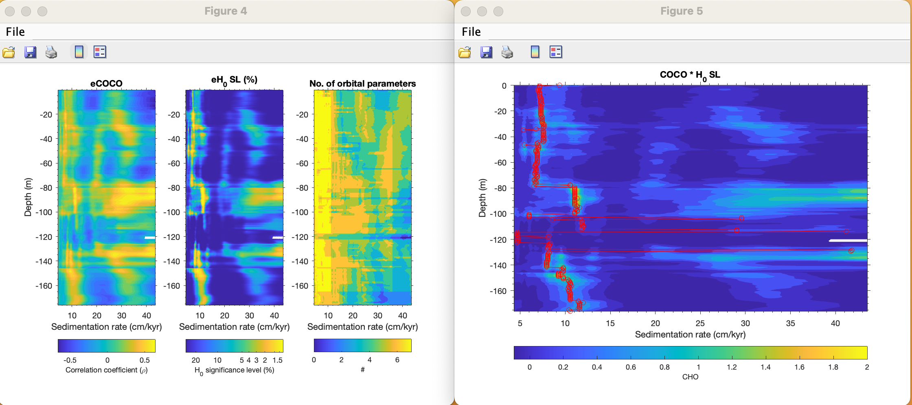

*ECOCO results. Right panel: red circles are calculated optimal sedimentation rate for each running window.*

“eCOCO Plot” Button: User can plot eCOCO results any time after eCOCO results are shown.

**Q: Which window should I use?**

A: A window that covers 1.5-2 * long eccentricity cycles will give a reliable result. If your series is dominated by 35 m cycles (405 kyr eccentricity cycles based on a mean sedimentation accumulation rate of 8.6 cm/kyr), then a 52.5 m (= 35 * 1.5) - 70 m (= 35 * 2) window may be good to keep the balance: A large window eCOCO loses resolution of variable sedimentation rates, and a small window may not give correct results.

**Q: How do I know the sedimentation rate is 8.6 cm/kyr?**

A: Run COCO!

**Q: What is the additional plot when I use eCOCO?**

A: It is pCOCO (Wang et al., 2024). This additional plot is calculated using this equation:

*ρ* * H0 = rho * (-1 * log10(H0-SL))

, where rho is the correlation coefficient as shown in the leftmost eCOCO figure; the H0-SL is the middle plot. For example, if a H0-SL = 0.003 (or 0.3%), and rho is 0.5, then -1*log10(0.003) = 2.523, rho * H0 = 0.5 * 2.523 = 1.26. This plot is to combine information from both eCOCO and eH0-SL to highlight the optimal sedimentation rate. It might help users identify the best sedimentation rate easily when individual eCOCO or eH0-SL plot is not clear.

**Q: The y-axis of my eCOCO plot is flipped.**

A: Click the eCOCO plot button at the bottom of the COCO/eCOCO GUI. In the popup window, type -1, and you will have 1 figure with a flipped Y axis.

### **Spectral Moments**

*This section is from the Manual for the Spectral Moments by* Sinnesael et al. (2018)*.*

*Q: What is meant by 'Spectral Moments'?*

*A: Mathematically speaking, moments are unique quantities describing a specific set of points. For example, in mechanics, the moments can describe the distribution of mass in a system. In statistics, the set of points can represent probability densities. For instance, for the commonly used normal distribution one would characterize its distribution by the mean (first moment), the variance (second moment) and so on. In the case of spectral moments, we apply the concept of moments on the spectral distribution of a signal (i.e. in this study a periodogram).*

*Q: OK, but how could this work practically?*

*The basic approach in this study is to calculate the spectral moments (here: mean frequency - first moment and bandwidth - second moment) over a data record using a moving window approach. This means that changes in the whole spectrum characteristics are evaluated over the record. Here we use simple periodograms as spectra to calculate the first two moments from for the data in a certain window. Then this window is moved by a certain step and the calculations are done again... this till the end of the record is reached where after all calculations over the record are combined using an overlap-add approach. This procedure gives the change of the spectral moments over the record and provides information on changing characteristcs of your signal. We included also the option to take the trend of the change of a spectral moment over the record and optionally couple this to a certain frequency (e.g. astronomical component) in the case that the hypothesis is that the changes in (astronomical) frequencies over a record are due to changing sedimentation rates.*

**Data requirement:**

Your input series must be uniformly sampled. If it is not, please interpolate it before using this routine.



**Steps**

**Step 1: Select Data**

In the Acycle Main Window, choose a uniformly sampled depth‑series file (*.txt).

**Step 2:** **Open Tool**

Go to “Time Series” – “Spectral Moments”

**Step 3:** **Zero padding edge**

Zero‑pad the series at both ends. The resulting plots will reveal the “missing” half‑window from a sliding‑window procedure, but this may distort sedimentation‑rate estimates at the ends (e.g., if the series has a trend).

Options:

“zero” (= add zeros)

“mirror” (= reflect data ends)

“mean” (= pad with the dataset’s mean)

“random” (= pad with random values)

**Step 4:** **Window size**

Set the sliding‑window length to 1–2 × the 405 kyr cycle wavelength.

Example: at 8.5 cm/kyr, 405 kyr ≈ 34.4 m → use a 45 m window.

*For more on window choice and component frequencies, see '2.3 Practical considerations' in Sinnesael et al., 2016, Astronomical component estimation (ACE v.1) by time-variant sinusoidal modeling published in the open-access journal of Geoscientific Model Development:* [*https://www.geosci-model-dev.net/9/3517/2016/gmd-9-3517-2016.html*](https://www.geosci-model-dev.net/9/3517/2016/gmd-9-3517-2016.html)

**Step 5:** **Step Size**

Enter the window advance (default = your sampling interval).

**Step 6: Window Padding**

Toggle zero‑padding within each sliding window (default = on).

**Step 7:** **Absolute sedimentation rate**

Provide a fixed mean rate (cm/kyr) to convert relative spectral‑moment rates into absolute values.

*Q: How do I pick this rate?*

*A: Use COCO and TimeOpt to estimate the mean sedimentation rate.*

**Step 8:** **Smooth model**

Choose how to smooth the rate curve: Polynomial (default), LOWESS, rLOWESS, LOESS, or rLOESS.

**Step 9.** **Run**

Click OK to perform the analysis. It may take several minutes for large datasets.



Spectral moments of the detrended Wayao GR data.

The bottom figure shows sedimentation rates varying from 11 cm/kyr down to 6 cm/kyr across the series, consistent with the eCOCO‑generated sedimentation‑rate map in the “Evolutionary Correlation Coefficient (eCOCO)” section of this User’s Guide.

## **4.8 Help**

### **文A/语言选择(language)**

Choose the interface language. Default is English. Chinese and Japanese are verified; other languages use Google Translate (use with caution).

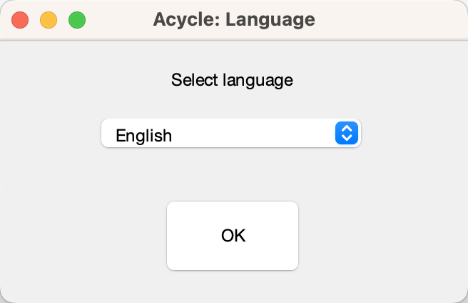 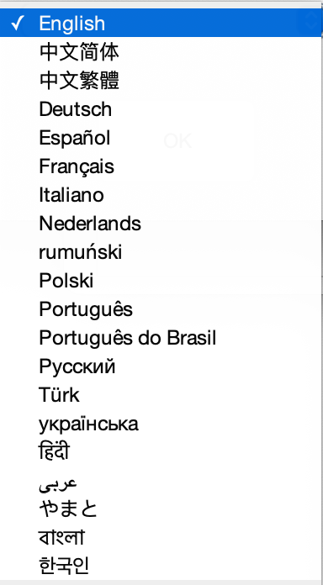

### **What’s New**

View the update log or online changelog.

### **Manuals**

Open the online User’s Guide:

https://acycle.org/manual/

### **Find Updates**

Check for new releases:

[https://github.com/mingsongli/*Acycle*](https://github.com/mingsongli/acycle)

https://acycle.org/downloads/

### **Copyright**

Open the copyright dialog.

### **Contact**

Visit mingsongli.com

## **4.9 Mini-robot**

This tool can do some work automatically with default settings.

Step 1: Click to select one data file (see **3.6 Data Requirement**) in the *Acycle* main window.

Step 2: Click the Mini-Robot button.

Step 3: Review parameters and click the “OK” button.

 

**It will do:**

**1. Data preparation**: check selected data: **remove NaN** values, **remove empty** values, **sort** data (based on the first column), remove duplicate numbers (“**Unique**”, replace with their mean value).

**2. Interpolation**: using the **mean**/median/max/min/user-defined sampling rate

**3. Detrending**: removing a long-term trend using user-defined parameters (default value is 35% LOWESS).

**4. Power spectral analysis**: to show significant frequencies; aided with a robust AR(1) red noise model using a log best-fit to the 25% median-smoothed spectrum.

**5. Evolutionary FFT**: using an adjusted sliding window.

**6. Wavelet transform**: using settings of user-defined period range.

**7. Save results**.

**8. Pause 0.5 seconds** after each above step.

# **5. DYNOT model Description**

Li et al. (2018a) *developed a dynamic noise after orbital tuning (DYNOT) model for the*

*sea-level changes based on the dynamic non-orbital signal in climate proxy records after subtracting orbital, i.e., astronomically forced climate signal. The DYNOT model is*

*supplemented by a second, independent lag-1 autocorrelation coefficient, or ρ1 model, which forms the basis of a statistical method for red noise estimation of time series. DYNOT/ρ1 modeling of a GR series of ODP Site 1119 over the past 1.4 myr correlates with the classic low-passed δ18O sea-level curve, demonstrating the efficacy of the sedimentary noise model.*

## **5.1 Data format**

*Data for the DYNOT model (supports .csv and .txt formats)*

Name: data

Size: m × 2 % must be a 2-column dataset

Column 1: time % unit must be in ka;

Column 2: value

**Notes**:

**1:** Proxy data should reflect water‑depth–related noise at your section/core.

**2:** No interpolation, normalization, or removal of long‑term trend (pre‑whitening) is required.

**3:** Remove extreme outliers.

**4:** Both increasing-upward and decreasing-upward time series are valid.

## **5.2 Startup**

1. Left‑click to select your dataset in the Acycle main window.

2. Choose “Timeseries” – “Sedimentary Noise Model” – “DYNOT”

3. The DYNOT GUI appears (Fig. 2).



Fig. 1. MatLab workspace for the DYNOT model.



Fig. 2. The DYNOT model

**4. To load data:**

**Click Data ready to load data** or load data ***from *.txt or *.csv file***

In the DYNOT menu: Select “File” 🡪 “Import Data (*.txt, *.csv) ” 🡪 Select data (chose “1119_gr_1400de_finetuned.txt” or “1119_gr_1400de_finetuned.csv”) 🡪 Click “Open ”



Fig. 3. Load data to DYNOT model.

## **5.3 Settings**

*Yellow: load data and run the model.*

*Red: Key settings. Check before running the model.*

*Green: Optional settings. Default values are okay for most running.*

5.3.0. Click Data ready (button) to load data into the DYNOT model.

5.3.1. Cut data (*optional*): These settings automatically show the beginning and the end of the time series, i.e., time span of the dataset. Unit is ka. If you want to choose a different interval, just type two new ages and click Cut.

5.3.2. Sampling rates (*optional*): These show a range of sample rates covering 90% of sample rates (Green Box 20 in Fig. 4). Unit is ka. A Monte Carlo method of hypothesis testing and the multi-taper method (MTM) of power spectral analysis will be undertaken, and so resampling must be applied. Sampling rates of proxy datasets in time are always greater than zero and so are non-normally distributed. Therefore, the Weibull distribution is used to represent sampling rate distributions for uncertainty analysis in the DYNOT model. To avoid an ultra-low or ultra-high, unrealistic sampling rate created by the Weibull distribution algorithm, we set the 5th and 95th percentiles of the sampling rate distribution as the default, lower and upper limits of generated, Weibull-distributed rates.

5.3.3. **Windows**: These values set sliding window range. Moving window length in units of time (<< total data length). Unit is ka.

Different windows affect results in two ways.

(1) The DYNOT model with a large window shortens DYNOT results, and the model with a small window lengthens them: *Nr* = *Ndata* – *window* + 1, where *Nr* is total number of DYNOT values of each simulation, *Ndata* is total number of interpolated data points, and *window* is the running window employed.

(2) The DYNOT model with a small running window generates higher resolution results, however, the variance of low-frequency cycles and total variance diminish simultaneously, which leads to increased uncertainty in non-orbital signal ratio estimation.

The DYNOT model with a small running window also increases the MTM power spectrum bandwidth (i.e., reduces frequency resolution). The expected sea-level variations of interest in the Early Triassic are 104 to 106 year-scale, i.e., the fifth to third-order sequences, therefore a comparable or shorter time window (e.g., 300-500 kyr, 400 kyr or shorter) should be adopted for DYNOT modeling.

5.3.4. Time-bandwidth product (*optional*): Time-bandwidth product of discrete prolate spheroidal sequences used for window. Typical choices are 2, 5/2, 3, 7/2, 4.

5.3.5. Zero-padding (*optional*). zero-padding number, e.g., 1000.

5.3.6. Step (*optional*). step of calculations; default is 5 ka.

5.3.7. **Number of Monte Carlo Simulations:** default is 1000. Maybe use 100 or 300 for a trial running. Recommended value for publication is >5000.

5.3.8. **Age of the time series**: The age in Ma will be used to estimated target orbital cycles in 5.3.9. You can use either 5.3.8 or 5.3.9 to tell the DYNOT model the target cycles.

5.3.9. **Target orbital cycles** (space delimited, in ka): 6 orbital cycles of long-eccentricity (405), short-eccentricity (125 and 95), obliquity (40.9 or shorter), precession (23.6, 22.3, and 19.1 or shorter). This is age dependent (see 7.8). The 405, 125, and 95 kyr cycles are assumed to be invariant through time. While the obliquity = 41-0.0332*age; precession 1 = 23.75-0.0121*age; precession 2 = 22.43-0.0121*age; precession 3=19.18-0.0079*age. These calculations are from Yao et al. (2015), and are based on the La2004 astronomical model (Laskar et al., 2004).



Fig. 4. Settings of the DYNOT model.

*Yellow: load data and run the model.*

*Red: Key settings. Check before running the model.*

*Green: Optional settings. Default values are okay for most running.*

5.3.10. Frequency ranges (*optional*): For the definition of the non-orbital signal ratio by Li et al. (2018a), cutoff frequencies and their bandwidths are crucial for estimation of variances of eccentricity, obliquity and precession signals. We vary each cutoff frequency assuming a uniform distribution with cutoff frequency ranges at ± 90% to ± 120% bandwidth. Here the bandwidth (*bw*) equals *nw*/*window*, where *nw* is time-bandwidth product of discrete prolate spheroidal sequences, and *window* is the running window.

5.3.11. Cutoff frequencies (*optional*): lower cutoff frequency (> 0) for estimation of total variance and upper cutoff frequency (< Nyquist frequency) for estimation of total variance.

5.3.12. Confidence levels (*optional*): default values show median and confidence levels (e.g., 50%, 68%, 80%, 90%, and 95%) of the DYNOT results.

5.3.13. Interpolation (*optional*): In 5.3.3, a smaller *Nr* compared to *Ndata* leads to a “no data” effect at the very beginning and/or very end of the DYNOT results. To avoid this problem and to provide a better constraint for noise estimation, technically, the DYNOT model is interpolated and randomly shifts and plots simulation results of a single iteration at the same time scale of the dataset, although the plots also generate relatively smoothed DYNOT spectra when a gap is shorter than 2 × *window*. Here 1000 is adequate for the DYNOT model.

5.3.14 Shift plot grids (*optional*): See 5.3.13 for interpretation. Default is 15. One can also use 15-30 for the better shape of the beginning and the end of the DYNOT spectra.

5.3.15. Number of physical cores (*optional*): This detects the physical cores of the CPU of the computer.

5.3.16. Number of itineraries to estimate the process time (*optional*): To estimate process time of the time-consuming DYNOT model, the model will run some itineraries. Default is 50.

5.3.17. Emergency note: Press “Ctrl” + “C” to cease the DYNOT process before the parallel computing. Press “Ctrl” + “X” to cease the DYNOT process during the parallel computing. You may need to type the following script in the command window to quite parallel computing.

>> delete(gcp(‘nocreate’))

5.3.18. Click the button to run the model.

5.3.19. A window shows the dataset.

5.3.20. A window shows sample rates of the dataset OR the DYNOT spectrum of the dataset.

## **5.4. Running the DYNOT model**

Click the Let’s go button to run the DYNOT script. In the command window, the estimated running time will appear:

16:21:20 Begin the process ...

16:22:54 First 50 iterations suggest: remain >= 0h:7m:27sec

% The model runs the first 50 iterations to estimate that the total running time will last ca. 7 minutes 27 seconds. The real run-time may be 10s seconds to several minutes longer than this estimate.

Starting parallel pool (parpool) using the 'local' profile ... connected to 4 workers.

16:23:07 Current iteration takes 1.11 seconds

16:23:08 Current iteration takes 1.21 seconds

16:23:15 Current iteration takes 1.19 seconds

16:26:26 Current iteration takes 1.38 seconds

% Start parallel computing and show time of each iteration.

Parallel pool using the 'local' profile is shutting down.

>> Done. % Stop parallel computing and display the DYNOT result (Fig. 5).



Fig. 5. DYNOT sea-level model of the gamma-ray series at ODP site 1119 from 0 to 1.4 Ma.

## **5.5. Output Files**

After running the DYNOT model, the median value of noise and percentiles of the outputs will be saved as text files.

The GUI menu (Fig. 6) can be used to:

#1: save a MatLab-fig in the working directory entitled “plots_.fig”.

#2: save a PDF file of the plots in the working directory entitled “plots_.pdf”

#3: pop-up display the DYNOT spectrum in a new window.

#4: save DYNOT output data in the working directory entitled “result_handles.mat”.

**Caution: Change names of output files, or they will be overwritten by new files.**



Fig. 6. Output files

# **6. Case Studies**

## **6.1 Typical procedures in cyclostratigraphy**

[https://github.com/mingsongli/*Acycle*/wiki#typical-procedures](https://github.com/mingsongli/acycle/wiki#typical-procedures)

The identification of potential astronomical signals in paleoclimate data series using Acycle involves the following steps:

1. Users must formulate the data in an [input format accepted by Acycle](https://github.com/mingsongli/acycle/wiki/3.-Getting-Started#36-data-requirement) ([examples](https://github.com/mingsongli/acycle/wiki/4.5-Basic-Series#examples)).
2. Original data may need [sorting, removing empty values, or averaging multiple values](https://github.com/mingsongli/acycle/wiki/4.6-Math#sortuniquedelete-empty) assigned to the same depth (time).
3. The data must be [interpolated](https://github.com/mingsongli/acycle/wiki/4.6-Math#interpolation) to a uniform sampling interval ([example](https://github.com/mingsongli/acycle/wiki/Examples#step-3-interpolation)).
4. [Detrending](https://github.com/mingsongli/acycle/wiki/4.7.1-Detrending) is usually useful ([example](https://github.com/mingsongli/acycle/wiki/Examples#step-4-detrending)).
5. [Power spectral analysis](https://github.com/mingsongli/acycle/wiki/4.7.3-Spectral-Analysis) is used to identify dominant frequencies. Fitting a [red noise model](https://github.com/mingsongli/acycle/wiki/4.7.3-Spectral-Analysis#6-red-noise-panel) to the background spectrum can help to determine which spectral peaks are significantly different from noise ([example](https://github.com/mingsongli/acycle/wiki/Examples#step-5-power-spectral-analysis)).
6. Users may need [evolutionary power spectral analysis](https://github.com/mingsongli/acycle/wiki/4.7.4-Evolutionary-Spectral-Analysis) ([example](https://github.com/mingsongli/acycle/wiki/Examples#step-5-evolutionary-spectral-analysis-1)) for inspecting changes in frequency patterns through the data series.
7. A method that applies a [correlation coefficient approach](https://github.com/mingsongli/acycle/wiki/4.7.12-Correlation-Coefficient-(COCO)) jointly determines optimal sedimentation rate and tests the null hypothesis that no Milankovitch frequency is present in the data ([example](https://github.com/mingsongli/acycle/wiki/Examples#step-7-correlation-coefficient)).
8. Based on the wavelengths (stratigraphic thicknesses) of prominent cycles in a stratigraphic data series, and an assumed sedimentation rate, [filtering tools](https://github.com/mingsongli/acycle/wiki/4.7.6-Filtering) may be applied to isolate specific frequency bands ([example](https://github.com/mingsongli/acycle/wiki/Examples#step-8-filtering)).
9. Stratigraphic data series may be correlated/tuned using the [“Age Scale”](https://github.com/mingsongli/acycle/wiki/4.7.8-Age-Scale) function in Acycle based on the astronomical cycles inferred from filtering ([example](https://github.com/mingsongli/acycle/wiki/Examples#step-9-age-model-and-tuning)).
10. Other approaches are provided to decipher hidden information in the data, for example, a [sedimentary noise model](https://github.com/mingsongli/acycle/wiki/4.7.11-Sedimentary-noise-model) for stratigraphic data from marginal marine successions that are linked to [sea level changes](https://www.nature.com/articles/s41467-018-03454-y).

**Steps 3-10** are commonly time-consuming, and **Steps 2-6** can be done automatically with a “mini-robot” embedded in Acycle.

Next page: Flowchart of cyclostratigraphic analysis in ***Acycle*** software

**

## **6.2 Example #1: Insolation**

**Data**: Insolation at 65°N on June 22 over the past 2 million years

**Age**: 0-2000 ka

**Proxy**: Insolation.

**Target**:

Identify the dominant insolation cycles over the past 2 million years

**Tool:**

*Acycle* software (<https://github.com/mingsongli/acycle>)

**References**:

Berger A.L., 1978. A simple algorithm to compute long term variations of daily or monthly insolation. Contribution No. 18, Institut d’Astronomie et de Géophysique Georges Lemaître, Université Catholique de Louvain, Louvain-la-Neuve, Belgique, 17 p.

Laskar, J., Robutel, P., Joutel, F., Gastineau, M., Correia, A.C.M., Levrard, B., 2004. A long-term numerical solution for the insolation quantities of the Earth. Astronomy & Astrophysics 428, 261-285.

### **Step 1: Load data**

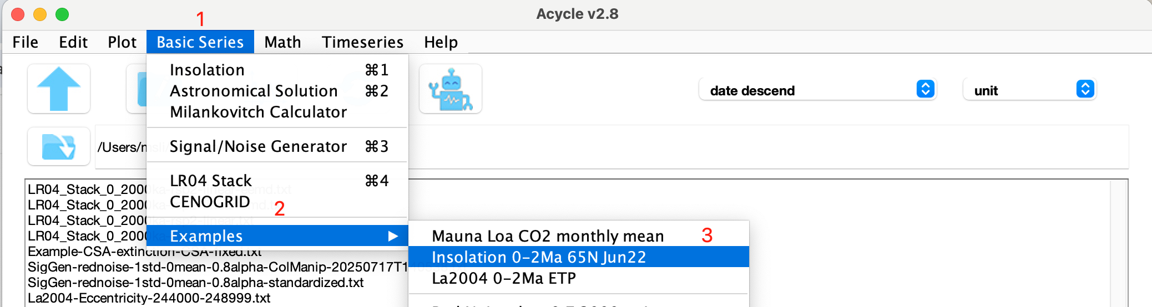

You will have the following data and figure.



### **Step 2: Data pre-processing**

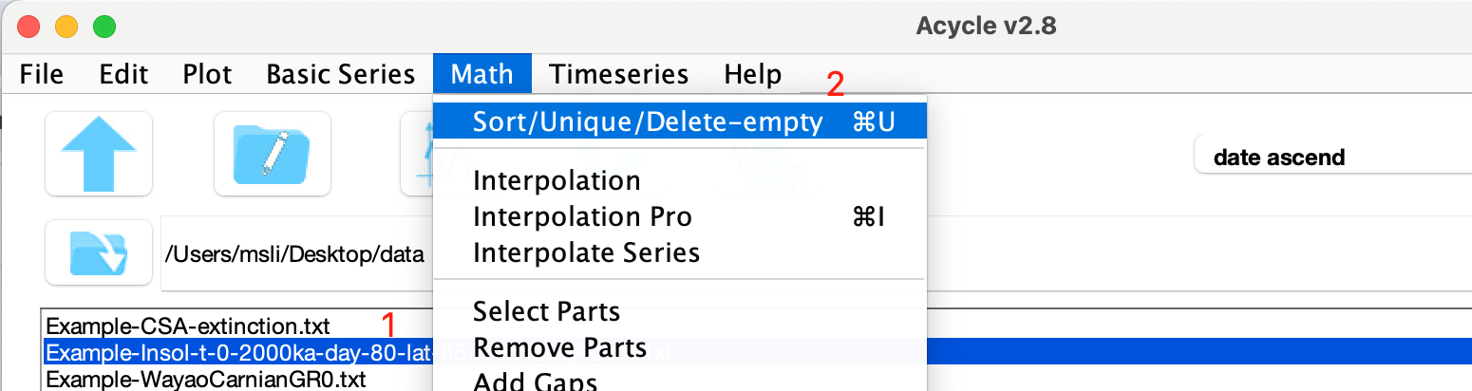 

Since the data are not in ascending order, sort them first.

### **Step 3: Detrending**

Remove the series mean (insolation).

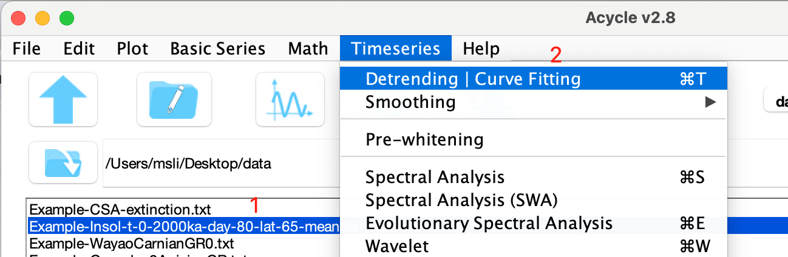



You will have:



### **Step 4: Power Spectral Analysis**

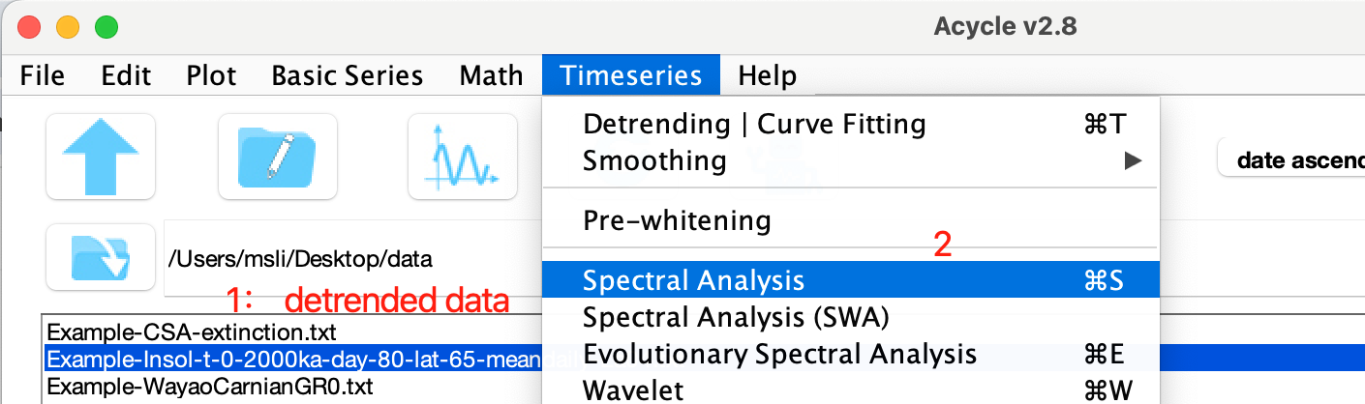

Using the following settings:

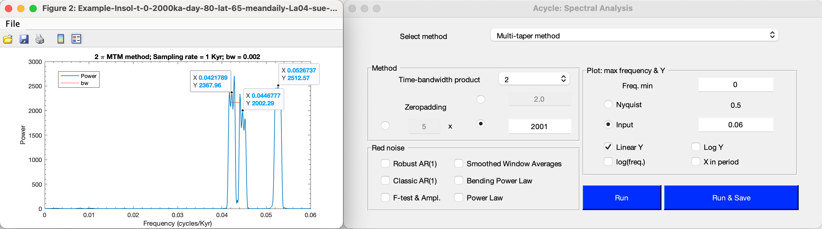

The 2π MTM (multi-taper method) power spectrum shows three peaks: 1/0.04218 kyr-1= 23.7 kyr, 1/0.04468 kyr-1= 22.4 kyr, and 1/0.05267 kyr-1= 19.0 kyr.

### **Step 4: Evolutionary Spectral Analysis**

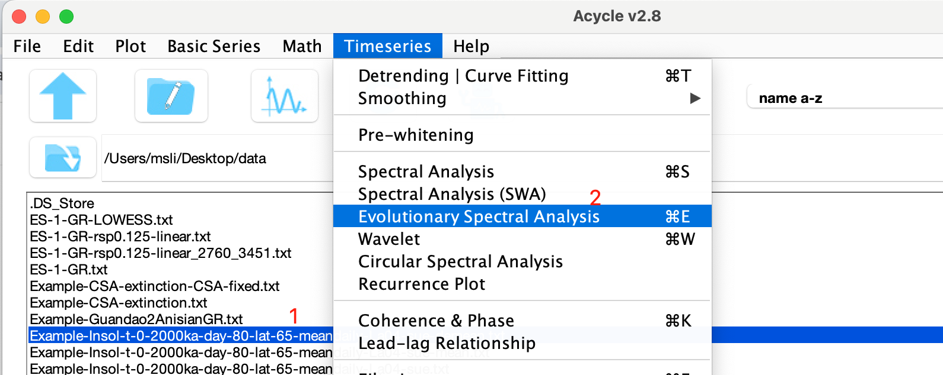

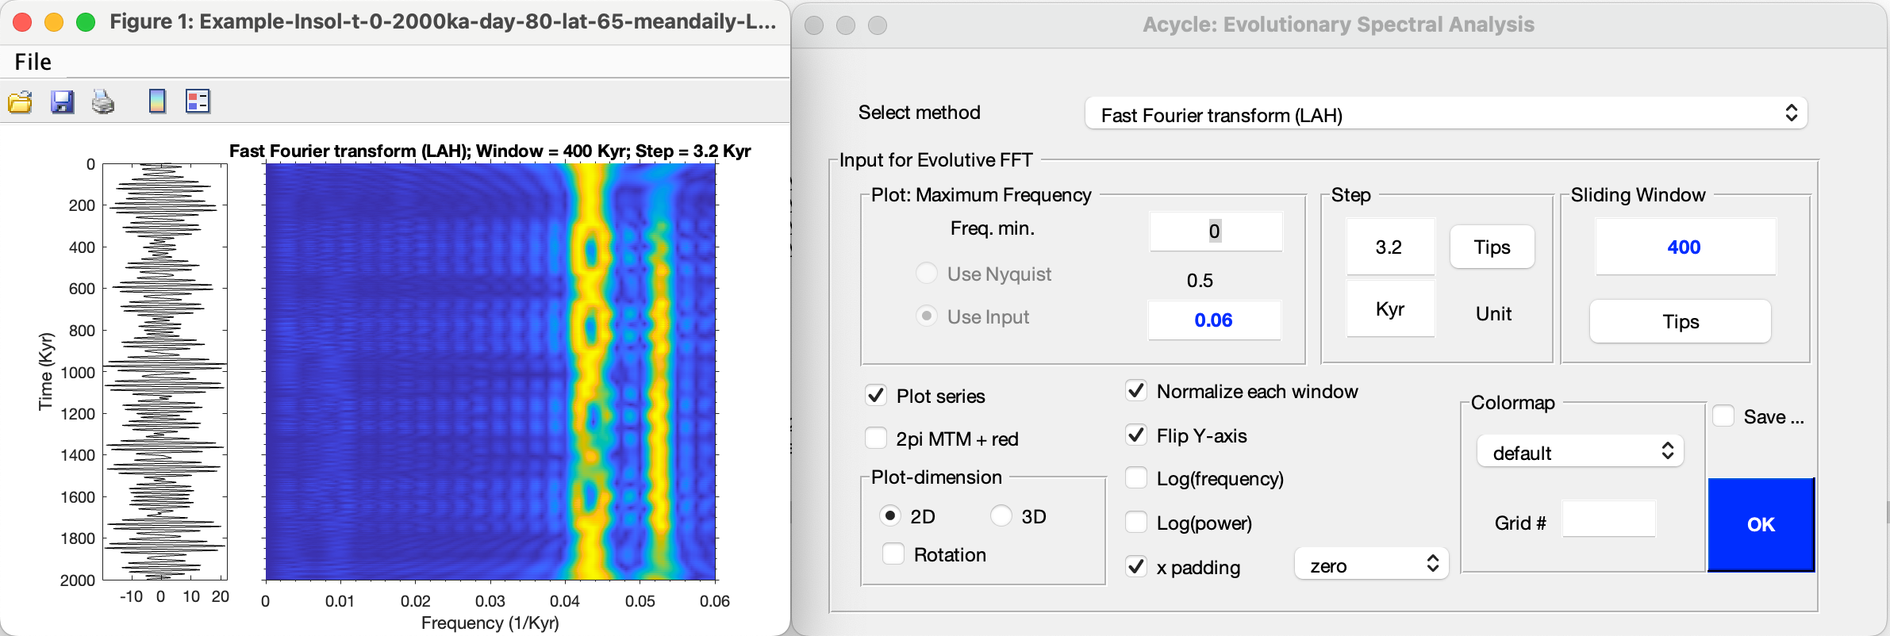

This series is dominated by precession cycles, and the 405‑kyr modulation is clearly visible in the evolutionary FFT (blue arrows).

## **6.3 Example #2: La2004 Astronomical Solution (ETP)**

**Data**: La2004 ETP over the past 2 million years

**Age**: 0-2000 ka

**Formulating ETP**:

Laskar et al. (2004) astronomical solutions of Eccentricity, Tilt (obliquity), and Precession are combined as:

ETP = standardized E + standardized T - standardized P

, where standardized E = (E – mean(E))/ standard deviation of E (and similarly for T and P).

**Target**:

Identify dominant frequencies of the ETP series

**Tool:**

*Acycle* software (<https://github.com/mingsongli/acycle>)

**Reference**:

Laskar, J., Robutel, P., Joutel, F., Gastineau, M., Correia, A.C.M., Levrard, B., 2004. A long-term numerical solution for the insolation quantities of the Earth. Astronomy & Astrophysics 428, 261-285.

### **Step 1: Load data**

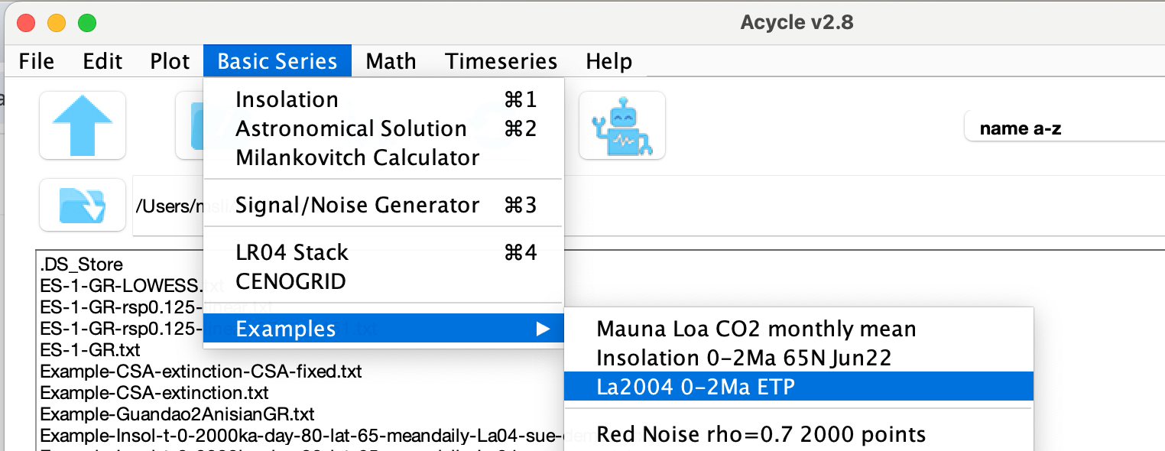

You will have:



### **Step 2: Data pre-processing**

Since the data are not in ascending order, sort them first.

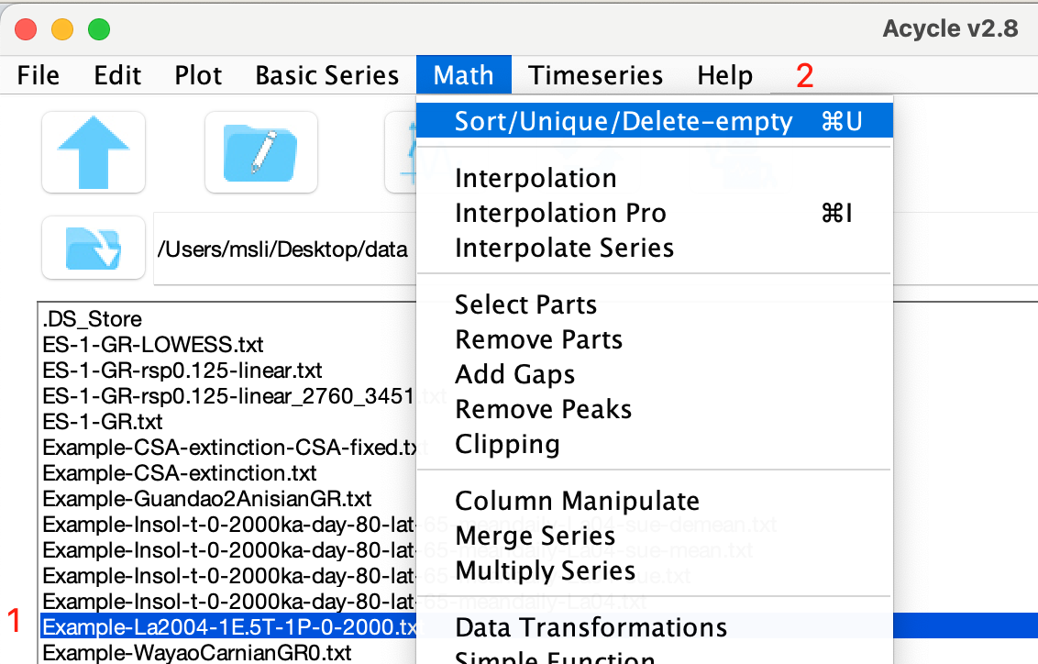 

### **Step 3: Detrending**

Remove the series mean.

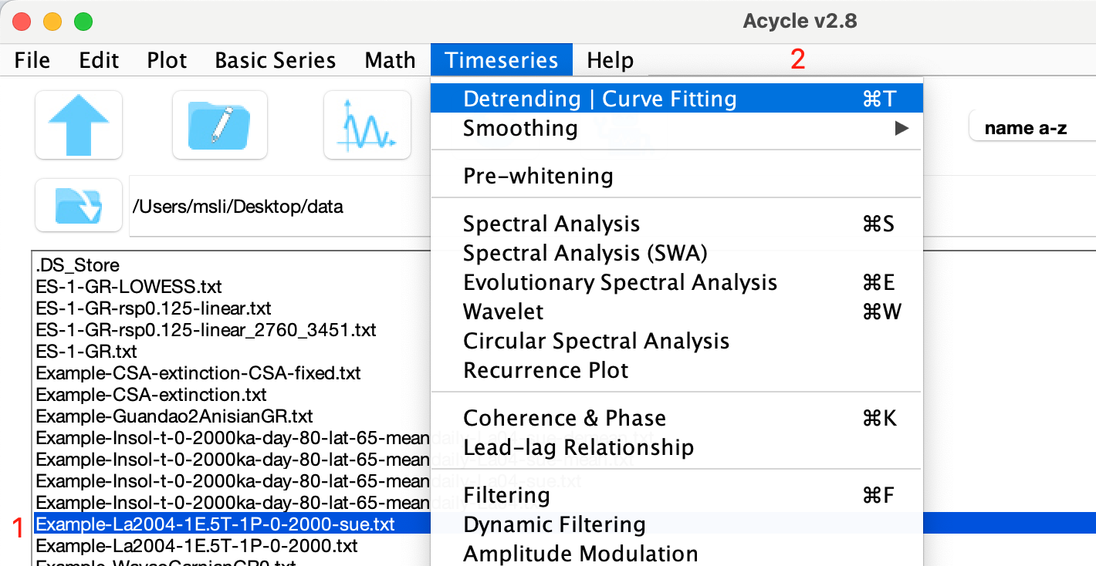



### **Step 4: Power Spectral Analysis**

Using these settings:

Seven peaks in the 2π MTMpower spectrum are at 1/405 kyr⁻¹ (405 kyr), 1/125 kyr⁻¹ (125 kyr), 1/95 kyr⁻¹ (95 kyr), 1/41 kyr⁻¹ (41 kyr), 1/23.7 kyr⁻¹ (23.7 kyr), 1/22.4 kyr⁻¹ (22.4 kyr), and 1/19.0 kyr⁻¹ (19.0 kyr).

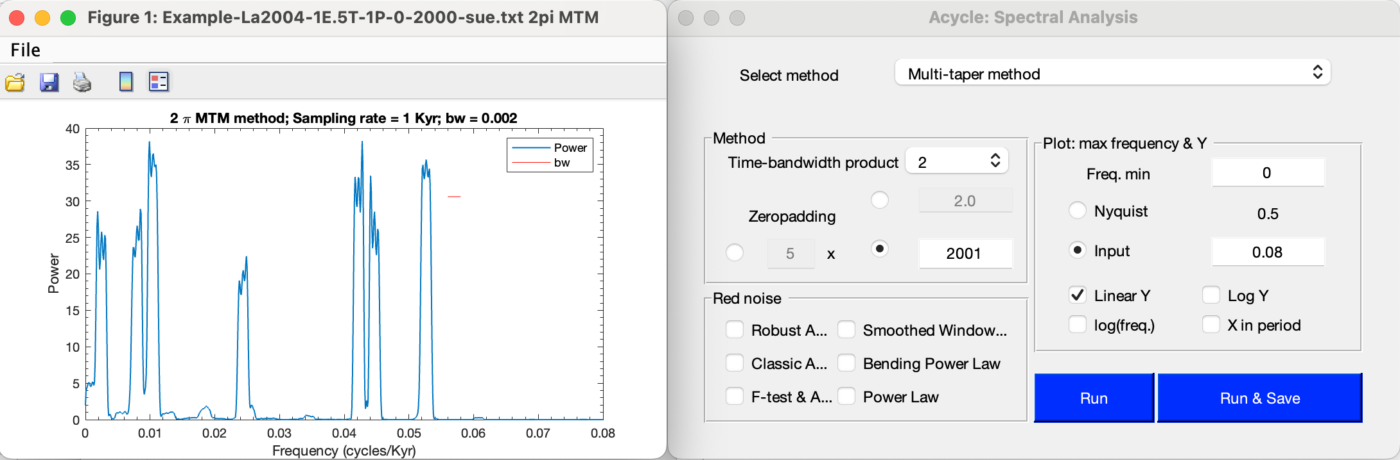

### **Step 5: Evolutionary Spectral Analysis**



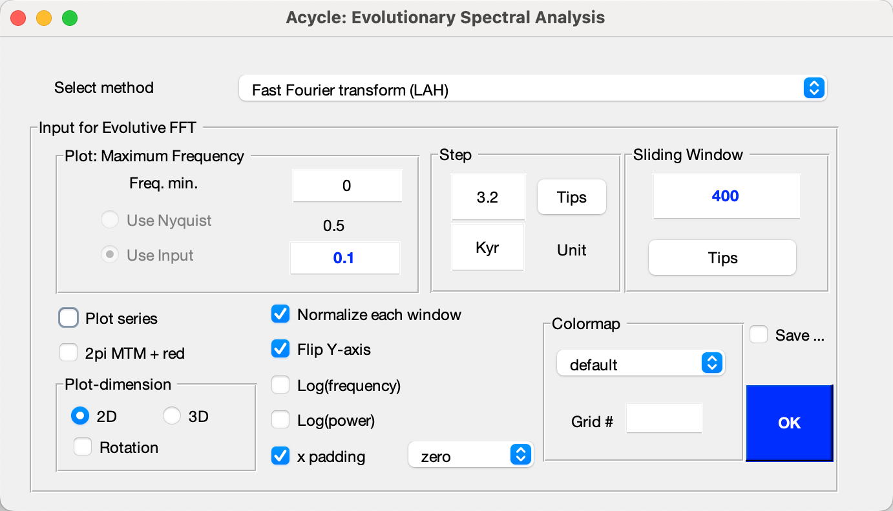

This series is dominated by 405 kyr long eccentricity, ~100 kyr short eccentricity, 41 kyr obliquity, 22/19 kyr precession cycles.

### **Step 6: Wavelet transform**

Using the following settings:

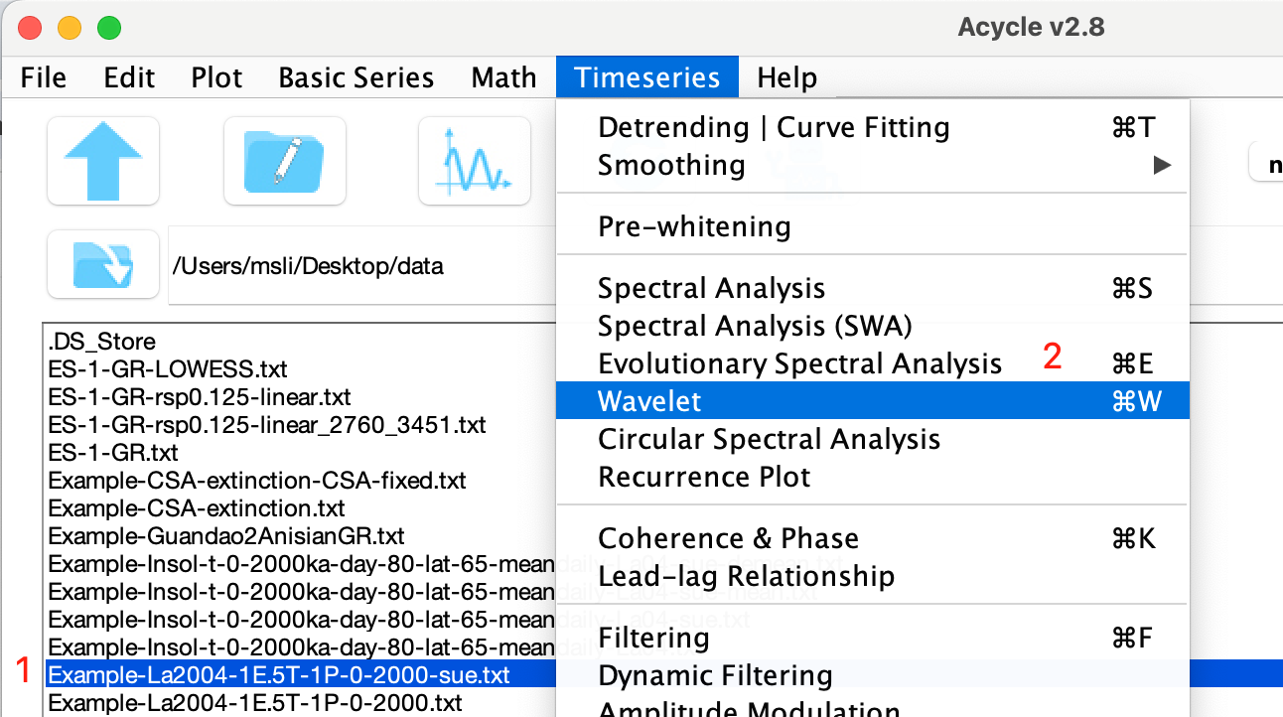 

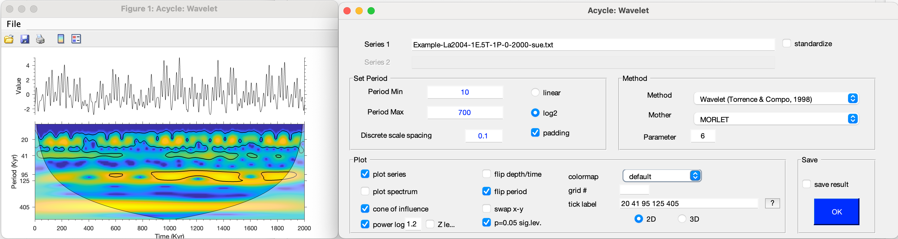

## **6.4 Example #3: Carnian cyclostratigraphy**

**Section**: Wayao section, Guizhou, South China

**Age**: Middle Carnian

**Lithology**: The limestone beds of the Zhuganpo Formation display patterns of variable bed thicknesses and changing clay content within the limestones as reflected in relative weathering resistance.

**Proxy**: These factors influence the natural gamma-ray (GR) signal with higher intensities indicating higher average clay contents (Li et al., 2019).

**Target**:

You will learn typical data-processing steps in cyclostratigraphy.

**Tool:**

*Acycle* software (<https://github.com/mingsongli/acycle>).

**Reference**:

Zhang, Y., Li, M., Ogg, J.G., Montgomery, P., Huang, C., Chen, Z.-Q., Shi, Z., Enos, P., Lehrmann, D.J., 2015. Cycle-calibrated Magnetostratigraphy of middle Carnian from South China: Implications for Late Triassic Time Scale and Termination of the Yangtze Platform. Palaeogeography, Palaeoclimatology, Palaeoecology 436, 135-166.

### **Step 1. Load Data**

Select Basic Series 🡪 Examples 🡪 Late Triassic Wayao gamma ray.

The gamma ray data file “Example-WayaoCarnianGR0.txt” will load and display in the *Acycle* main window.

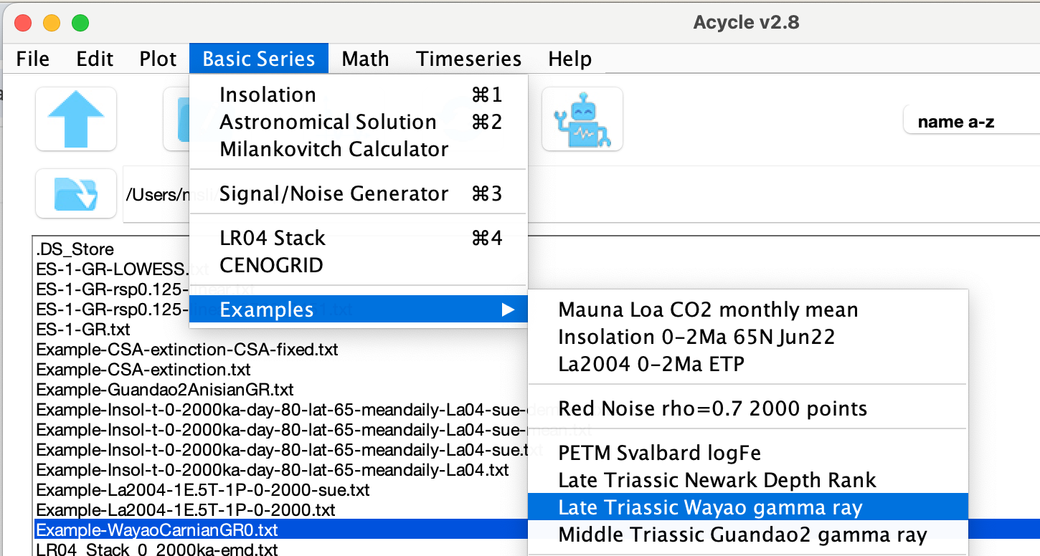

Left-click the file, then choose Plot 🡪 Plot to visualize it. Double-click the file to view the *Acycle*-accepted format.



### **Step 2. Data Preparation**

*Acycle* includes toolboxes for data preparation. You can sort data in ascending order. Two or more values at the same time (or depth) can be averaged using the "Unique" function.

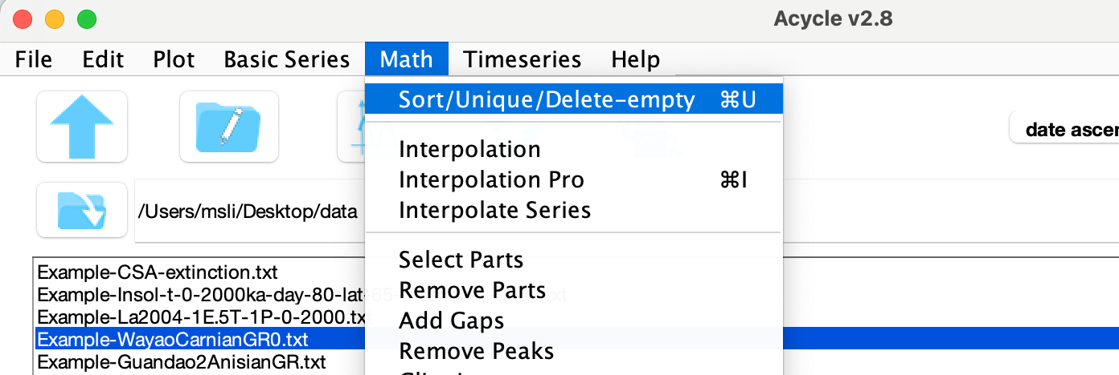

### **Step 3. Interpolation**

Stratigraphic depth or time series are typically irregularly spaced due to uncertain timescales or difficulty in data collection. Interpolation generates a uniformly spaced series.

First, select Plot 🡪 Sampling Rate.



You’ll see that sampling intervals are irregular, with a median of 0.3333 and a mean of 0.35341 (in the upper right corner of the figure). 

Go to Math 🡪 Interpolation (or Ctrl + I), enter 0.33 (m), and click OK.

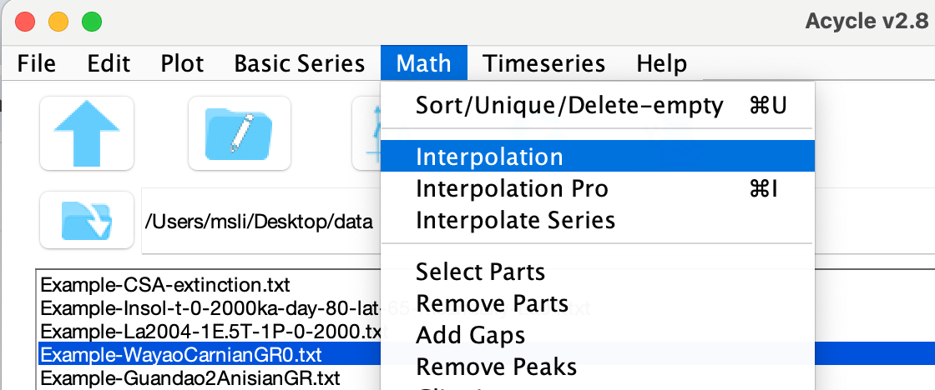 

A new file named “Example-WayaoCarnianGR0-rsp0.33.txt”.

### **Step 4. Detrending**

Detrending removes long‑term trends to ensure that data variability oscillates around a zero mean and to prevent low‑frequency power from leaking into higher frequencies.

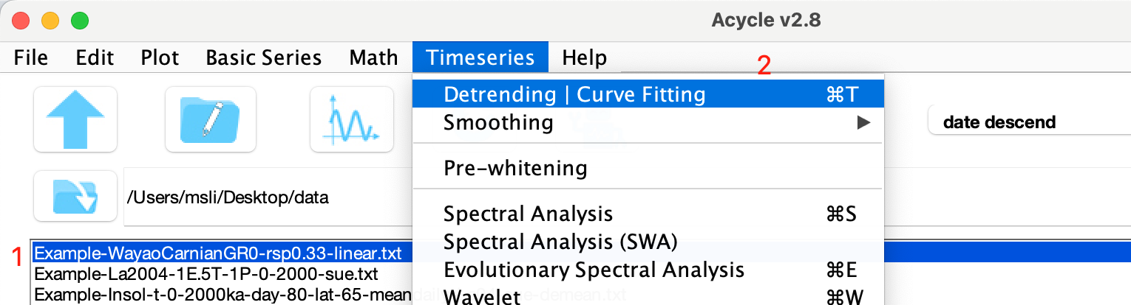

Select the file; then choose Timeseries 🡪 Detrending (or CTRL + T).

In the pop-up, set the window size and detrending method, then click OK to display the trends.

Don’t close the “*Acycle*: Detrending” or “New figure” window. Adjust the window size in the left panel to see instant updates on the right.



Select & Save detrending Model. For example, choose an **80 m LOWESS** trend to remove long‑term drift without discarding key cycles.

The *Acycle* main window now shows “Example-WayaoCarnianGR0-rsp0.33-80-LOWESS.txt” (detrended series) and “***-LOWESStrend.txt” (trend file).



### **Step 5. Power spectral analysis**

Power spectral analysis evaluates the distribution of time series variance (power) as a function of frequency to identify periodic components.

Select the detrended file, then “TimeSeries” 🡪 “Spectral Analysis”.

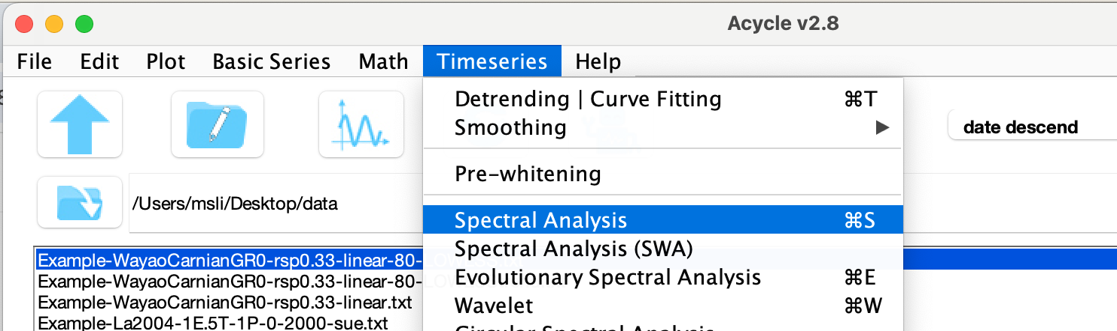

Choose Multi-taper method (MTM) with a robust AR (1) red-noise model.

**Parameters:**

2π MTM with 5× zero-padding to increase frequency resolution

Max frequency = 1 cycle/m

Linear Y-axis

Noise model: Robust AR(1) red noise background

Smoothing (right panel): 20% median smoothing, with spectrum fitted on a logarithmic power scale

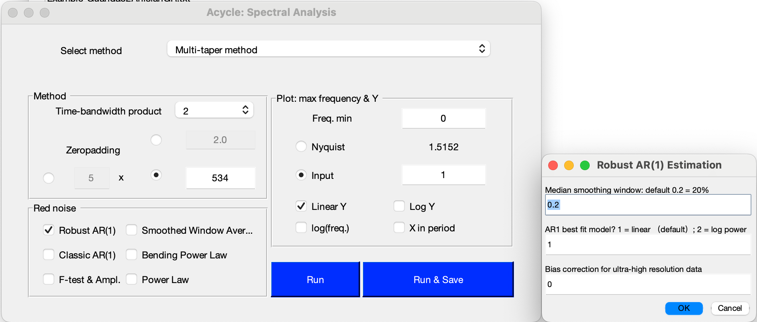

Note: Period = 1 / frequency (e.g., 1/0.02951 cycles/m ≈ 33.9 m).



The resulting MTM spectrum shows the 20% median‑smoothed spectrum, the AR(1) background, and the 90%, 95%, 99%, 99.9% confidence intervals.

*Peaks above 95% confidence occur at ≈ 33.9 m, 10 m, 7 m, 2.6 m, and 1.8 m, corresponding to 405 kyr, 119 kyr, 83 kyr, 31 kyr, and 21.5 kyr cycles.*

*Since Acycle v2.1, tick “X in period” to display the spectrum in the period domain.*

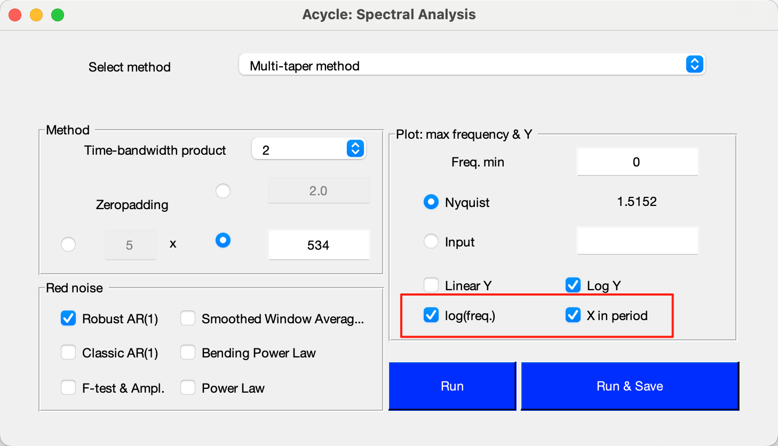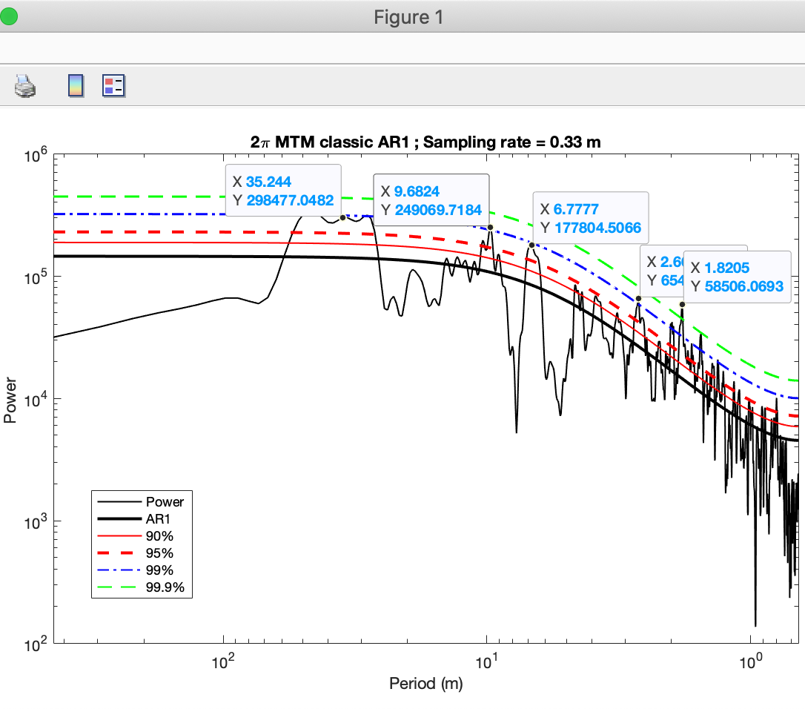

### **Step 6. Evolutionary power spectral analysis**

Select your data, then “TimeSeries” 🡪 Evolutionary Spectral Analysis.

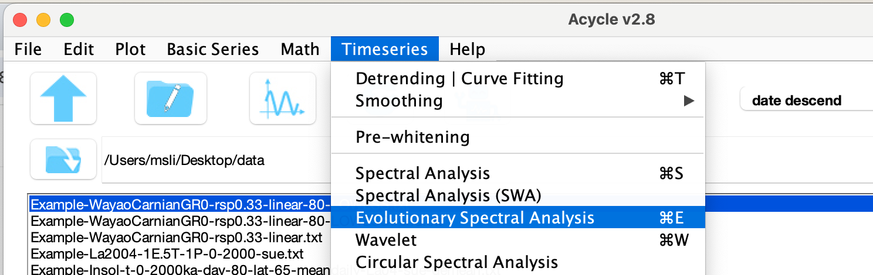

Settings.

Sliding window = 40 m (≈1.5-2× the longest cycle of 33.9 m)

Max frequency = 0.7 (emphasize low-frequency power)

Normalize each window so each peak has unit amplitude

Flip Y-axis ( data’s first column increases upward)

Click OK to display results.

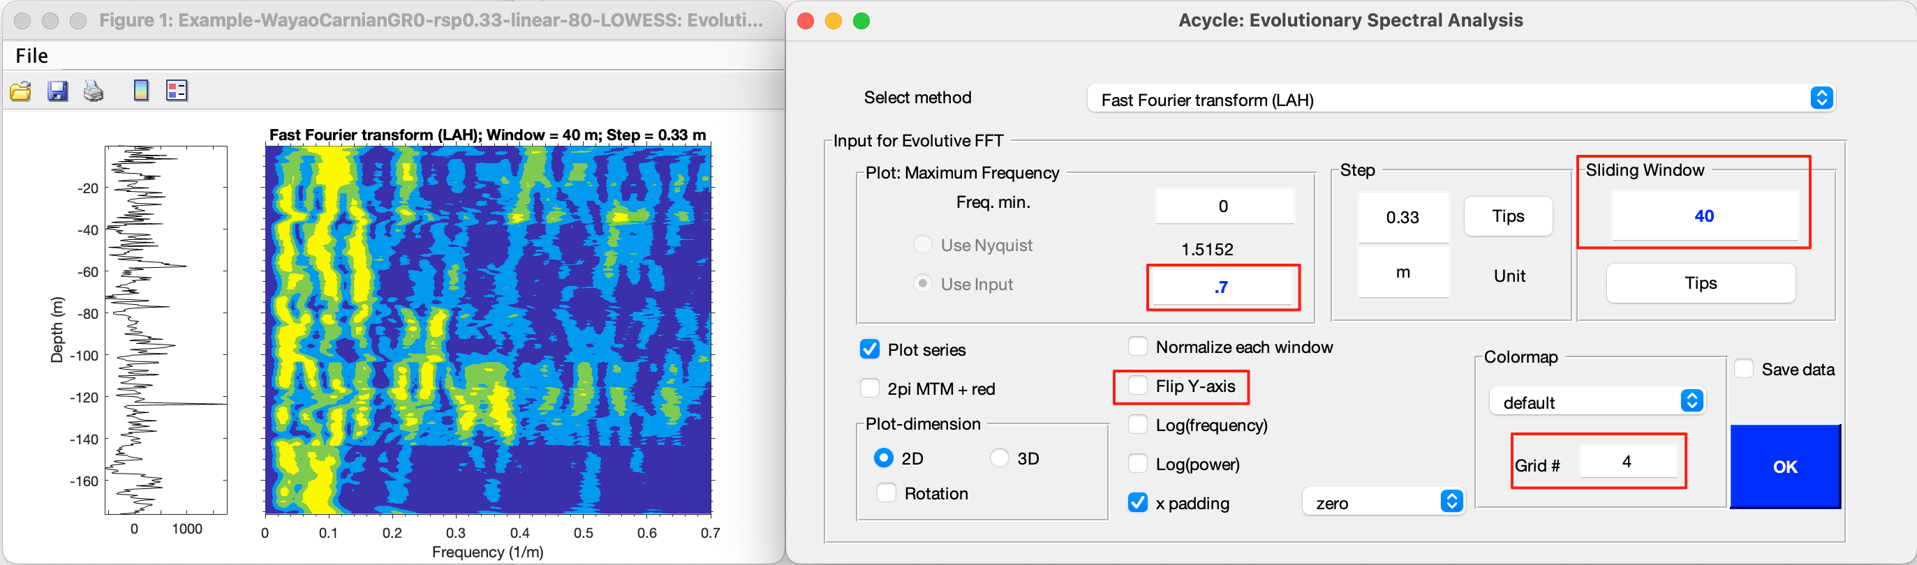

Don’t close the panels – you can adjust frequency limits, colormap, or flip the Y-axis afterward.

This figure shows that the ~34 m cycle remains stable in frequency (period), suggesting little variation in sedimentation rate.

### **Step 7. Correlation coefficient**

To estimate the most likely sedimentation rate, select the detrended data, then click “Timeseries” 🡪 Correlation coefficient.

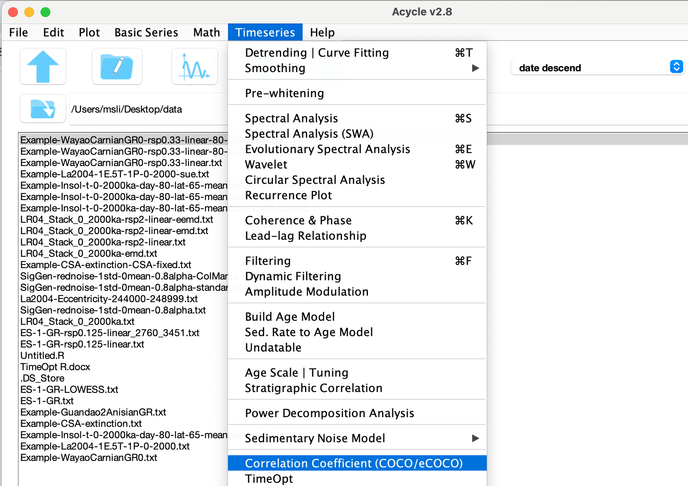

* Median age: Enter the median age of your data (~230 Ma). Uncertainty ±2–5 Myr is acceptable.
* Sedimentation rate range: Use the defaults or adjust as needed.
* Monte Carlo simulations: use 1000 (or 500) for an initial test; use 2000 (or more) for publication-quality results.
* Split series: If your data set is very long, set “Number of slices” to 2 or 3.



You will see a figure and a log file of all settings. It indicates an optimal rate of ~8.1 cm/kyr with 0.1% significance.





Now perform an eCOCO analysis with a **45 m** window to track variable sedimentation rates.





### **Step 8. Filtering**

Filters isolate specific frequency bands.

Select your data, then “Timeseries” 🡪 Filtering.

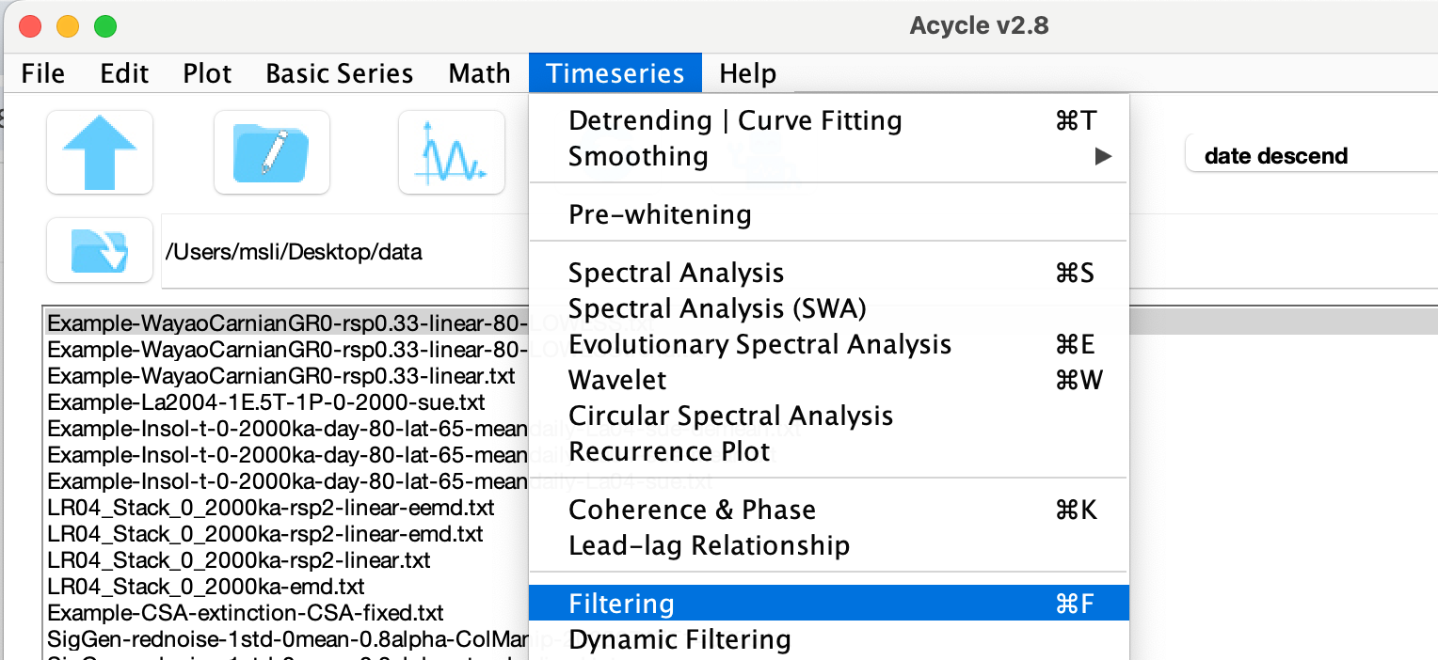

In the pop-up window, select the high and low cutoff frequencies, choose the Gaussian method, and click “Save Data”.

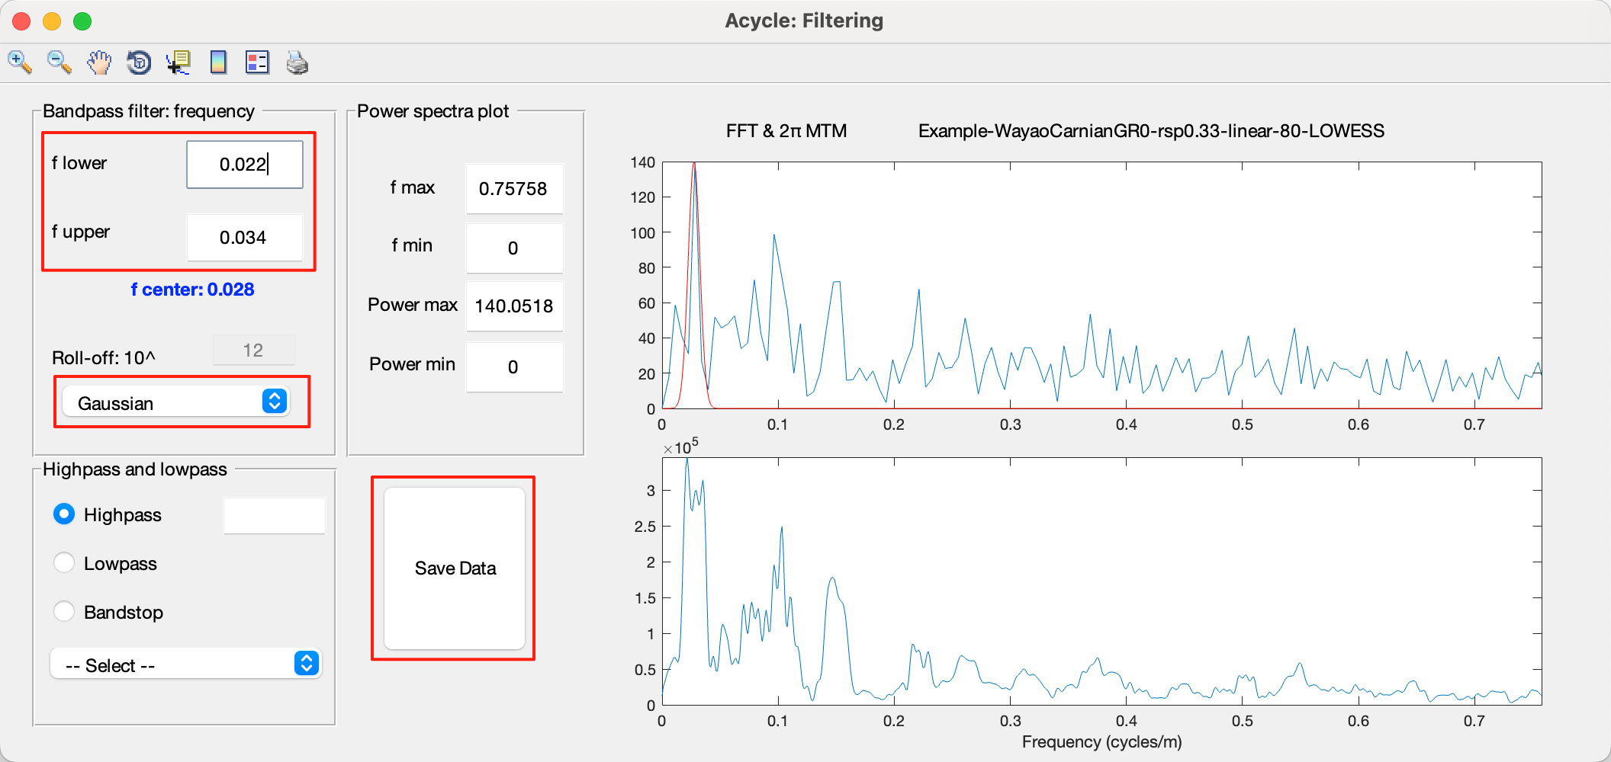

You will see the filtered series in the *Acycle* main window.





### **Step 9. Age model & tuning**

The “Age Scale” toolbox in *Acycle* converts depth-domain data to time-domain once an age model exists.

Assuming the 33.4 m cycles correspond to 405 kyr, select:

“Example-WayaoCarnianGR0-rsp0.33-80-LOWESS-gaus-0.028+-0.006.txt”

Then Timeseries 🡪 Build Age Model and click OK to generate:

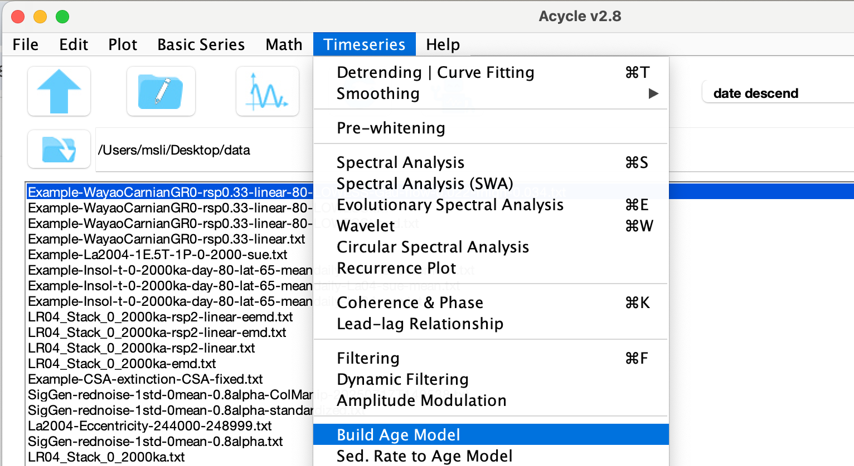



Example-WayaoCarnianGR0-rsp0.33-80-LOWESS-gaus-0.028+-0.006-agemod-405-max.txt

Next, Timeseries 🡪 Age Scale: select the age model file, choose the series to tune, and click OK.



The tuned file will be:

“Example-WayaoCarnianGR0-TD-Example-WayaoCarnianGR0-rsp0.33-80-LOWESS-gaus-0.028+-0.006-agemod-405-max.txt”



### **Step 10. Repeat steps.**

You can repeat Steps 3-6 and Step 8 as needed.

# **References**

Berger, A., Loutre, M., Dehant, V., 1989. Influence of the changing lunar orbit on the astronomical frequencies of pre‐Quaternary insolation patterns. Paleoceanography 4, 555-564.

Charles, A.J., Condon, D.J., Harding, I.C., Pälike, H., Marshall, J.E.A., Cui, Y., Kump, L., Croudace, I.W., 2011. Constraints on the numerical age of the Paleocene-Eocene boundary. Geochemistry, Geophysics, Geosystems 12.

Husson, D., 2014. MathWorks File Exchange: RedNoise_ConfidenceLevels, <http://www.mathworks.com/matlabcentral/fileexchange/45539-rednoise-confidencelevels/content/RedNoise_ConfidenceLevels/RedConf.m>.

Jiang, Q., Li, M., Yao, W., Wei, R., Ji, K., Zhang, H., Jin, Z., 2025. Astrochronology of the Paleocene–Eocene Thermal Maximum on the East Tasman Plateau. Global and Planetary Change 252, 104882.

Kodama, K.P., Hinnov, L., 2015. Rock Magnetic Cyclostratigraphy. Wiley-Blackwell.

Laskar, J., Fienga, A., Gastineau, M., Manche, H., 2011. La2010: a new orbital solution for the long-term motion of the Earth. Astron Astrophys 532.

Laskar, J., Robutel, P., Joutel, F., Gastineau, M., Correia, A.C.M., Levrard, B., 2004. A long-term numerical solution for the insolation quantities of the Earth. Astron Astrophys 428, 261-285.

Li, M., Barnes, H.L., 2019. Orbitally forced sphalerite growth in the Upper Mississippi Valley District. Geochemical Perspectives Letters 12, 18-22.

Li, M., Hinnov, L.A., Huang, C., Ogg, J.G., 2018a. Sedimentary noise and sea levels linked to land–ocean water exchange and obliquity forcing. Nature Communications 9, 1004.

Li, M., Huang, C., Hinnov, L., Chen, W., Ogg, J., Tian, W., 2018b. Astrochronology of the Anisian stage (Middle Triassic) at the Guandao reference section, South China. Earth and Planetary Science Letters 482, 591-606.

Li, M., Huang, C., Hinnov, L., Ogg, J., Chen, Z.-Q., Zhang, Y., 2016. Obliquity-forced climate during the Early Triassic hothouse in China. Geology 44, 623-626.

Li, M., Huang, C., Ogg, J., Zhang, Y., Hinnov, L., Wu, H., Chen, Z.-Q., Zou, Z., 2019. Paleoclimate proxies for cyclostratigraphy: Comparative analysis using a Lower Triassic marine section in South China. Earth-Science Reviews 189, 125-146.

Li, M., Kump, L.R., Hinnov, L.A., Mann, M.E., 2018c. Tracking variable sedimentation rates and astronomical forcing in Phanerozoic paleoclimate proxy series with evolutionary correlation coefficients and hypothesis testing. Earth and Planetary Science Letters 501, 165-179.

Lisiecki, L.E., Raymo, M.E., 2005. A Pliocene‐Pleistocene stack of 57 globally distributed benthic δ18O records. Paleoceanography 20.

Lomb, N.R., 1976. Least-squares frequency analysis of unequally spaced data. Astrophysics and Space Science 39, 447-462.

Lougheed, B.C., Obrochta, S., 2019. A Rapid, Deterministic Age‐Depth Modeling Routine for Geological Sequences With Inherent Depth Uncertainty. Paleoceanography and Paleoclimatology 34, 122-133.

Lutz, T.M., 1985. The magnetic reversal record is not periodic. Nature 317, 404-407.

Mann, M.E., Lees, J.M., 1996. Robust estimation of background noise and signal detection in climatic time series. Climatic Change 33, 409-445.

Marwan, N., Carmen Romano, M., Thiel, M., Kurths, J., 2007. Recurrence plots for the analysis of complex systems. Physics Reports 438, 237-329.

Meyers, S.R., 2014. astrochron: An R Package for Astrochronology. <http://cran.r-project.org/package=astrochron>.

Meyers, S.R., 2015. The evaluation of eccentricity‐related amplitude modulation and bundling in paleoclimate data: An inverse approach for astrochronologic testing and time scale optimization. Paleoceanography.

Olsen, P.E., Kent, D.V., 1996. Milankovitch climate forcing in the tropics of Pangaea during the Late Triassic. Palaeogeography, Palaeoclimatology, Palaeoecology 122, 1-26.

Paillard, D., Labeyrie, L., Yiou, P., 1996. Macintosh program performs time‐series analysis. Eos, Transactions American Geophysical Union 77, 379-379.

Rampino, M.R., Caldeira, K., Zhu, Y., 2020. A 27.5-My underlying periodicity detected in extinction episodes of non-marine tetrapods. Historical Biology, 1-7.

Rampino, M.R., Caldeira, K., Zhu, Y., 2021. A pulse of the Earth: A 27.5-Myr underlying cycle in coordinated geological events over the last 260 Myr. Geoscience Frontiers 12, 101245.

Scargle, J.D., 1982. Studies in astronomical time series analysis. II-Statistical aspects of spectral analysis of unevenly spaced data. The Astrophysical Journal 263, 835-853.

Sinnesael, M., Zivanovic, M., De Vleeschouwer, D., Claeys, P., 2018. Spectral Moments in Cyclostratigraphy: Advantages and Disadvantages compared to more classic Approaches. Paleoceanography and Paleoclimatology 33, 493-510.

Stothers, R.B., 1991. Linear and circular digital spectral analysis of serial data. The Astrophysical Journal 375, 423-426.

Thomson, D.J., 1982. Spectrum estimation and harmonic analysis. Proceedings of the IEEE 70, 1055-1096.

Torrence, C., Compo, G.P., 1998. A practical guide to wavelet analysis. Bulletin of the American Meteorological Society 79, 61-78.

Vaughan, S., Bailey, R., Smith, D., 2011. Detecting cycles in stratigraphic data: Spectral analysis in the presence of red noise. Paleoceanography 26.

Waltham, D., 2015. Milankovitch Period Uncertainties and Their Impact On Cyclostratigraphy. Journal of Sedimentary Research 85, 990-998.

Wang, M., Li, M., Hajek, E.A., Kemp, D.B., Wu, Y., Zhu, H., Huang, C., Zhang, H., Ji, K., Zhang, R., Wei, R., Jin, Z., 2024. Assessing the preservation of orbital signals across different sedimentary environments: Insights from stochastic sedimentation modeling. Earth and Planetary Science Letters 642, 118866.

Weedon, G.P., Page, K.N., Jenkyns, H.C., 2019. Cyclostratigraphy, stratigraphic gaps and the duration of the Hettangian Stage (Jurassic): insights from the Blue Lias Formation of southern Britain. Geological Magazine, 1-41.

Westerhold, T., Marwan, N., Drury, A.J., Liebrand, D., Agnini, C., Anagnostou, E., Barnet, J.S.K., Bohaty, S.M., De Vleeschouwer, D., Florindo, F., Frederichs, T., Hodell, D.A., Holbourn, A.E., Kroon, D., Lauretano, V., Littler, K., Lourens, L.J., Lyle, M., Pälike, H., Röhl, U., Tian, J., Wilkens, R.H., Wilson, P.A., Zachos, J.C., 2020. An astronomically dated record of Earth’s climate and its predictability over the last 66 million years. Science 369, 1383-1387.

Yao, X., Zhou, Y., Hinnov, L.A., 2015. Astronomical forcing of a Middle Permian chert sequence in Chaohu, South China. Earth and Planetary Science Letters 422, 206-221.

Zeebe, R.E., 2017. Numerical Solutions for the orbital motion of the Solar System over the Past 100 Myr: Limits and new results. The Astronomical Journal 154, 193.

Zeebe, R.E., Lourens, L.J., 2019. Solar System chaos and the Paleocene–Eocene boundary age constrained by geology and astronomy. Science 365, 926-929.

Zhang, R., Jin, Z., Li, M., Gillman, M., Chen, S., Liu, Q., Wei, R., Shi, J., 2023. Long-term periodicity of sedimentary basins in response to astronomical forcing: Review and perspective. Earth-Sci Rev 244, 104533.

Zhang, Y., Li, M., Ogg, J.G., Montgomery, P., Huang, C., Chen, Z.-Q., Shi, Z., Enos, P., Lehrmann, D.J., 2015. Cycle-calibrated Magnetostratigraphy of middle Carnian from South China: Implications for Late Triassic Time Scale and Termination of the Yangtze Platform. Palaeogeography, Palaeoclimatology, Palaeoecology 436, 135-166.